Arab Open University- Egypt Branch



**Faculty of Computer Studies**

**Information technology and Computing Department**

**HR Performance Dashboard for Promotion Prediction.**

**Student Name: Lina Mohey El-Din Gomaa**

**Student ID: 1951710183**

**TM471B: Final Year Project, 2023**

**Project Supervision:**

**Dr. Ibrahim Mohamed El Hasnony**

**Acknowledgment**

I would like to express my sincere gratitude to Dr. Ibrahim for his invaluable guidance throughout this project. His expertise and support were instrumental in helping me organize and plan the project effectively. I am truly grateful for his time, effort, and dedication, which have contributed significantly to the success of this project

Table of Contents

**Chapter 4:** 6

**Design, Implementation and Testing** 6

**4.1 Introduction** 6

**4.2 Data** 7

**4.2.1 Database Schema** 7

**4.3 Design Phase** 9

**4.3.1 Home Section** 9

**4.3.2 Login Modal** 10

**4.3.3 Visualization Dashboard** 10

**4.3.4 Report of Visualizations:** 11

**4.3.5 Employees Page** 13

**4.3.6 Delete Employee/All Employees Modal:** 13

**4.3.7 Add Employee Page:** 13

**4.3.8 Update Employee Page:** 14

**4.3.9 View Employee Page:** 15

**4.3.10 Promoted Employees Page** 15

**4.3.11 Generating Report of Promoted Employees** 16

**4.3.12 Work Goals Page** 16

**4.3.13 Prediction Page** 16

**4.3.14 Not Found Page** 18

**4.4 Implementation Phase** 18

**4.4.1 Programming Tools** 18

**4.4.2 Data Cleaning** 18

**4.4.3.1 Model I: Prediction using Logistic Regression** 20

**4.4.3.2 Model II Prediction using Support Vector Machine** 21

**4.4.3.3 Model III Prediction using Naïve bayes:** 22

**4.4.3.4 Model IV Prediction using XGBoost** 23

**4.4.4 Website code:** 24

**4.4.4.1 Login Authentication:** 24

**4.4.4.2 Dashboard’s side bar:** 24

**4.4.4.3 Dashboard Charts:** 25

**4.4.4.4 Generating report:** 34

**4.4.4.5 Employee’s page:** 35

**4.4.4.6 Read Employees from database query:** 37

**4.4.4.7 Update Employee’s promotion status query:** 37

**4.4.4.8 Delete Employee query:** 37

**4.4.4.9 Delete all employees' query:** 38

**4.4.4.10 Search query:** 38

**4.4.4.11 Add Employee’s page:** 38

**4.4.4.12 Add Employee Query:** 39

**4.4.4.13 Update Employee’s Page:** 40

**4.4.4.14 Update Employee query:** 41

**4.4.4.15 View Employee’s page:** 42

**4.4.4.16 Read Employee query:** 43

**4.4.4.17 Promoted Employee’s page:** 43

**4.4.4.18 Promoted Employee’s name and department query** 45

**4.4.4.19 Work goals’ page:** 45

**4.4.4.20 Prediction page:** 46

**4.4.4.21 Prediction API:** 47

**4.4.4.22 Not found page:** 47

**4.4.5 Implementation issues:** 48

**4.5 Testing** 48

**4.5.1 Performance Testing** 48

**4.5.2 Functionality Testing** 49

**4.5.2 Security Testing** 49

**4.5.6 Database Testing** 49

**4.7 Methodology** 49

**4.8 Conclusion** 50

**Chapter 5:** 51

**Results and Discussions** 51

**5.1 Introduction** 52

**5.1.1 Data visualization** 52

**5.2 Model Results:** 58

**5.2.1 Model I: Prediction usin g Logistic Regression results:** 58

**5.2.2 Model II Accuracy using Support Vector Machine results:** 59

**5.2.3 Model III Prediction using Naïve bayes results:** 60

**5.2.4 Model IV Prediction using XGBoost results:** 61

**5.3 Model Comparison:** 62

**5.4 Model Serialization** 62

**5.5 Model Integration:** 63

**5.6 Comparing related work:** 68

**5.6.1 The UI of Compared Model:** 69

**5.7 Goals Achieved** 70

**5.8 Features** 70

**Chapter 6:** 71

**Conclusion and Future work** 71

**6.1 Summary of project** 72

**6.2 Future Work** 73

**7. References** 74

**8. Appendices** 74

**8.1 Flask code for quick prediction form:** 74

**8.2 Prediction form page code:** 78

# 

# **Chapter 4:**

# **Design, Implementation and Testing**

# 

# **4.1 Introduction**

This chapter is dedicated to discussing the three critical phases of the system's development:, design, implementation and testing. By analyzing these stages of the system's creation, readers can gain a deeper understanding of its structure, functionality, and overall design. Next, we will outline the two types of testing that were performed to test the website: performance testing and functionality testing.

# **4.2 Data**

## **4.2.1 Database Schema**

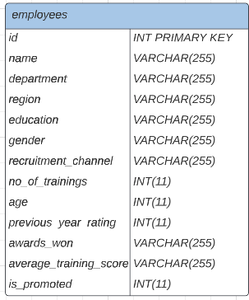

Figure 1 Database Schema

The database schema represents

the logical view of the entire database.

The "employees" is a database table that stores a variety of information about each employee in the organization. This includes personal information like id, name, age, and gender, as well as work-related data such as region, education, recruitment channel, number of trainings, and length of service. Additionally, the table also contains performance-related information such as awards_won, previous year ratings, average training score, and promotion status.

The "id” attribute is the primary key for the table, which can identify each employee in this table uniquely. The is_promoted attribute is the target variable that indicates if the employee is eligible for promotion or not.

**4.2. 2 Dataset**

The dataset used in this analysis contains information about employees in a company and their promotion status. The goal of this analysis is to develop a predictive model to forecast whether an employee will be promoted or not.

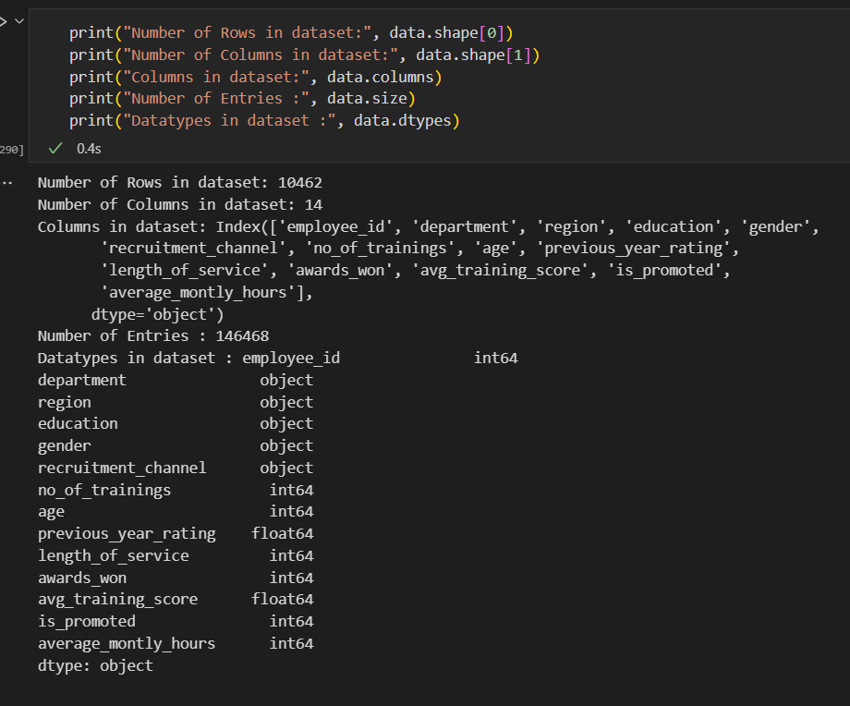

Figure 2 Data entries

In Figure 3, the dataset includes both numerical and categorical data, the data is separated accordingly. The pandas describe() function is used to generate a range of summary statistics that includes the count, mean, standard deviation, minimum, maximum values, and quantiles for the numerical data. The resulting output provides a detailed overview of the numerical data, these quantitative measures serve as a valuable guide for replacing any missing entries with appropriate values.

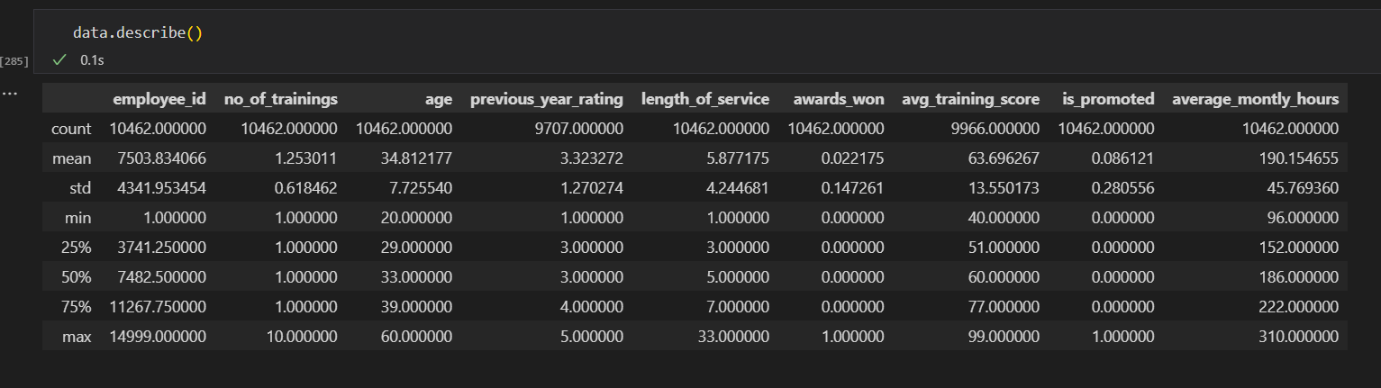

Figure 3 Data Description

# **4.3 Design Phase**

## **4.3.1 Home Section**





### 

Figure 4 Home Page

# 

## **4.3.2 Login Modal**



Figure 5 Admin Login

## **4.3.3 Visualization Dashboard**

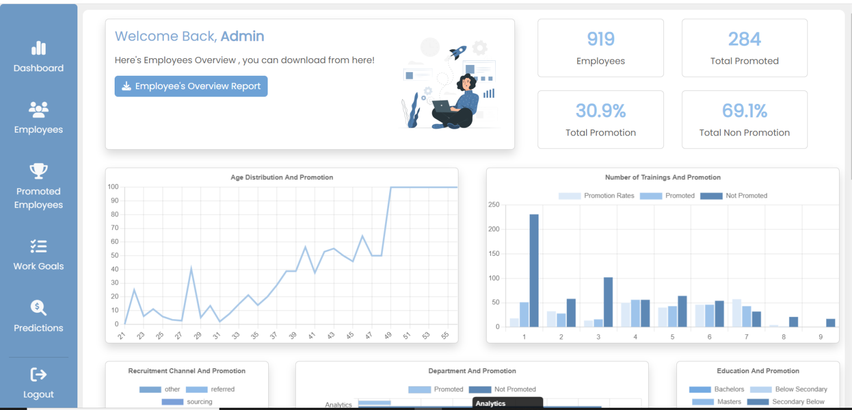

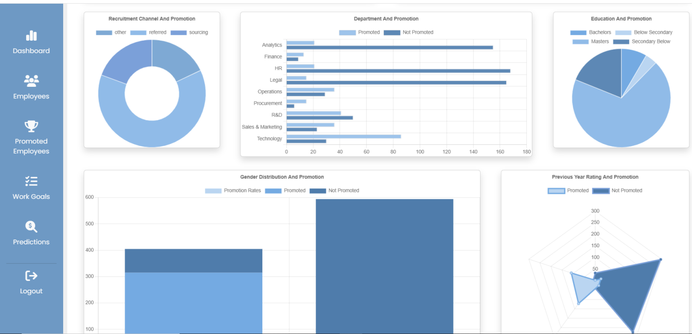

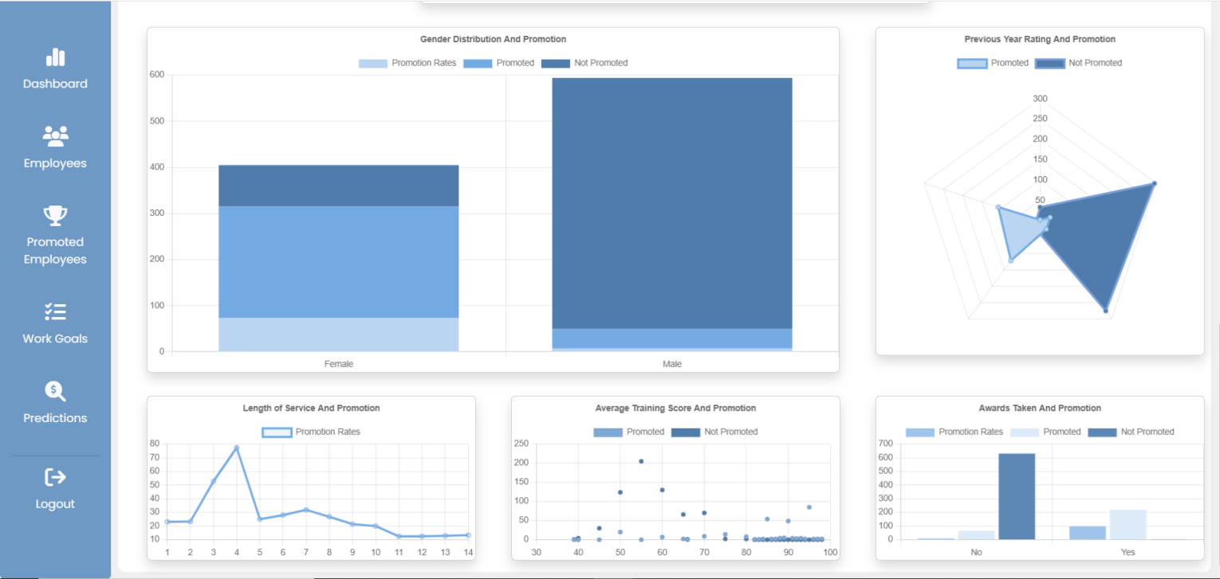

Figure 6 Admin Dashboard

## **4.3.4 Report of Visualizations:**

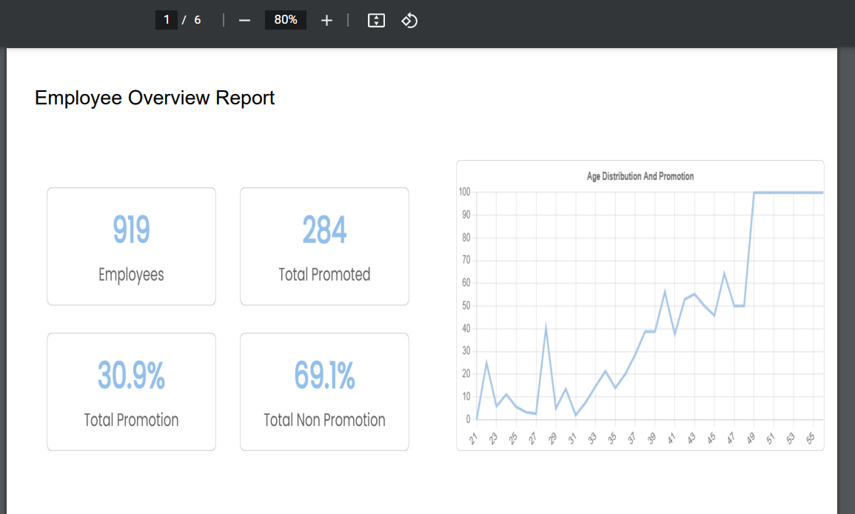

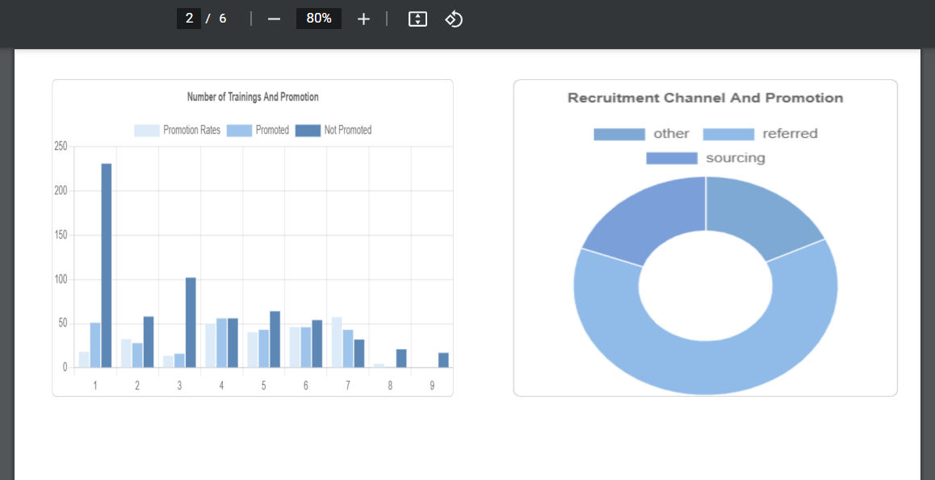



Figure 7 Admin Dashboard

#### **Generating Report of Visualizations:**



Figure 8 Dashboard Report



Figure 9 Dashboard Report

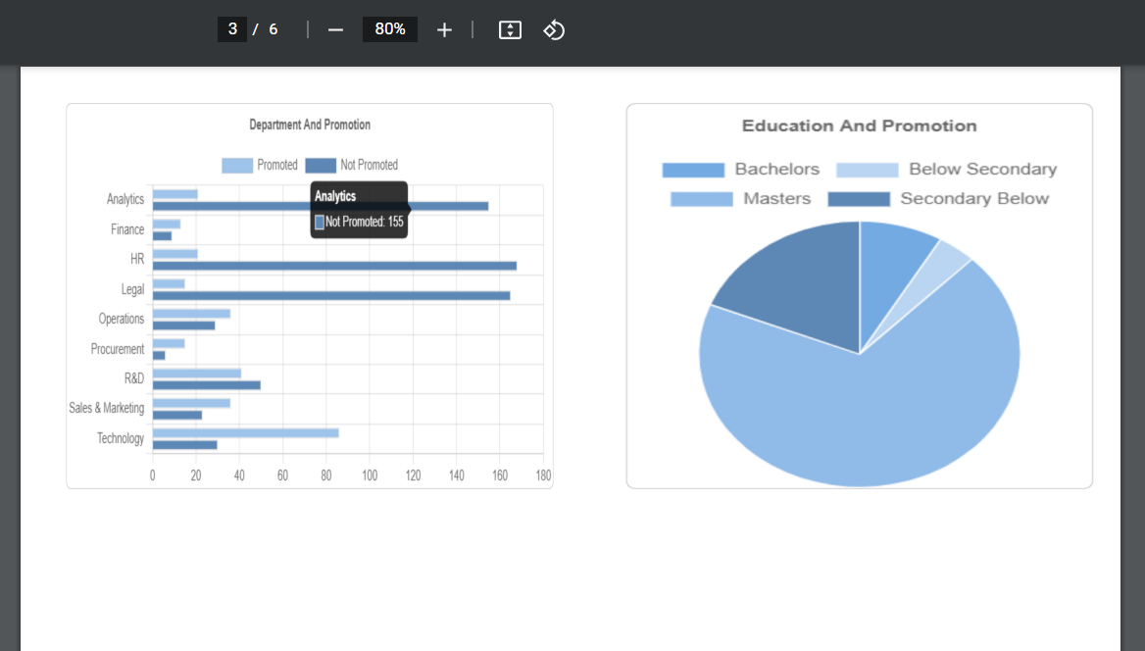

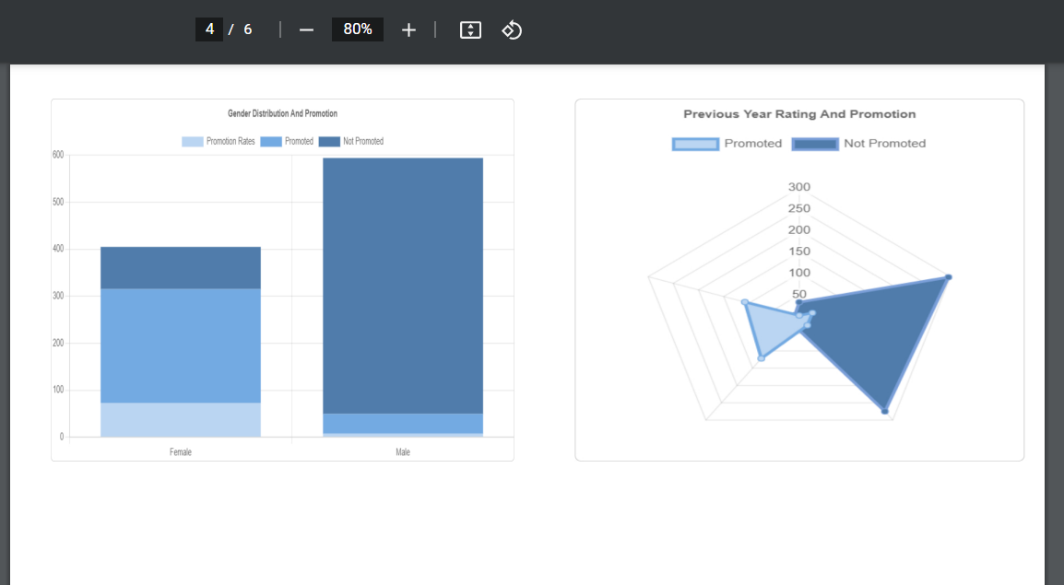

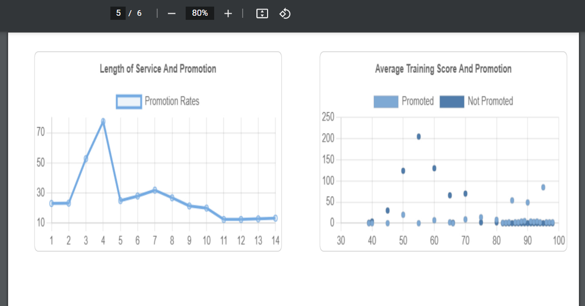

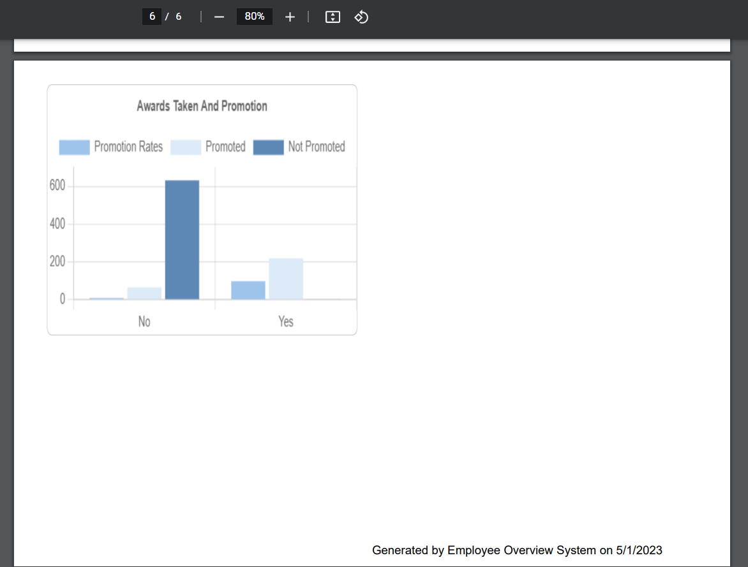

Figure 7 Dashboard Report



Figure 10 Delete All Employees Warning

## **4.3.5 Employees Page**

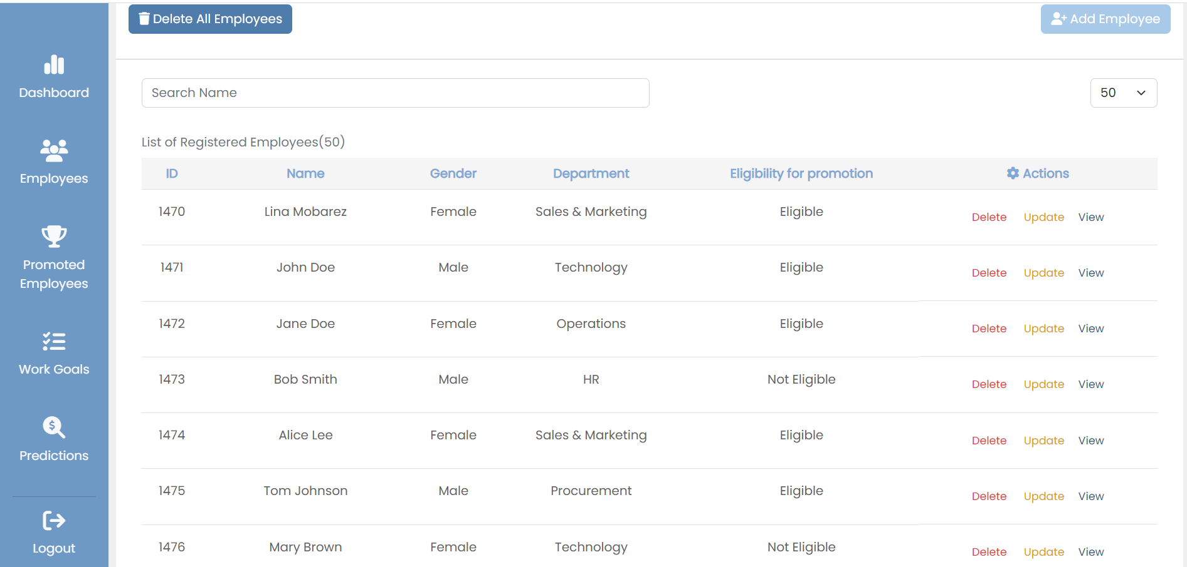

Figure 8 Employees Pag

## **4.3.6 Delete Employee/All Employees Modal:**

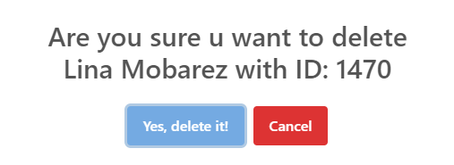

Figure 9 Delete Employee Warning

## **4.3.7 Add Employee Page:**

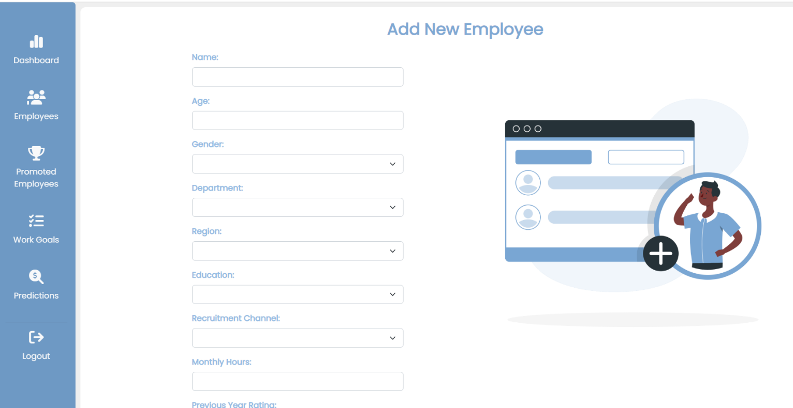

Figure 11 Add Employee Page

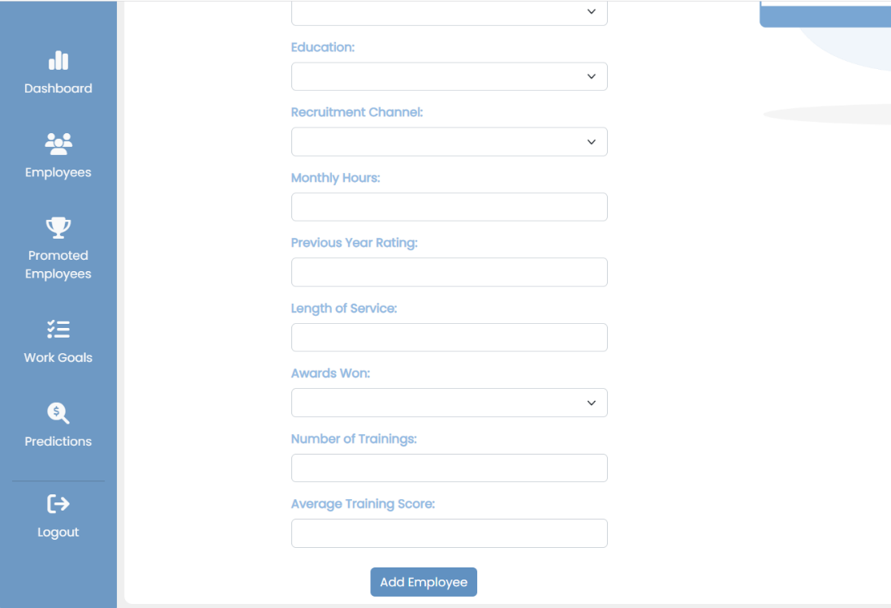

Figure 11 Add Employee Page

## **4.3.8 Update Employee Page:**

(Assume we clicked Update Lina Mobarez )

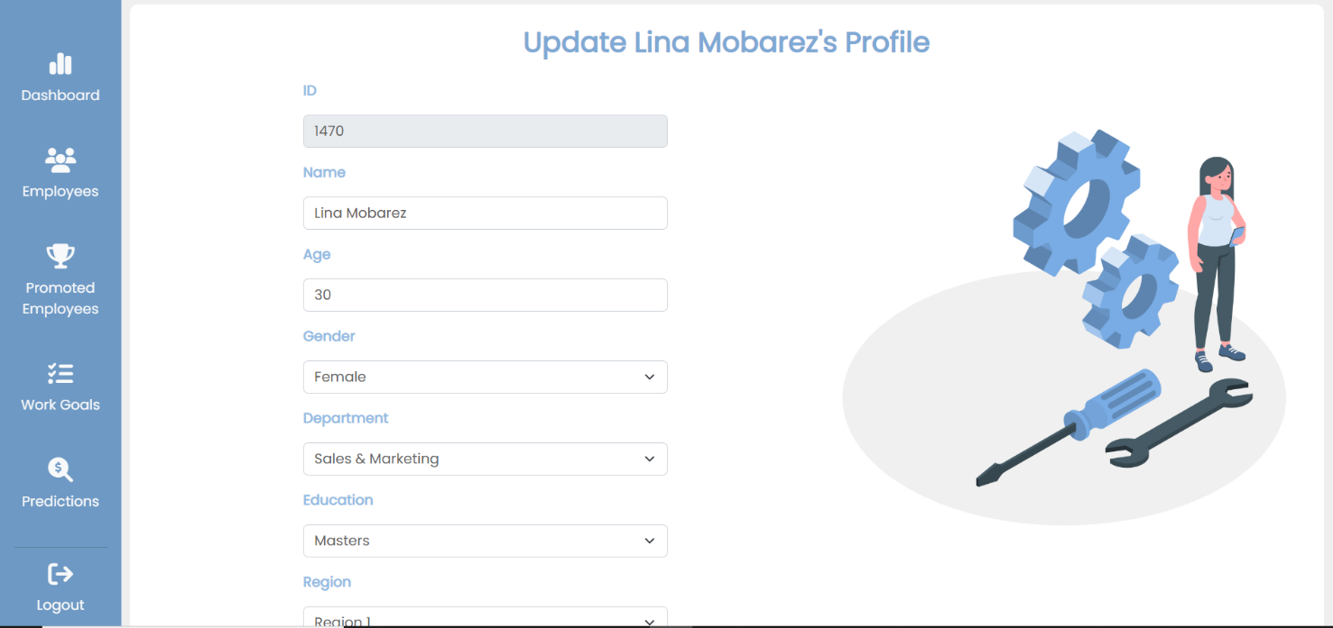

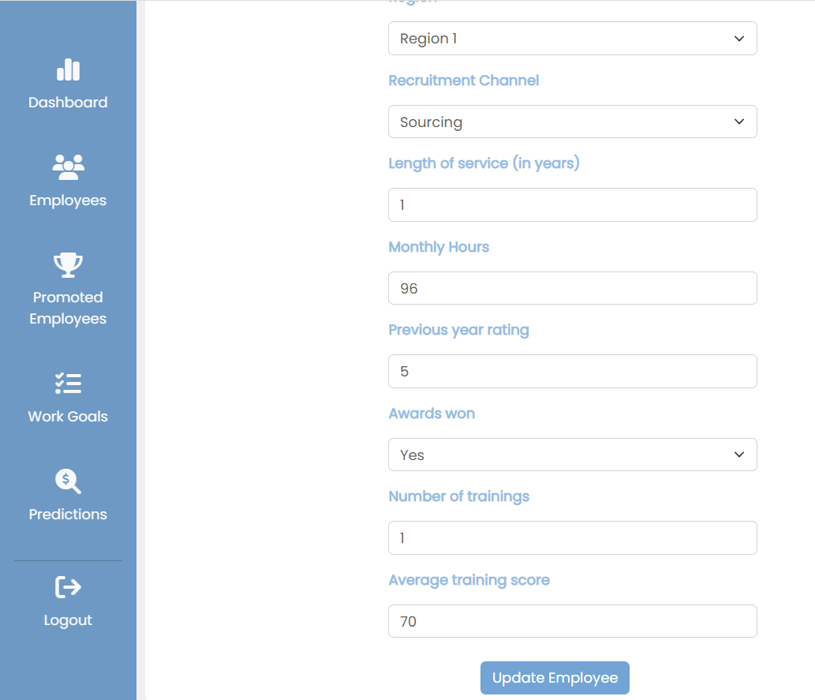

Figure 12 Update Employee Page

## **4.3.9 View Employee Page:**

(Assume we Updated and clicked view Lina Mobarez’s Profile)

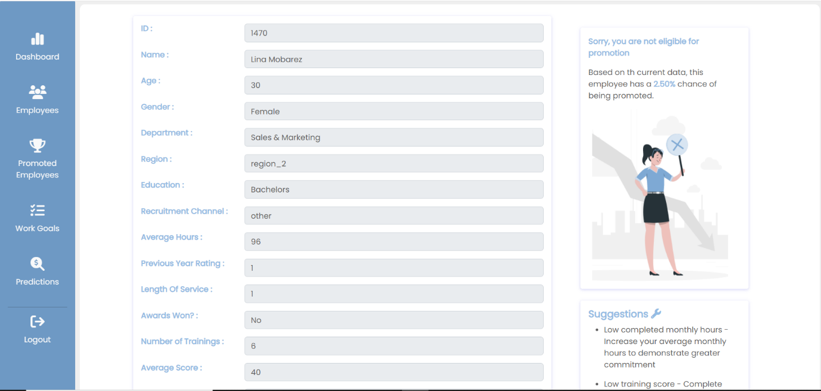

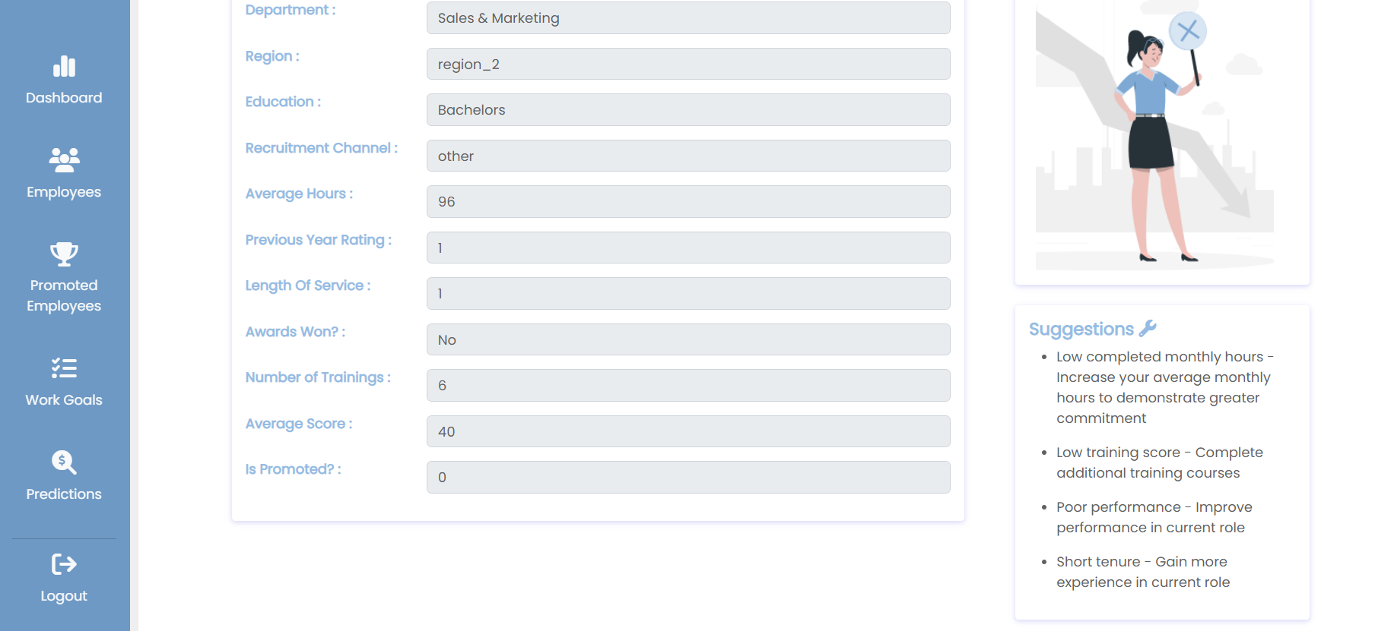

Figure 13 View Employee Page

## **4.3.10 Promoted Employees Page**

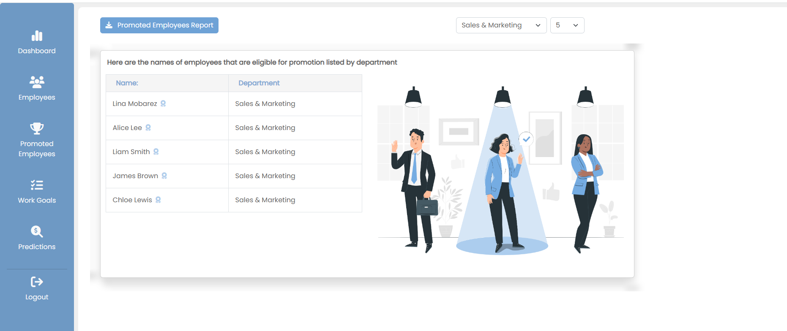

Figure 14 Promoted Employee Page

**We can filter by department and number:**

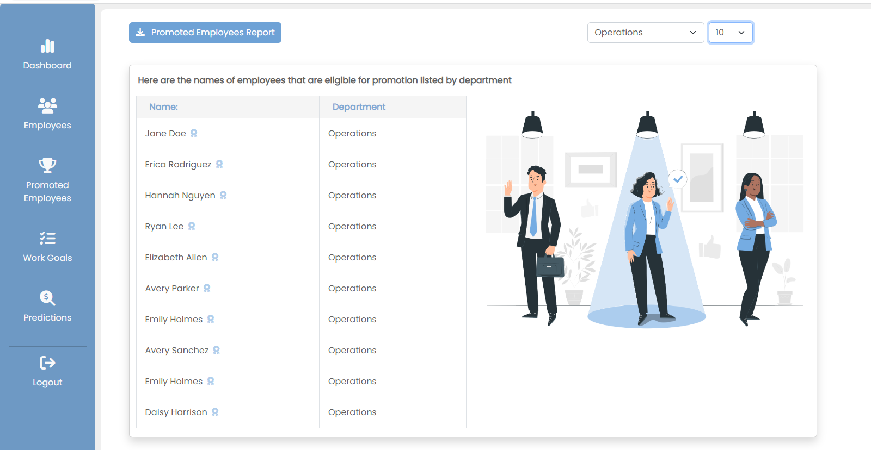

Figure 15 Promoted Employee Filtered by Department

## **4.3.11 Generating Report of Promoted Employees**

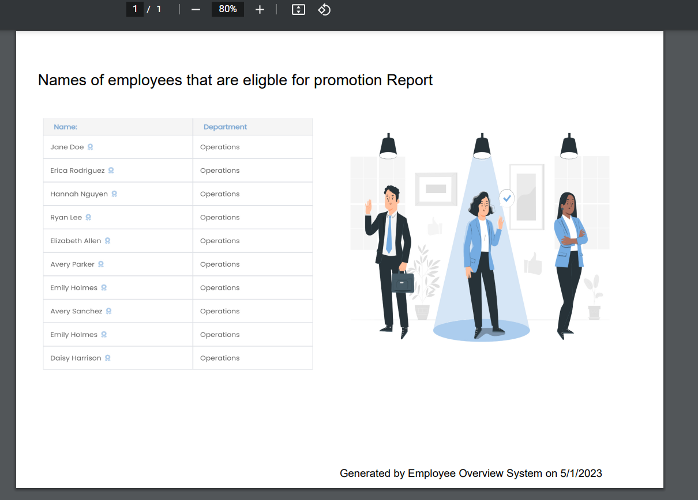

Figure 16 Promoted Employee Report

## **4.3.12 Work Goals Page**



Figure 17 Work Goals Page

## **4.3.13 Prediction Page**

**Output one:**

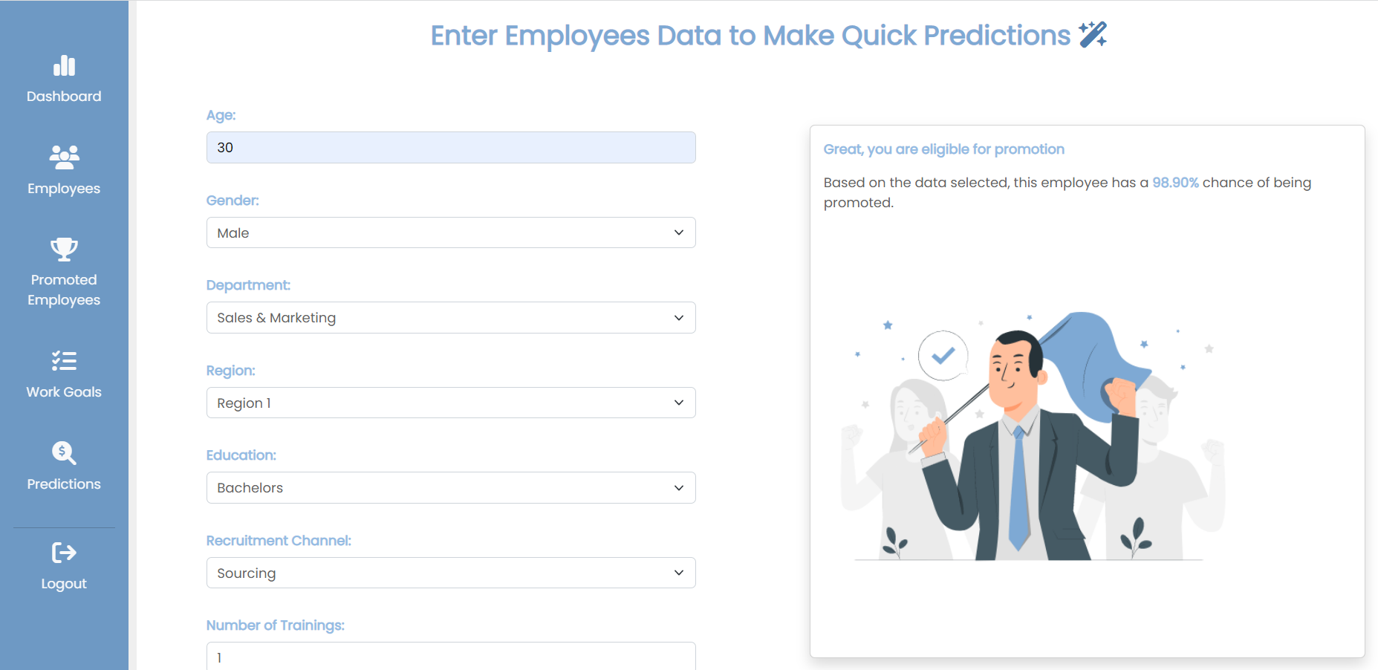



Figure 18 Prediction Page Output One

**Output two:**

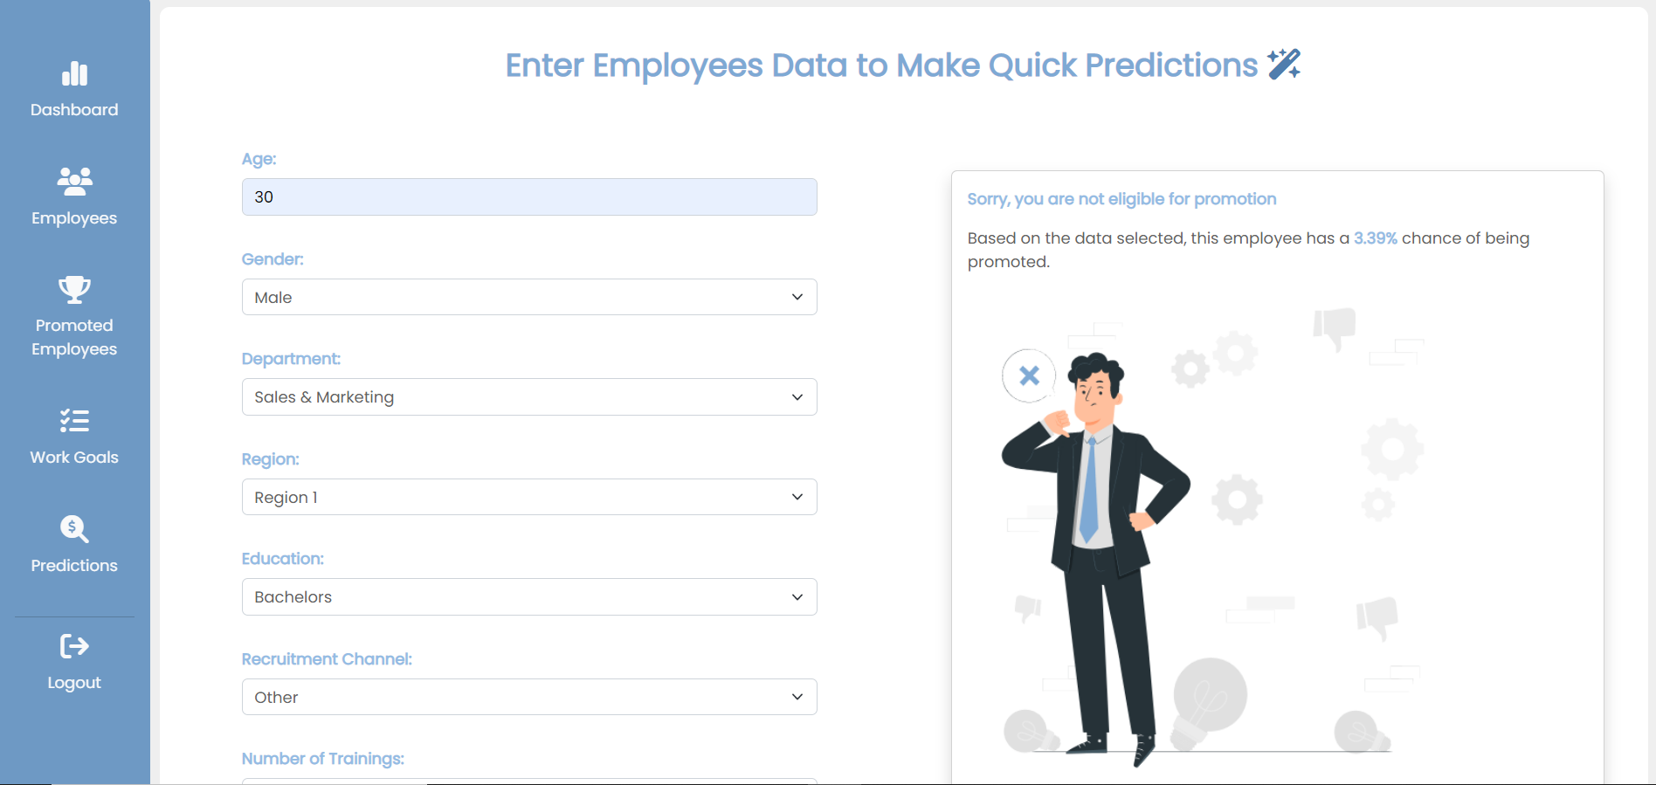

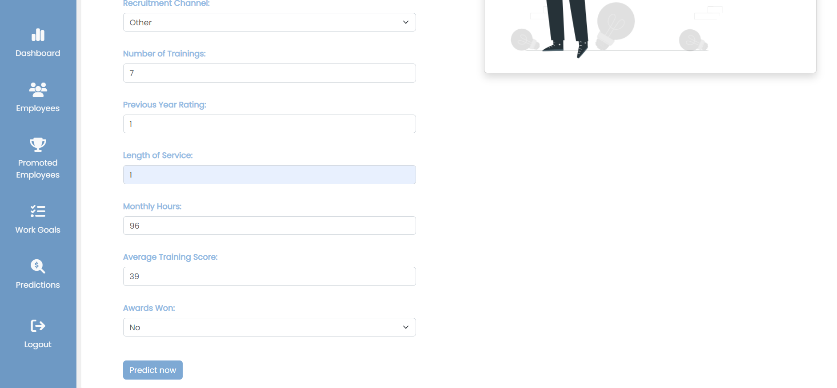

Figure 19 Prediction Page Output Two

## **4.3.14 Not Found Page**

When the user trying to access wrong page (page not found in system)



Figure 20 Not Found Page

# **4.4 Implementation Phase**

During the process of implementation various techniques are used to develop the website.

## **4.4.1 Programming Tools**

The system was developed using various web development techniques such as HTML5, CSS3, Bootstrap, JavaScript, and Vue.js to create a user-friendly interface. The website's layout, including login forms, tables, panels, and colors, was carefully designed to enhance the user's experience and promote productivity while reducing anxiety. PHP and MYSQL DBMS were used to make the system dynamic, storing user information in a database and enabling complex functions. Firebase was used for login authentications, ensuring the system's security and protecting user data.

## **4.4.2 Data Cleaning**

The goal of this analysis is to develop a predictive model to forecast whether an employee will be promoted or not. Before performing the analysis, the dataset was preprocessed to ensure that it was accurate, complete, and ready for analysis

**4.4.3 Model Building**

In Figure 21: The data.isnull().sum() method from the pandas library is used to obtain the sum of null values in columns of datasets, The output of this method indicates that there are some missing values in the dataset, particularly in the columns for 'education', 'previous_year_rating', and 'avg_training_score'.

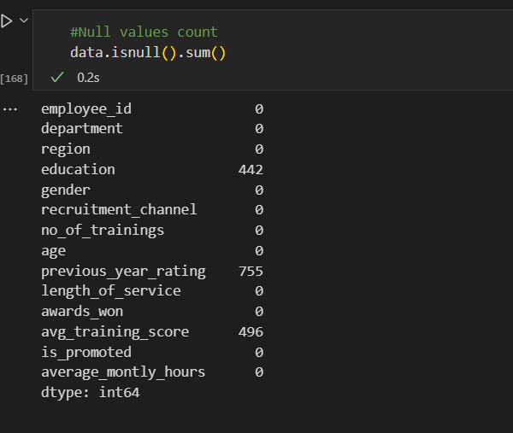

Figure 21 Null values

In Figure 22: The code then uses the fillna() method to fill in the missing values in the 'previous_year_rating', 'education', and 'avg_training_score' columns, with missing values in 'previous_year_rating' being replaced with 0, and missing values in 'education' and 'avg_training_score' being replaced with the mode of each column. By handling the missing values, the code ensures that the dataset is complete and ready for further analysis.

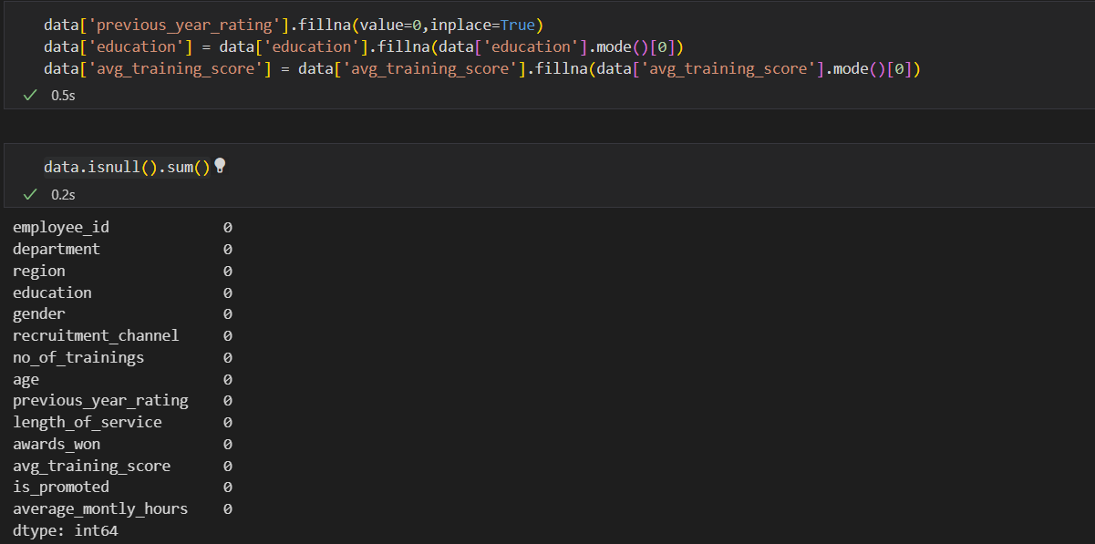

Figure 22 Null Values

To develop the model, we first need to encode categorical variables using a LabelEncoder to transform them into numerical labels. The features of the dataset are separated into independent variables (X) and dependent variables (y). The independent variables are the predictors that influence the dependent variable, which in this study is the 'is_promoted' column. The data is balanced using the SMOTE algorithm, and then the dataset is split into training and testing sets using the train_test_split() function from the sklearn library. The function randomly splits the dataset into a 20% testing set and an 80% training set, with the random_state parameter set to 42 to ensure reproducibility.

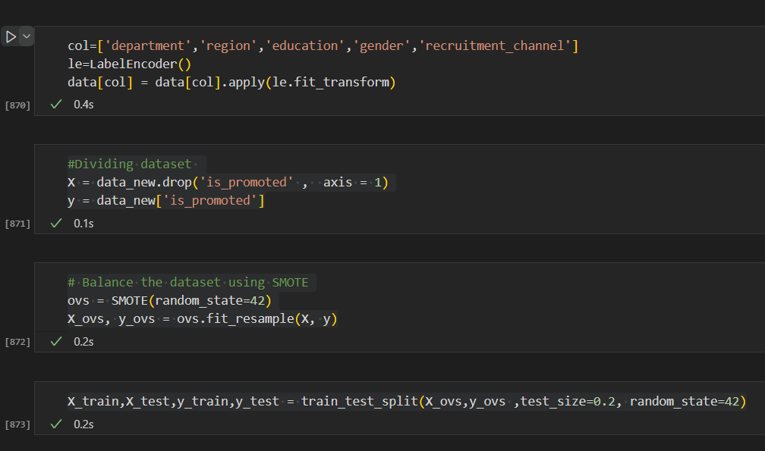

Figure 23 Oversampling and splitting dataset

### **4.4.3.1 Model I: Prediction using Logistic Regression**

The first model is Logistic regression which is a type of supervised learning algorithm used for classification tasks. It is commonly used when the target variable is binary ,but can also be used for multi-class classification tasks

So, the first part of the code fits the model to the training data and generates predictions for the training set. The accuracy_score() function is used to calculate the accuracy of the predictions on the training set, while f1_score() is used to calculate the

F1 score for promoted employees

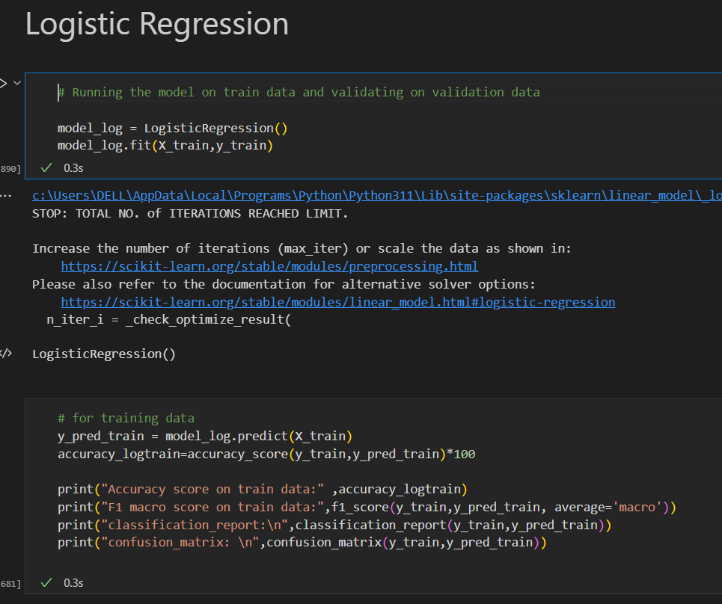

Figure 24 Logistic Regression Training

The second part of the code generates predictions for the test set

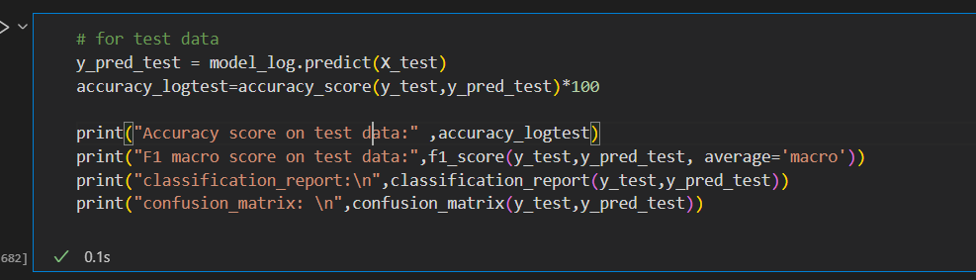

Figure 25 Logistic Regression Testing

### 

### **4.4.3.2 Model II Prediction using Support Vector Machine**

SVM is a supervised machine learning algorithm that can be used for classification and regression problems. The trained model is used to make predictions on the training data X_train using the predict() method. The accuracy score, F1 macro score, classification report, and confusion matrix are then calculated using the predicted labels y_pred_train and actual labels y_train.

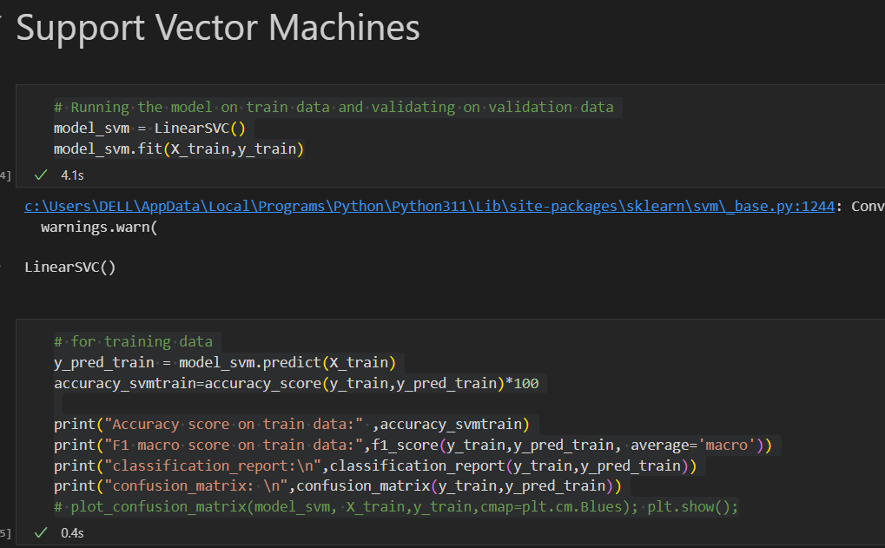

Figure 26 Support Vector Machine Training

The same steps are repeated for the test data X_test and y_test

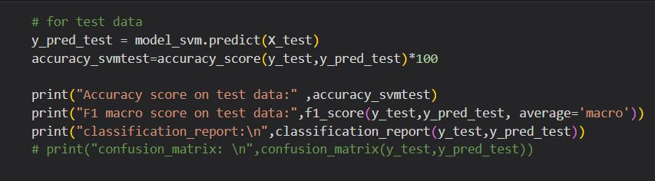

Figure 27 Support Vector Machine Testing

### **4.4.3.3 Model III Prediction using Naïve bayes:**

We will be using a Gaussian Naive Bayes (GNB) algorithm on a dataset for classification

The first step is to instantiate a GNB model using GaussianNB(). Then, the fit() method is called on the model with X_train and y_train as input parameters to train the model.

In the next step, the trained model is used to make predictions on the training data X_train using the predict() method. The accuracy score, F1 macro score, classification report, and confusion matrix are then calculated using the predicted labels y_pred_train and actual labels y_train.

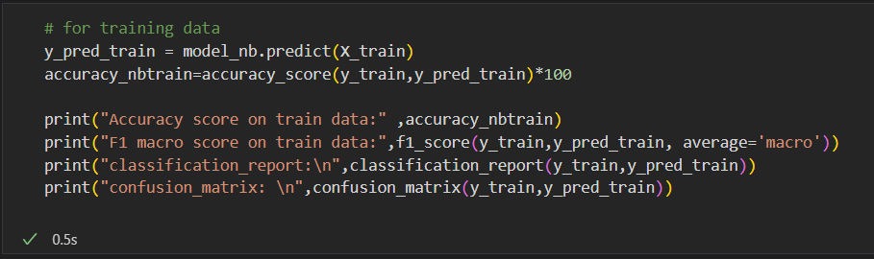

Figure 28 Naïve Bayes Training

The same steps are repeated for the test data X_test and y_test.

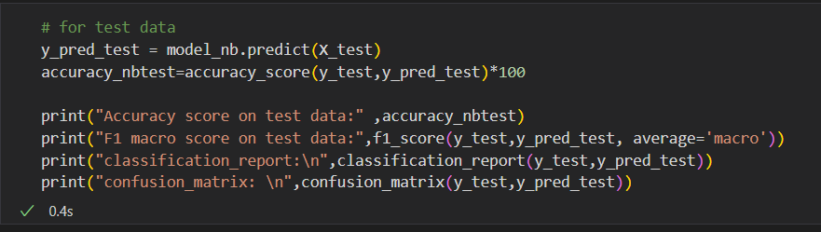

Figure 29 Naïve Bayes Testing

### **4.4.3.4 Model IV Prediction using XGBoost**

The model is instantiated using XGBClassifier() with specified hyperparameters such as n_estimators, max_depth, learning_rate, subsample, colsample_bytree, etc. The fit() method is called with X_train and y_train as input parameters to train the model.

In the next step, the trained model is used to make predictions on the training data X_train using the predict() method. The accuracy score, F1 macro score, classification report, and confusion matrix are then calculated using the predicted labels y_pred_train and actual labels y_train.

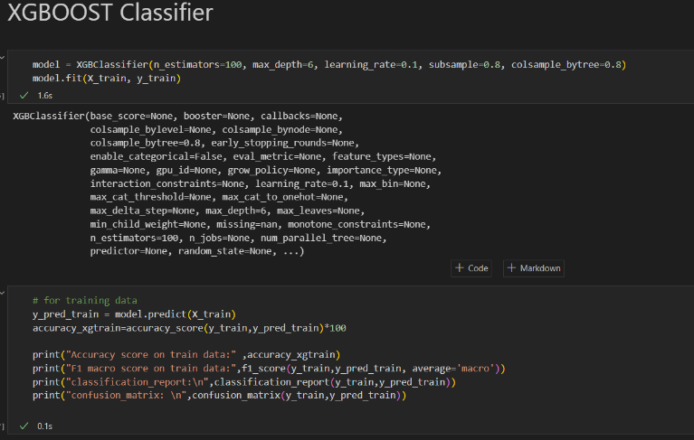

Figure 30 XGBOOST Training

The same steps are repeated for the test data X_test and y_test.

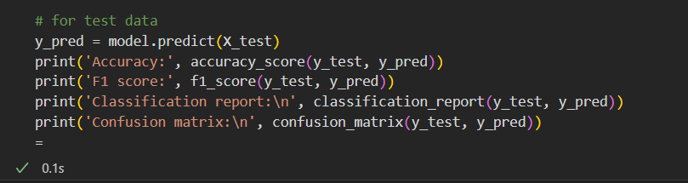

Figure 31 XGBOOST Testing

## **4.4.4 Website code:**

### **4.4.4.1 Login Authentication:**

In the Figure below: It has a form with two fields for email and password. When the user clicks the "Login" button, the loginUser() method is called, which first sets the loading data property to true and then uses Firebase to authenticate the user. If the authentication is successful, the user is redirected to the dashboard page. If it fails, an error message is displayed.

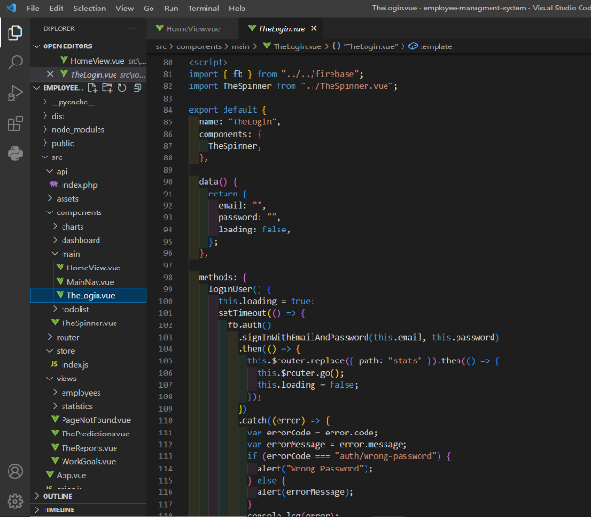

Figure 32 Login Authentication

### **4.4.4.2 Dashboard’s side bar:**

In the figure below, When the user clicks the logout button, the handleLogout method is called, which sets the loading property to true, waits for 2 seconds, signs the user out using Firebase Authentication, sets the isLoggedIn property to false, redirects the user to the home page, and sets the loading property back to false.

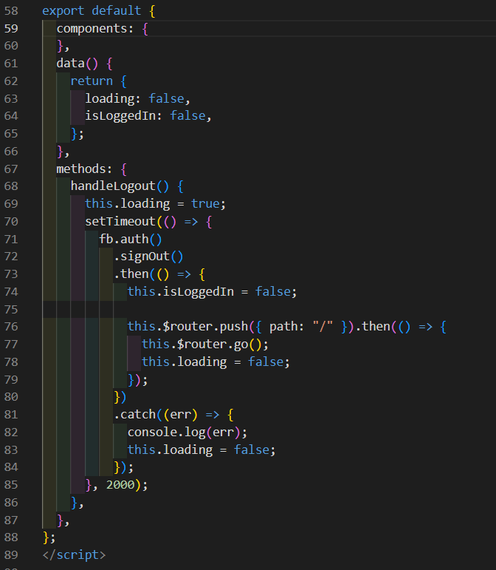

Figure 33 Dashboard's sidebar code

### **4.4.4.3 Dashboard Charts:**

In the Figures below: Each of the charts below is a Vue.js component that displays a type of chart using the Chart.js library. The chart shows the distribution of employees’ features and their promotion rates. The component fetches data from an API using Axios, processes the data, and stores it in the component's data properties. The renderChart method uses Chart.js to render the chart with the canvas element and the chart data and options. The options specify the chart title, legend, and the styling of chart elements such as points. The component imports the Chart.js and Axios libraries.

#### **4.4.4.3.1 Awards and promotion chart code:**

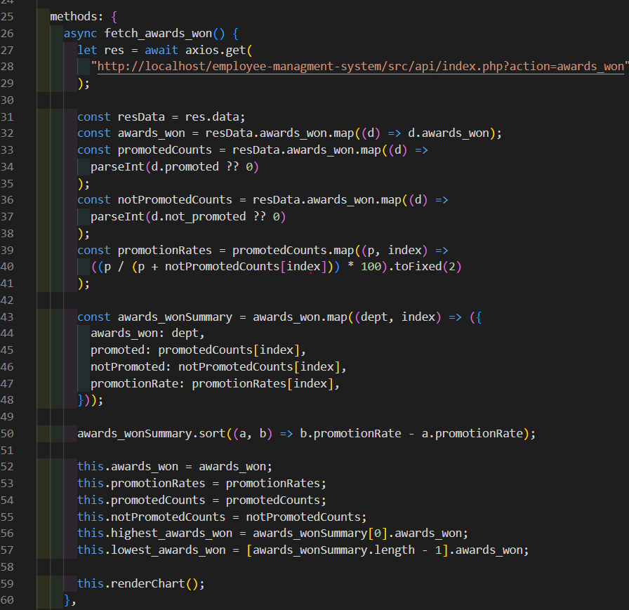

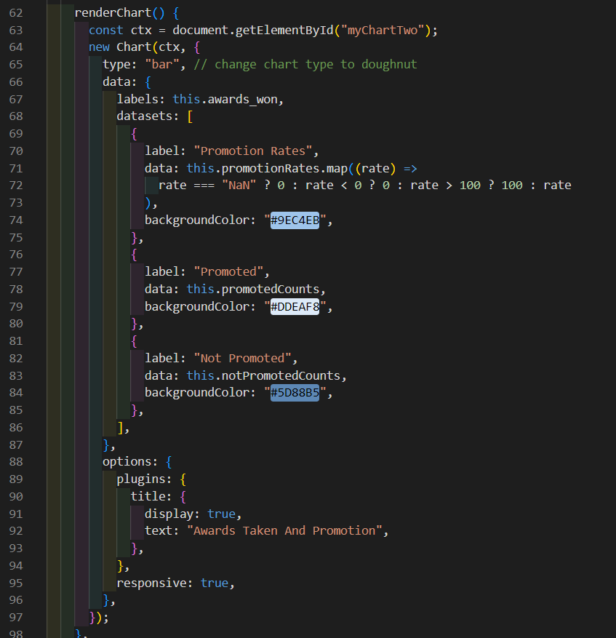

Figure 34 Awards and promotion chart code

##### **4.4.4.3.1.1Fetching awards data query from database to make chart**

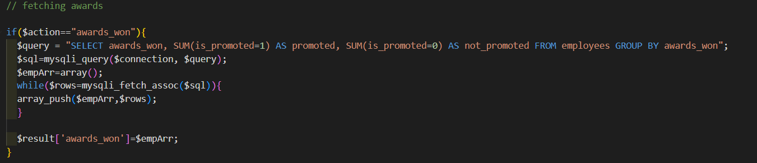

Figure 35 Fetching awards by promotion query

#### **4.4.4.3.2 Recruitment Channel And promotion chart code:**

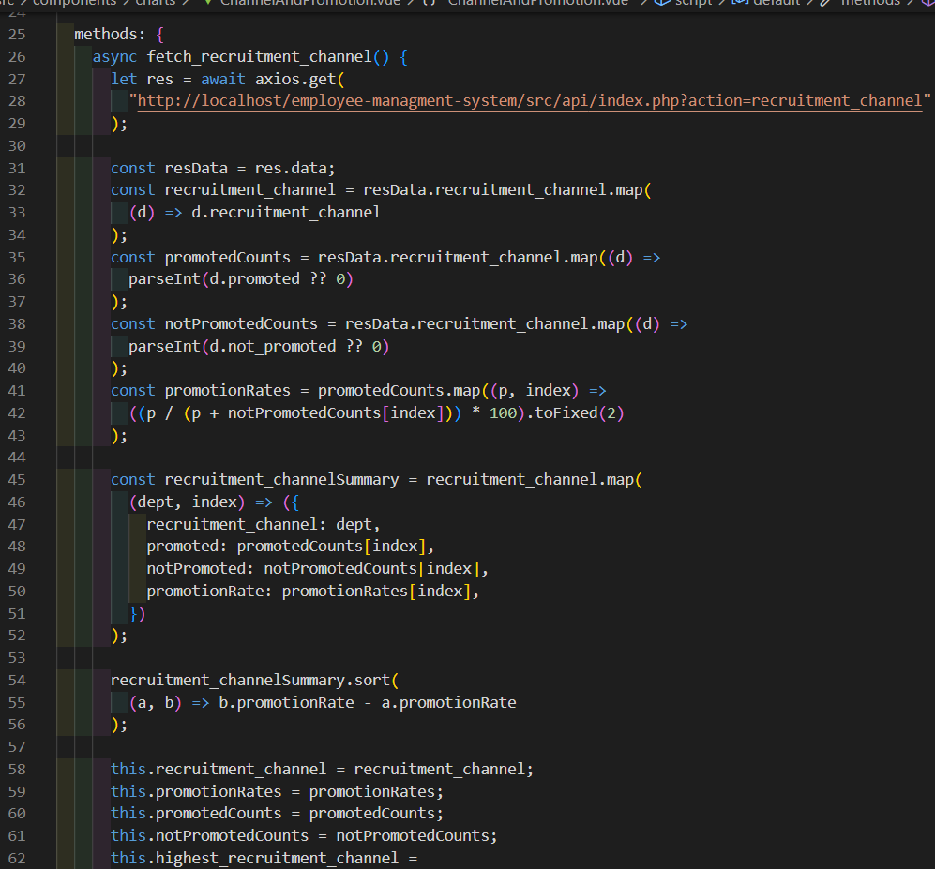

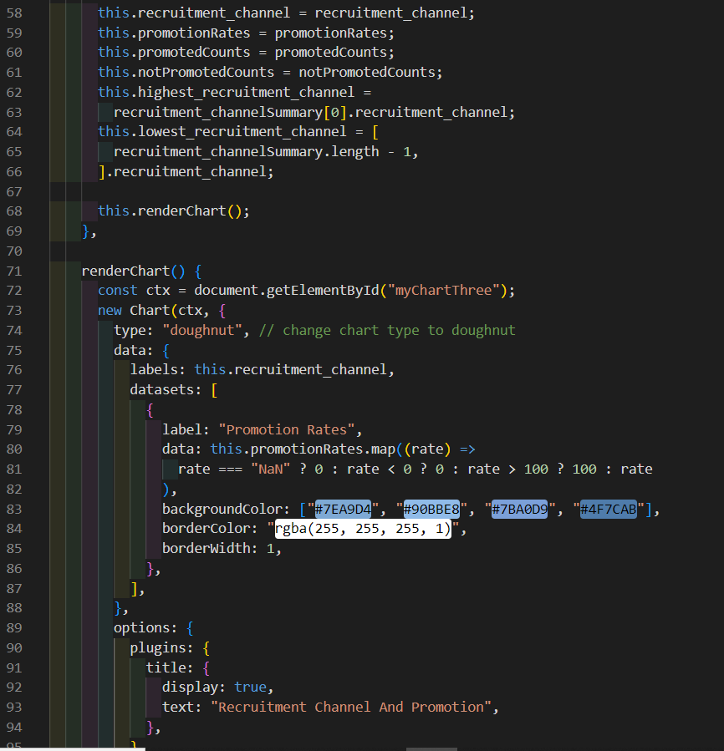

Figure 35 Recruitment Channel And promotion chart code

##### **Fetching Recruitment channel data query from database to make chart**

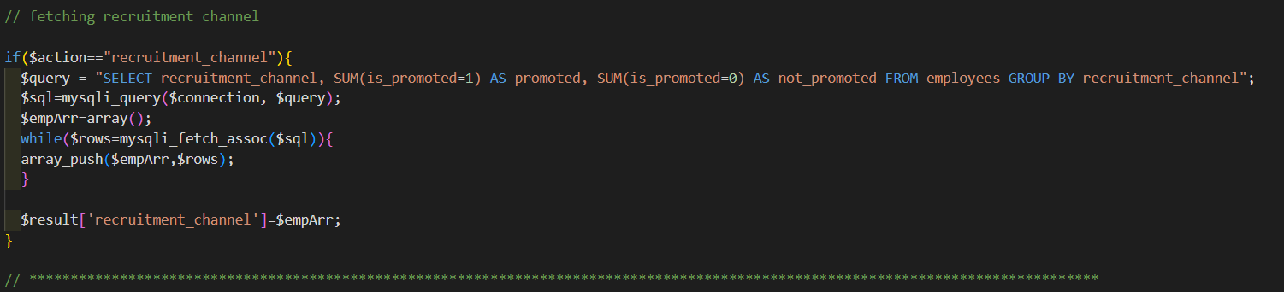

Figure 36 Fetching recruitment channel by promotion query

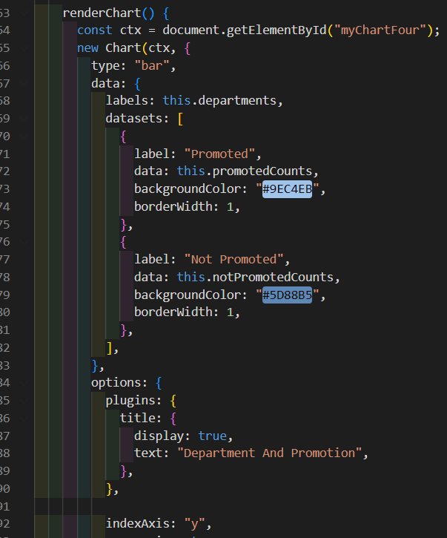

Figure 38 Department and Promotion chart code II

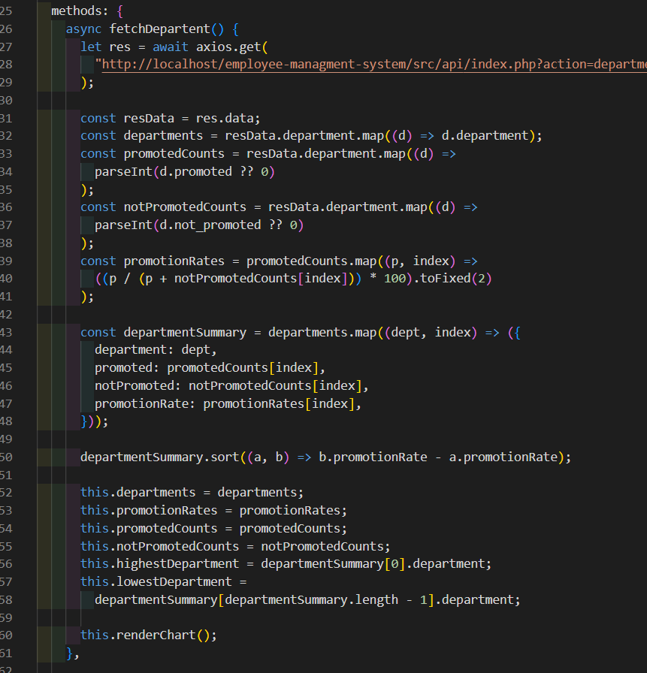

Figure 37 Department and Promotion chart code I

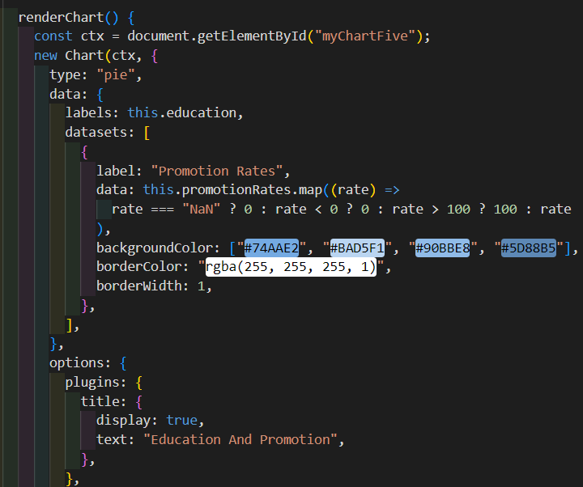

Figure 41 Education and promotion chart code II

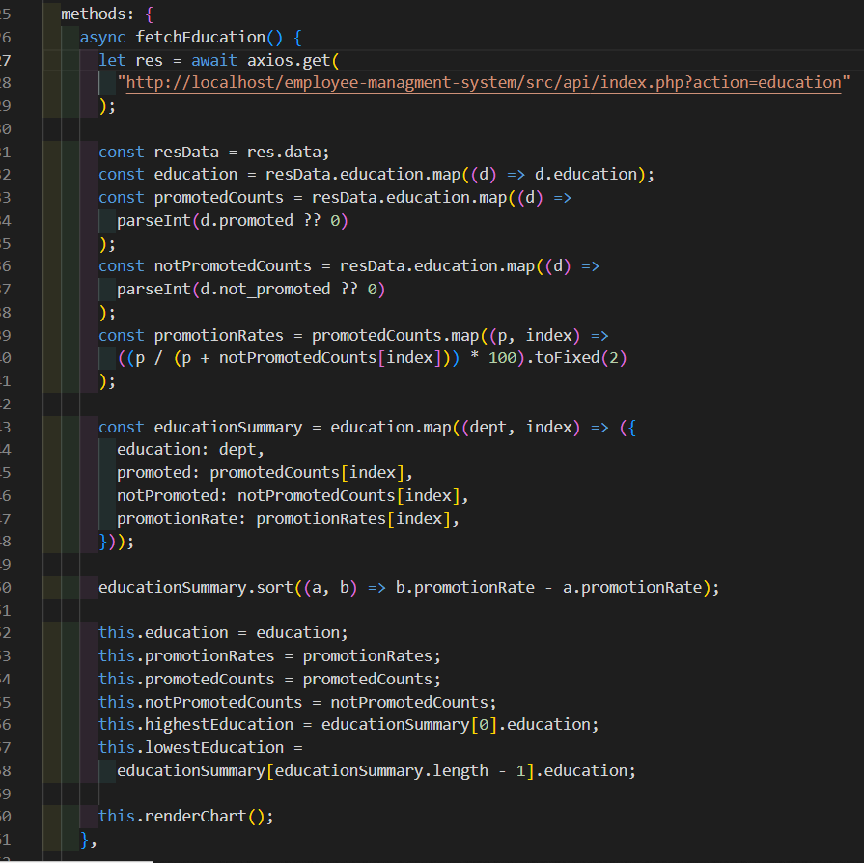

Figure 40 Education and promotion chart code I

#### **4.4.4.3.3 Department and Promotion chart code:**

#### **Fetching department data query from database to make chart**

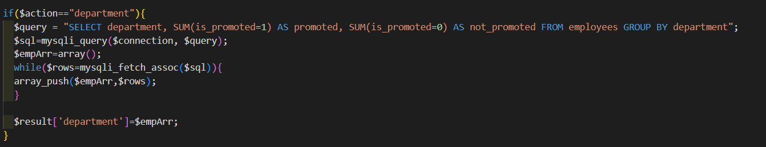

Figure 39 Fetching department by promotion query

#### **4.4.4.3.4 Education and promotion chart code:**

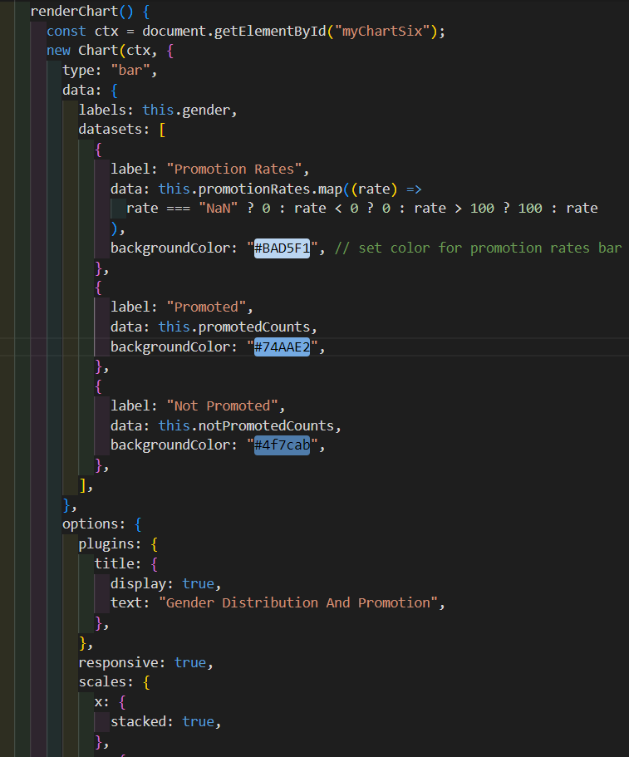

Figure 44 Gender and Promotion chart code II

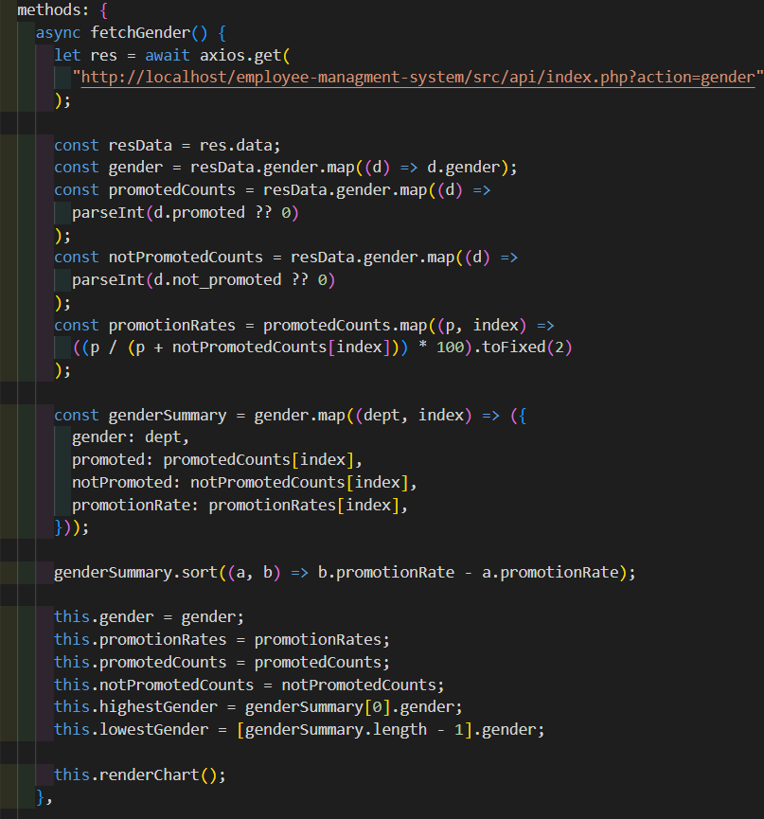

Figure 43 Gender and Promotion chart code I

#### **Fetching education data query from database to make chart**

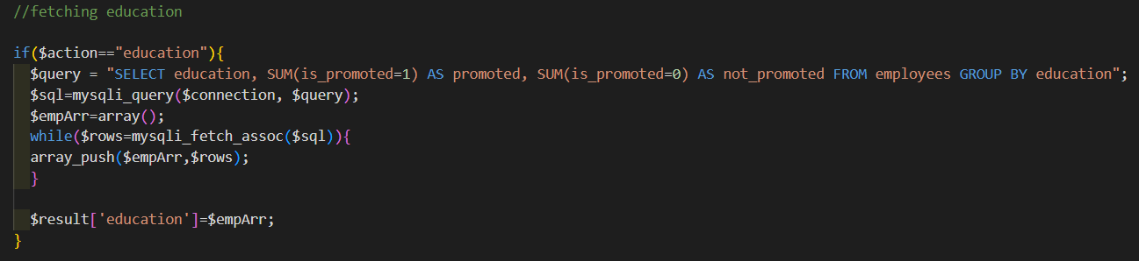

Figure 42 Fetching education by promotion query

#### **4.4.4.3.5 Gender and Promotion chart code:**

##### **Fetching gender data query from database to make chart**

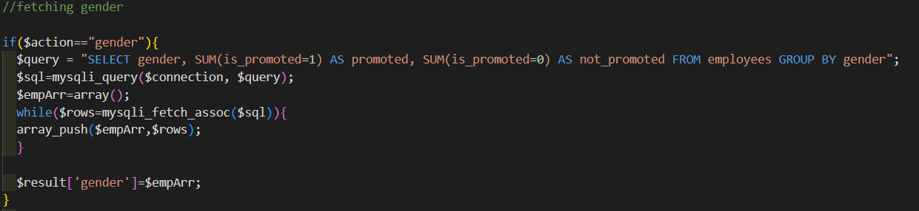

Figure 45 Fetching gender by promotion query

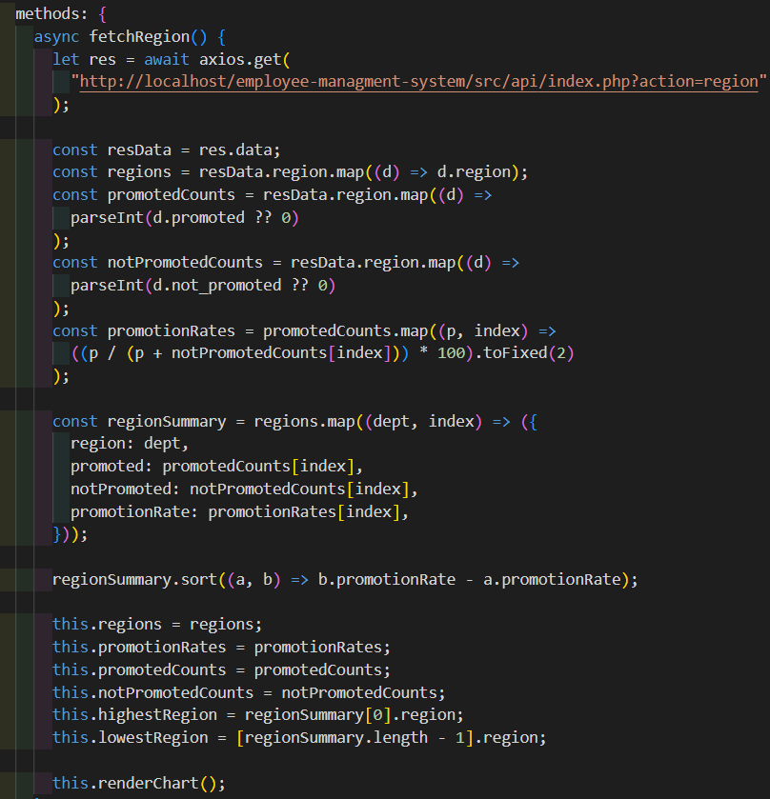

Figure 49 Region and Promotion chart code I

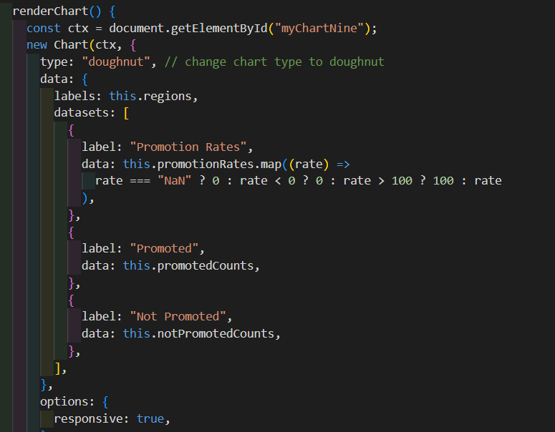

Figure 50 Region and Promotion chart code II

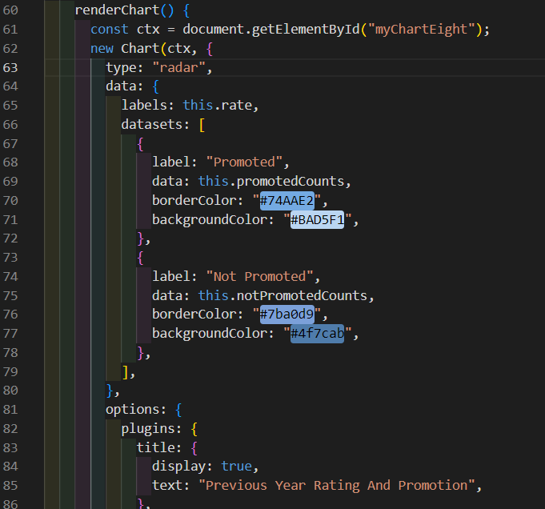

Figure 47 Previous Year Ratings and Promotion chart code II

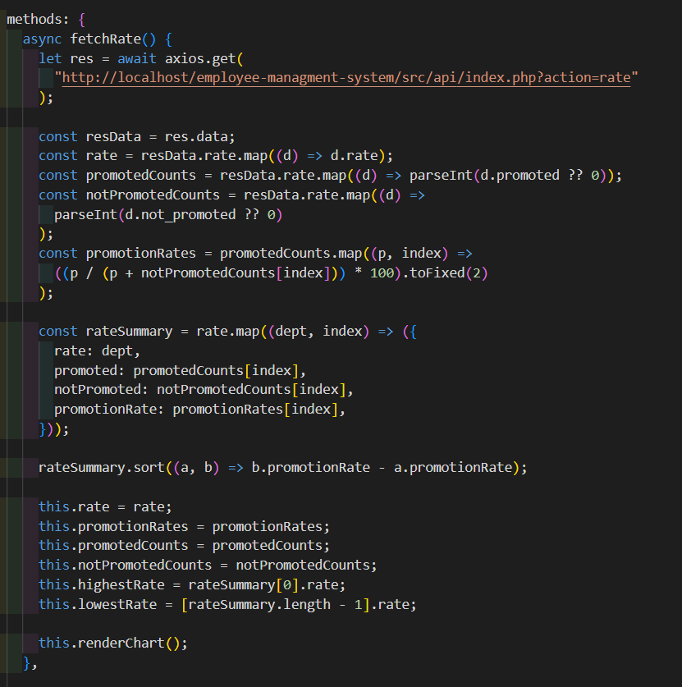

Figure 46 Previous Year Ratings and Promotion chart code I

#### **4.4.4.3.6 Previous Year Ratings and Promotion chart code:**

##### **Fetching previous year ratings data query from database to make chart**

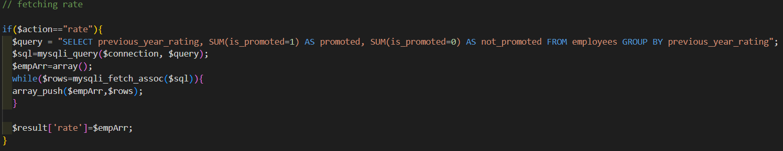

Figure 48 Fetching previous year ratings by promotion query

#### **4.4.4.3.7 Region and Promotion chart code:**

##### **Fetching Region data query from database to make chart**

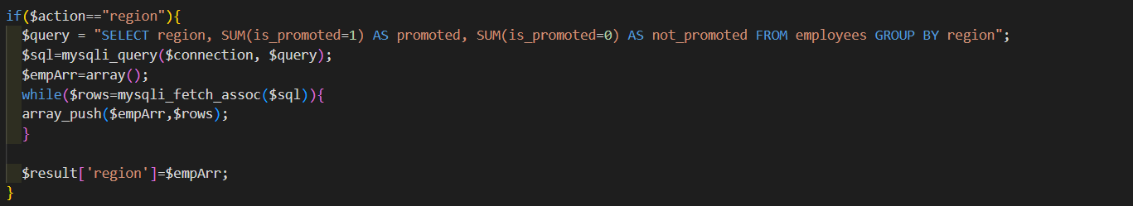

Figure 51 Fetching Region by promotion query

#### **4.4.4.3.8 Service and Promotion chart code:**

##### **Fetching Length of service data query from database to make chart**

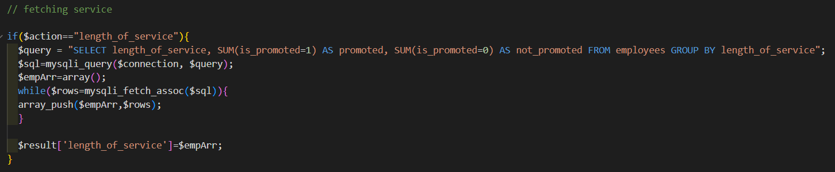

Figure 54 Fetching Length of service by promotion query

##### **Fetching Number of trainings data query from database to make chart**

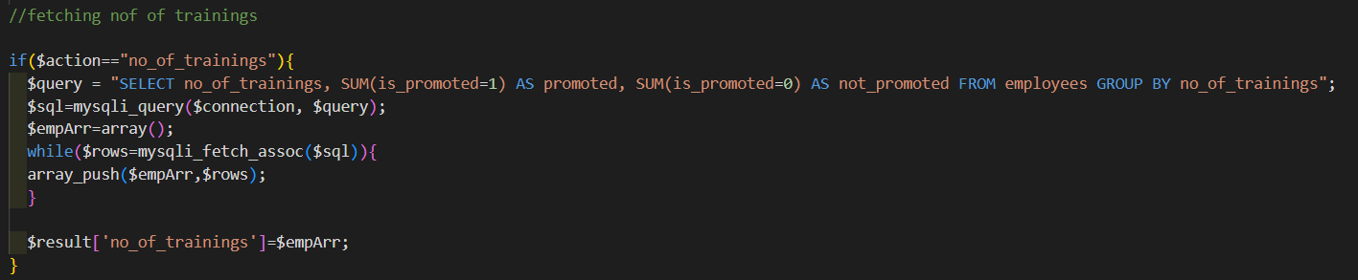

Figure 55 Fetching number of training by promotion query

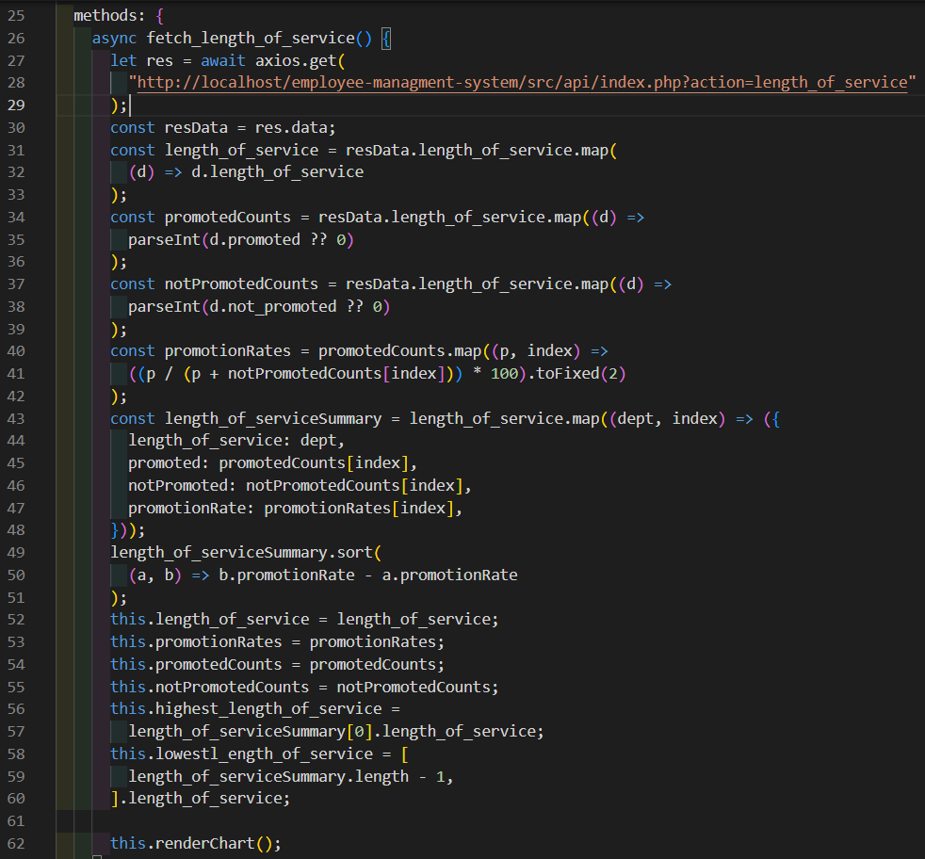

Figure 52 Service and Promotion chart code I

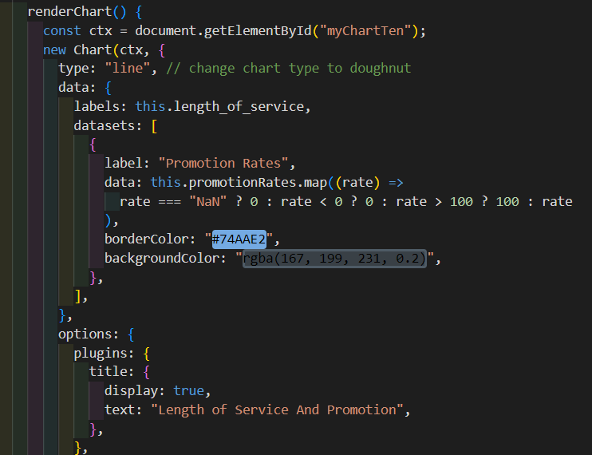

Figure 53 Service and Promotion chart code II

#### **4.4.4.3.9 Number of Training and Promotion chart code:**

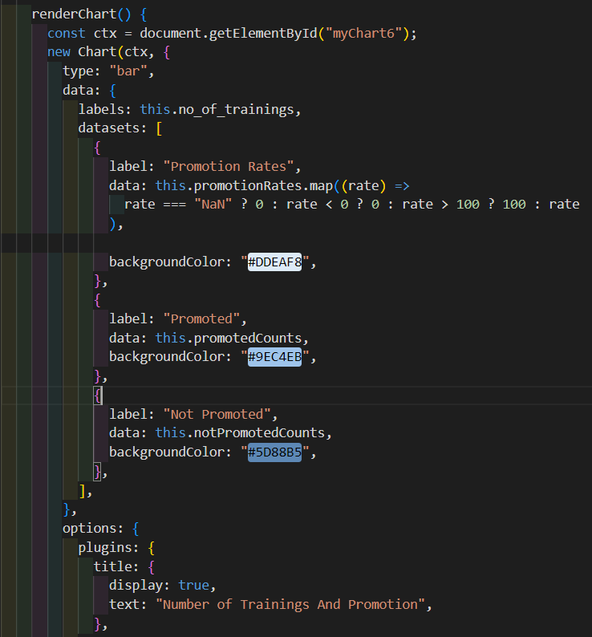

Figure 57 Number of Training and Promotion chart code II

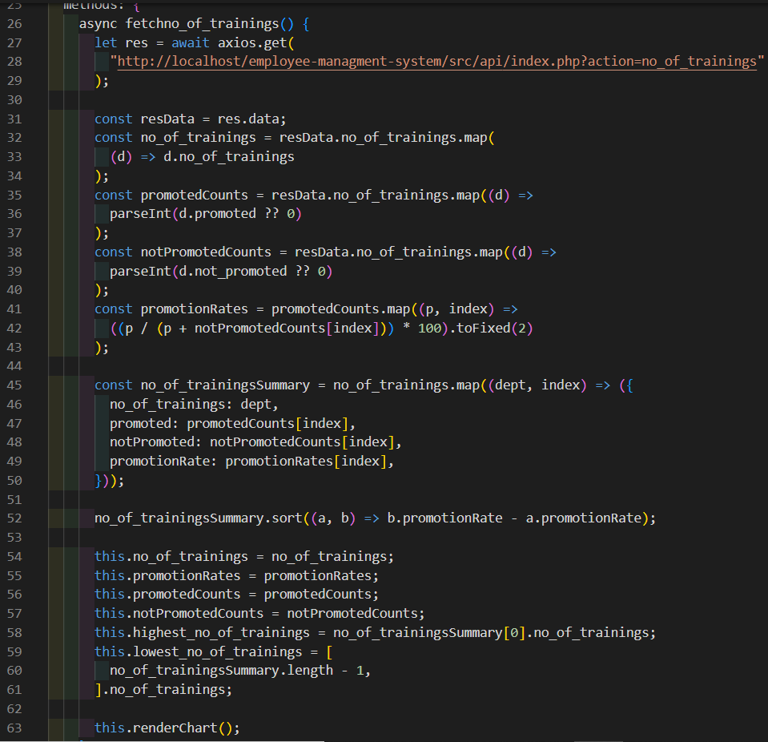

Figure 56 Number of Training and Promotion chart code I

#### **4.4.4.3.10 Average Score of Training and Promotion chart code**

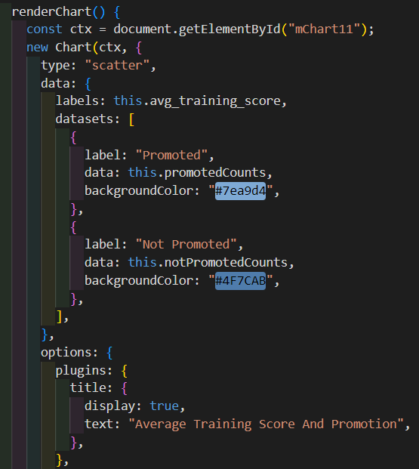

Figure 59 Average Score and Promotion chart code II

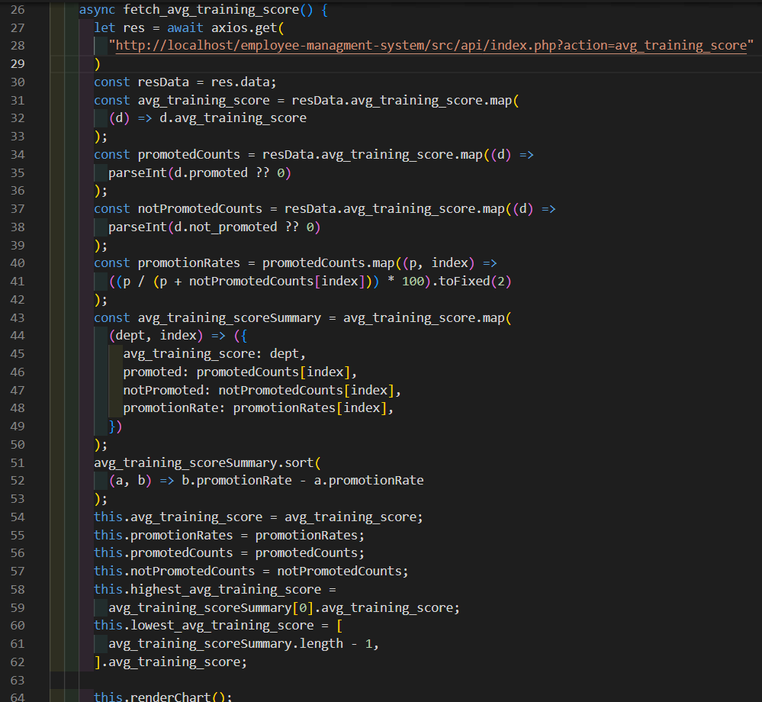

Figure 58 Average Score and Promotion chart code I

##### **Fetching Average training score data query from database to make chart**

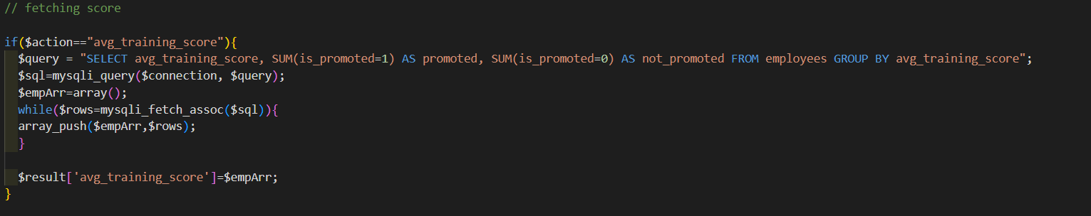

Figure 60 Fetching Average training score by promotion query

#### **4.4.4.3.11 Summary Overview charts code:**

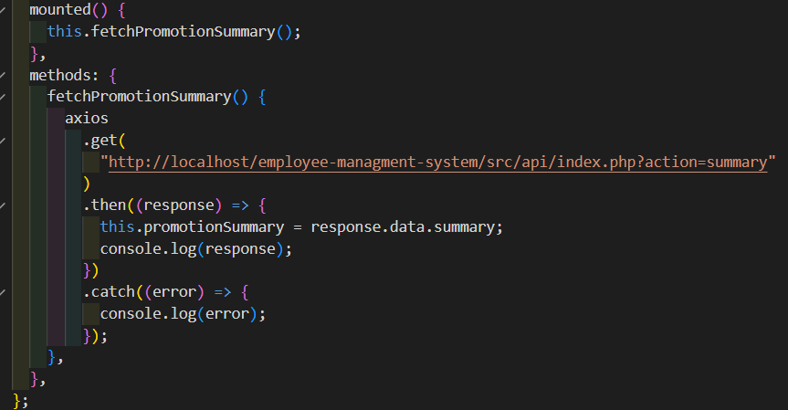

Figure 61 Summary Overview charts code

##### **Fetching Summary overview data query from database to make chart**

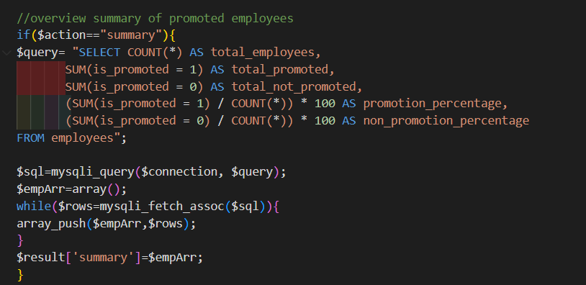

Figure 62 Summary Overview data query code

### **4.4.4.4 Generating report:**

In the figure below, It’s a Vue.js method called generateReport() that generates a PDF report of employee data from charts. The method uses the jsPDF and html2canvas libraries to create the PDF and convert each chart element on the page to an image and add it to the PDF. The method calculates the available width and height on each page and the size of each chart, handles chart placement, adds new pages when necessary, and adds a title to subsequent pages. Finally, it adds a footer to the last page of the PDF that includes the date and time the report was generated and saves the PDF file with the name "report.pdf". This method assumes that there are chart elements on the page with a CSS class of "chart" so it can select them.

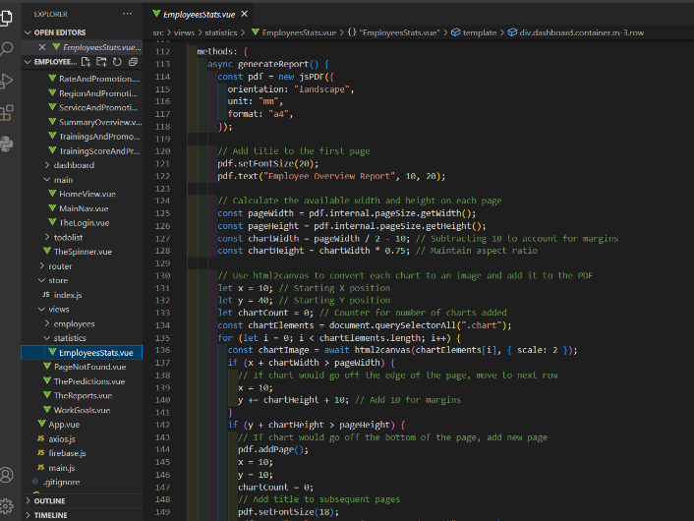

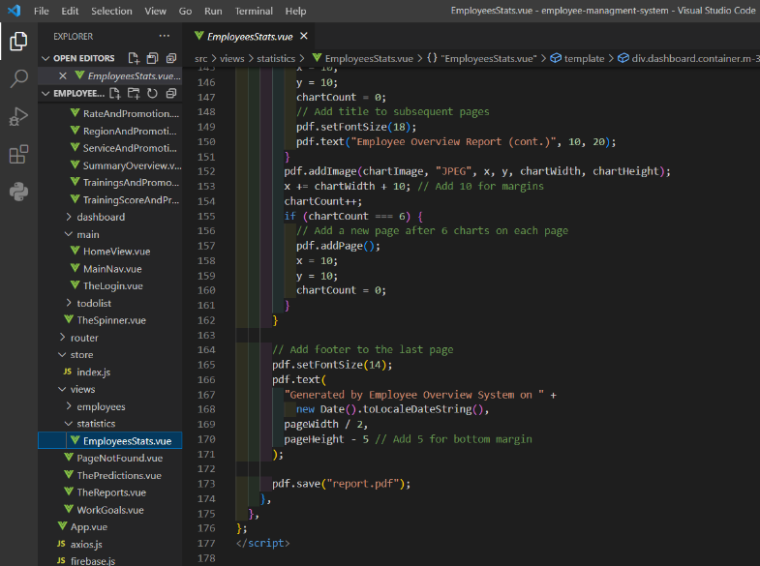

Figure 63 Generating report code

### **4.4.4.5 Employee’s page:**

In Figures below, it’ a component that displays a table of employee data, with options to search, delete, update, and view individual employees. It also includes a spinner icon for loading feedback while server requests are being processed. The component fetches employee data from a server using the axios library and displays it in a table. It includes a search box that filters the employee data based on name. It also includes a dropdown that allows the user to set a limit on the number of employees displayed. The component includes two methods for deleting employees: deleteEmployee and deleteAllEmployees. deleteEmployee deletes a single employee by sending a POST request to the server, and deleteAllEmployees deletes all employees in the table. Both methods display a confirmation prompt using the Swal library and show a spinner while the request is being processed.The component includes a predict method that sends a GET request to an external API to predict whether an employee is eligible for promotion based on various employee data fields. The results of the prediction are then displayed in the table. The component also includes methods for adding, updating and viewing individual employees, which use the router-link component from Vue Router to navigate to different pages.

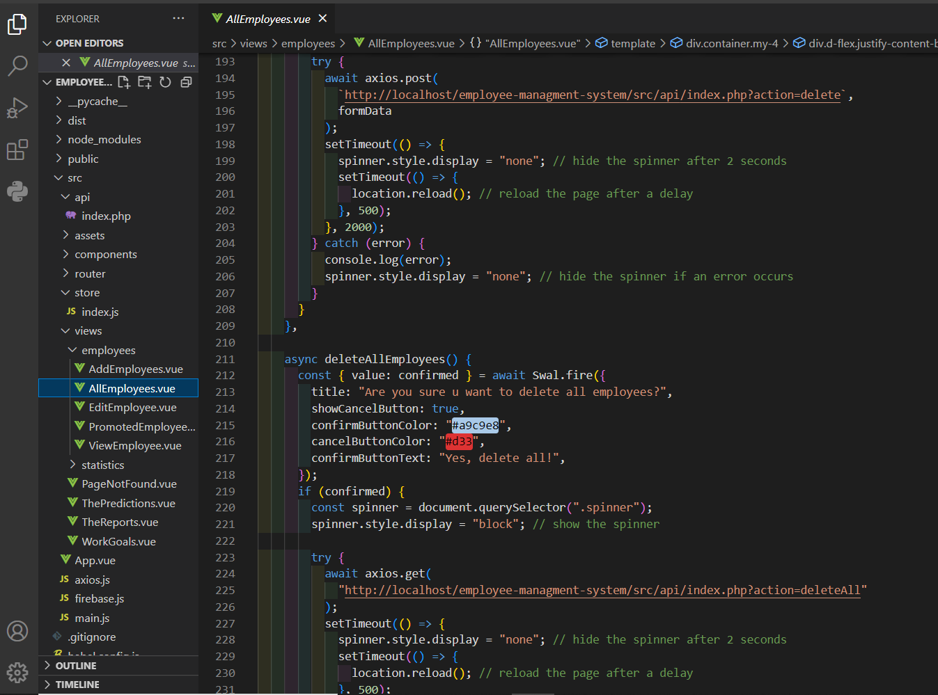

Figure 64 Employee's page code I

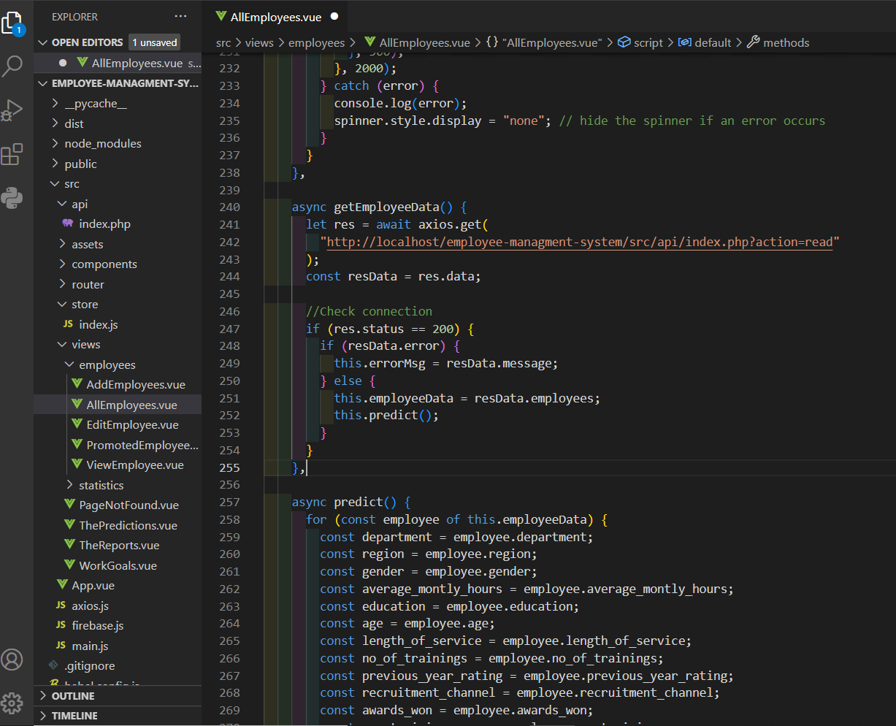

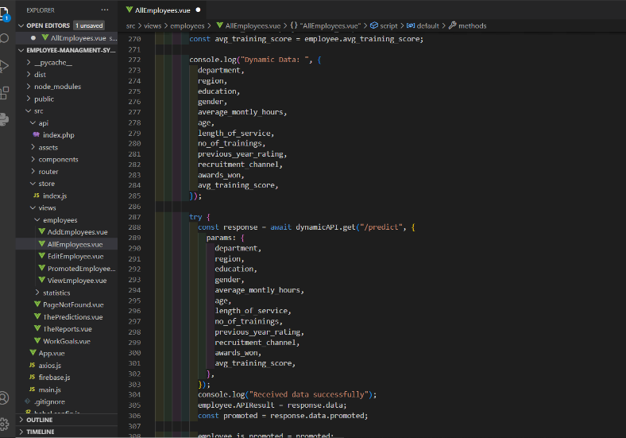

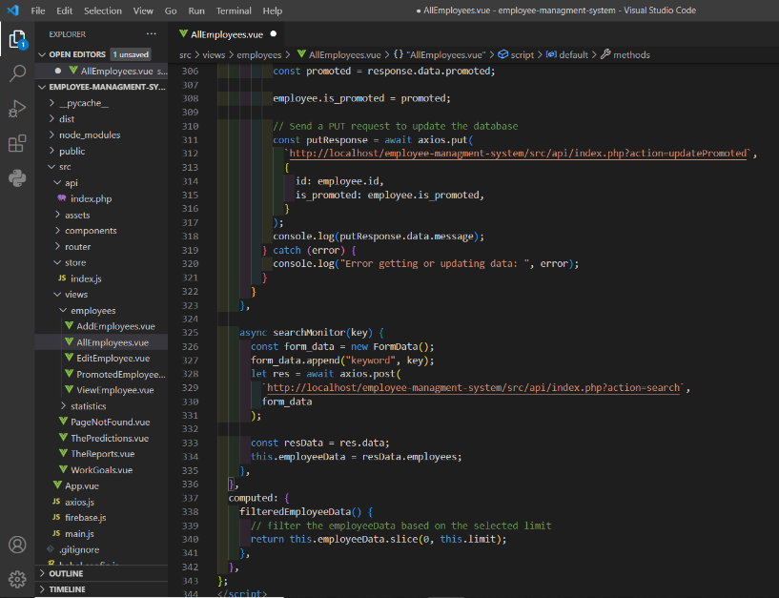

Figure 65 Employee's page code II

**API to connect to port 5000 so it can predict the promoted employees through predict:**

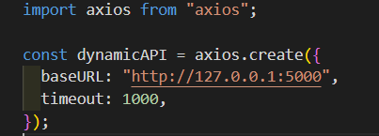

Figure 66 API to fetch dynamic flask

### **4.4.4.6 Read Employees from database query:**

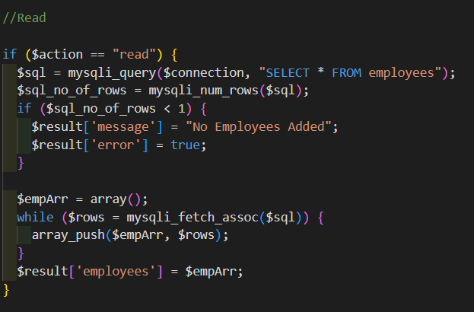

Figure 67 Read Employees from database query

### **4.4.4.7 Update Employee’s promotion status query:**

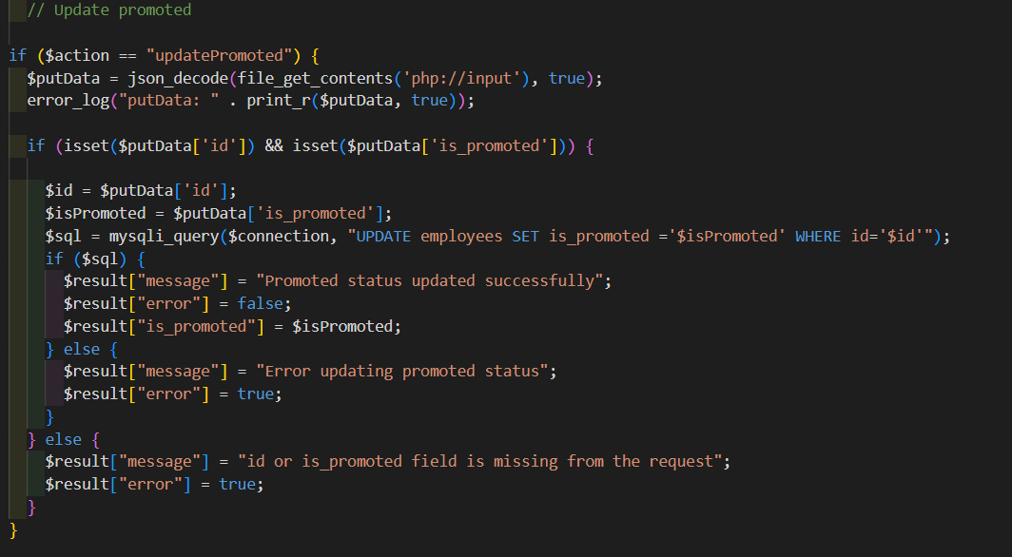

Figure 68 Update Employees query

### **4.4.4.8 Delete Employee query:**

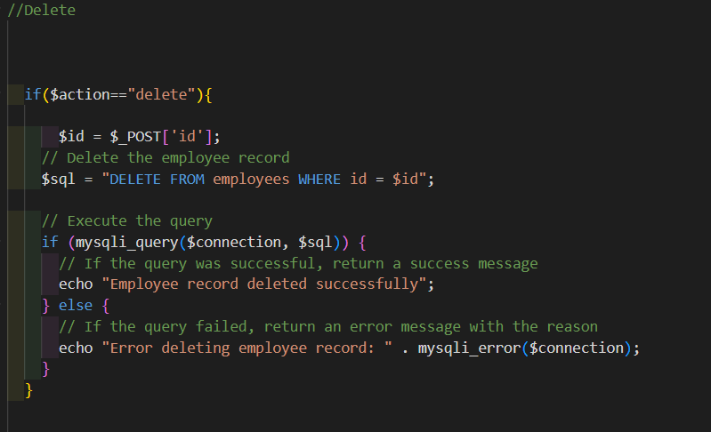

Figure 70 Delete employee query

### **4.4.4.9 Delete all employees' query:**

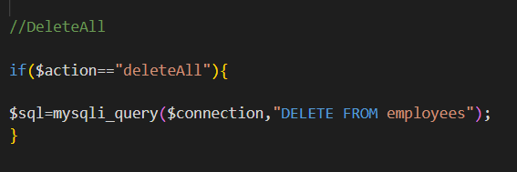

Figure 71 Delete all employees query

### **4.4.4.10 Search query:**

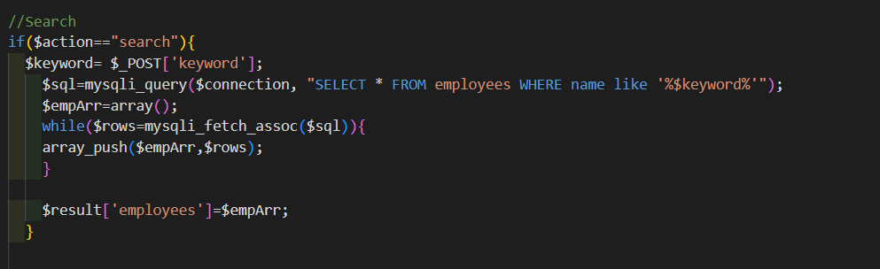

Figure 72 Search query

### **4.4.4.11 Add Employee’s page:**

In Figures below, the component represents a form for adding a new employee to an employee management system. It includes form input elements for various employee attributes. The "addEmployee" method validates the form, displays a spinner and success message, creates a FormData object, sends an HTTP POST request to submit the form data, resets the form, and navigates back to the employee list page.

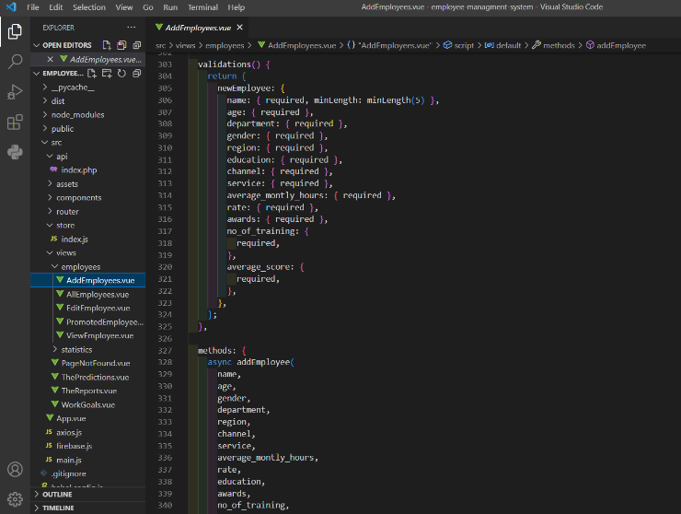

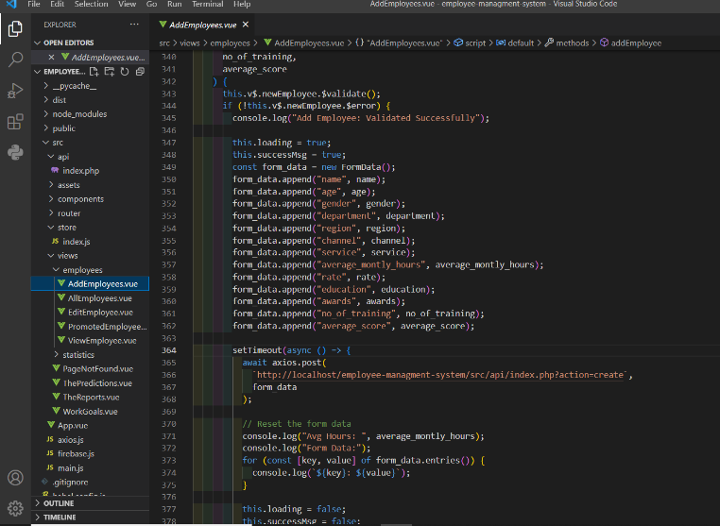

Figure 73 Add Employee Page code

### **4.4.4.12 Add Employee Query:**

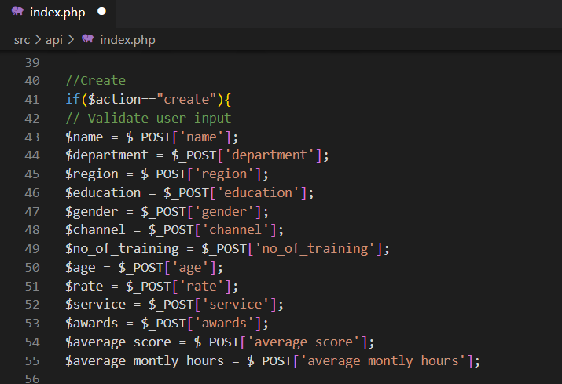

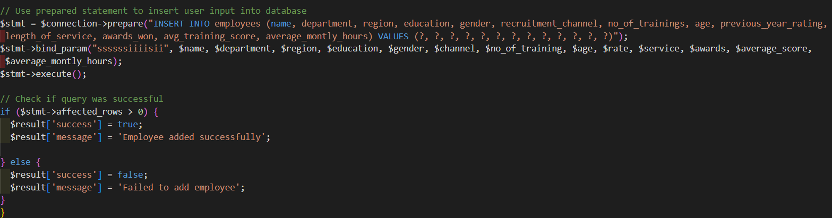

Figure 74 Add Employee query

### **4.4.4.13 Update Employee’s Page:**

In figure below: It’s a component that represents a form for editing an employee's profile in an employee management system. It includes methods for fetching and updating employee data. The form includes input fields for various employee attributes, such as name, age, gender, department, region, education, recruitment channel, etc. The component uses Axios library to send HTTP requests to the server for updating employee data.

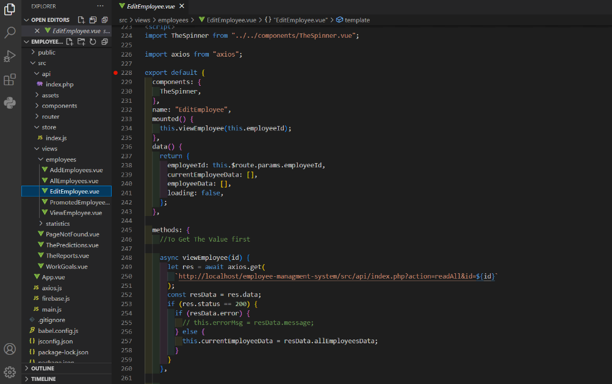

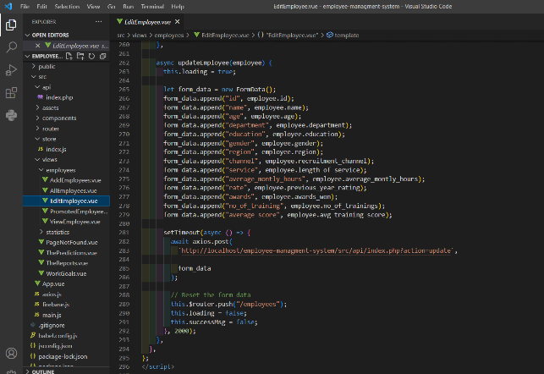

Figure 75 Update Employee Page code

### **4.4.4.14 Update Employee query:**

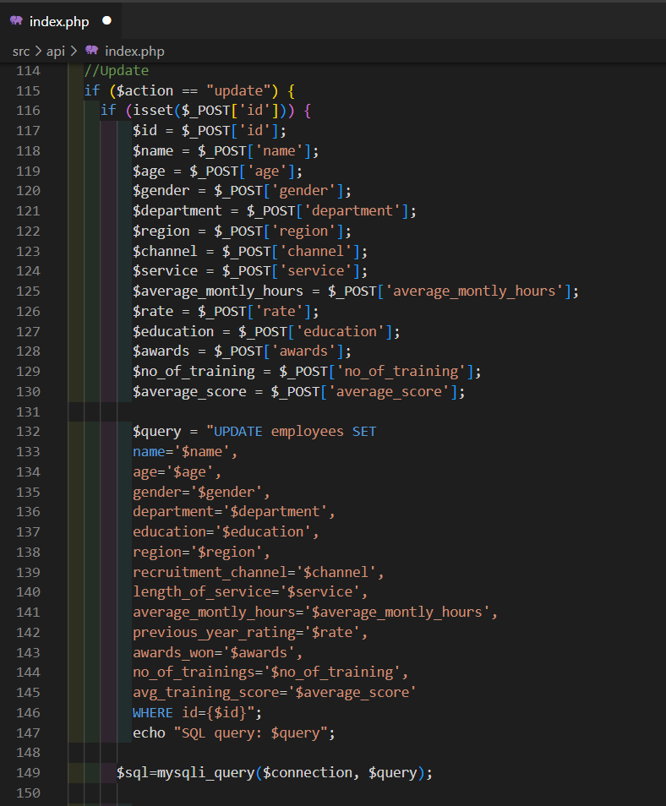

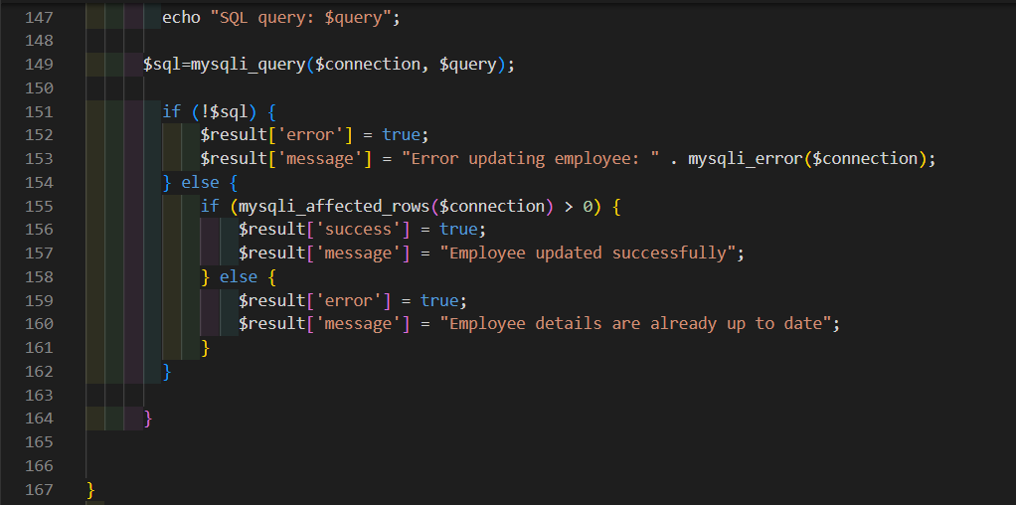

Figure 76 Update Employee query

### 

### **4.4.4.15 View Employee’s page:**

In Figures below, it’s a component that displays employee information and includes a section for predictions about their eligibility to be promoted and if they need training it retrieves data from an API using Axios and displays the results in a separate section. The viewEmployee method is called when the component is mounted and retrieves employee data based on the employee ID passed as a parameter.

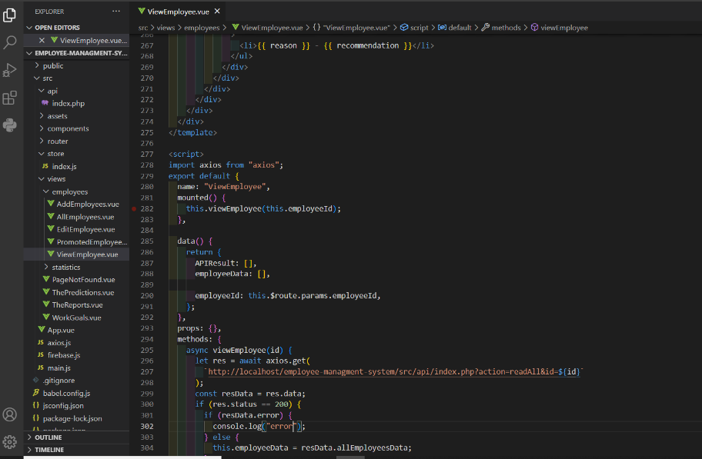

Figure 77 View Employee Page code

### **4.4.4.16 Read Employee query:**

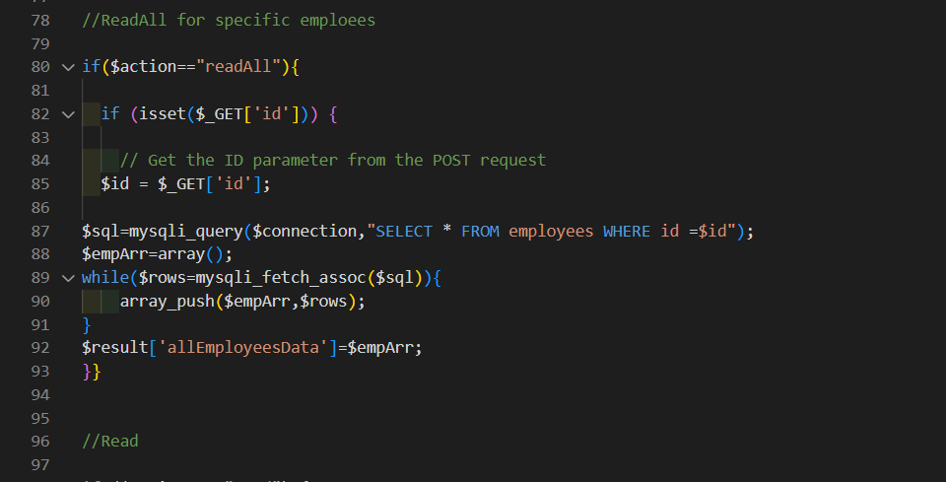

Figure 78 Read Employees query

### **4.4.4.17 Promoted Employee’s page:**

In Figures below, it’s a component that displays promoted employees’ names and department, it can generate reports of employees eligible for promotion. The component defines methods to fetch promoted employees from an API endpoint, generate a PDF report of promoted employees using jsPDF and html2canvas, and filter promoted employees based on the selected department and limit. The component's computed property returns a filtered list of promoted employees.

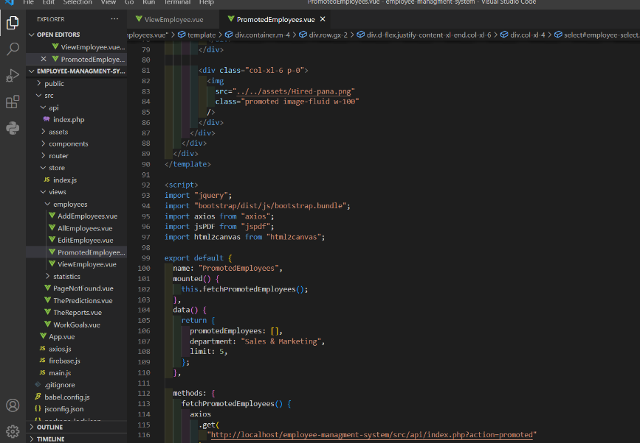

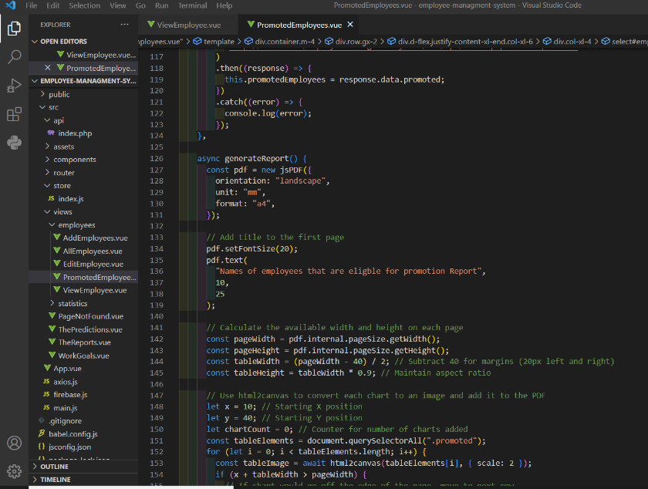

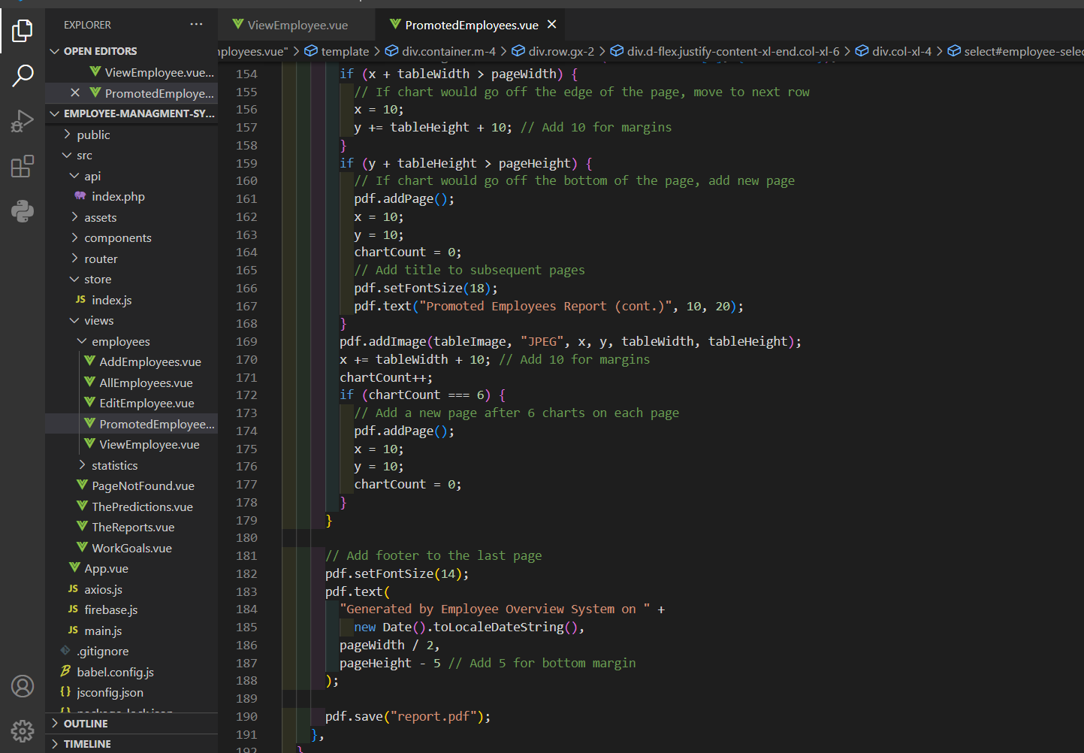

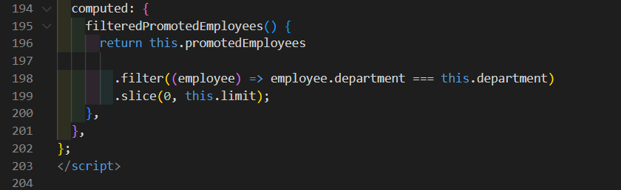

Figure 79 Promoted Employee code

### **4.4.4.18 Promoted Employee’s name and department query**

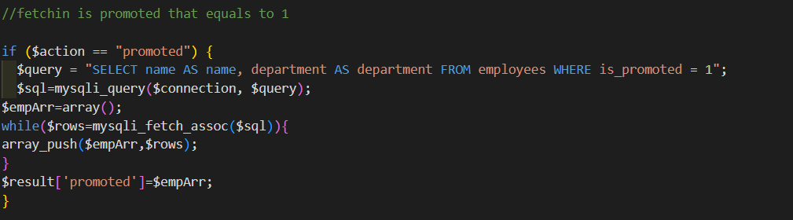

Figure 80 Query to fetch the promoted employee’s name and department

### **4.4.4.19 Work goals’ page:**

In Figure below, It displays a to-do list with a chart showing the percentage of completed tasks. The component imports several external libraries such as Chart.js. The component's state includes a list of to-do items stored in localStorage. The component contains computed properties to filter the to-do items based on the hideCompleted boolean and to calculate the number and percentage of completed tasks. The component's methods include adding, removing, and updating to-do items, as well as creating and updating the chart.

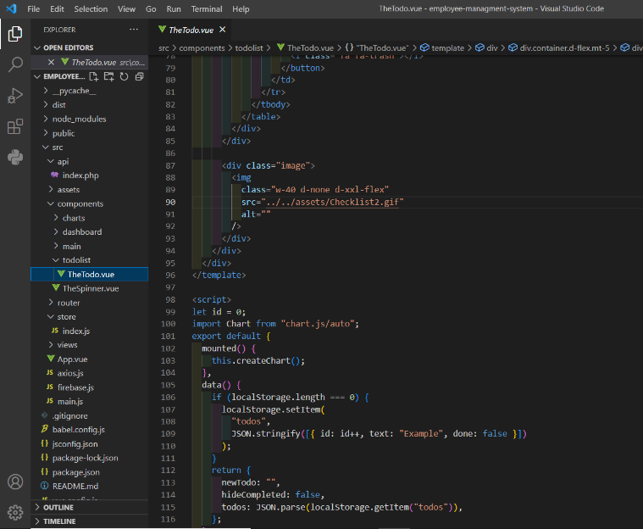

Figure 81 Work Goals Page code

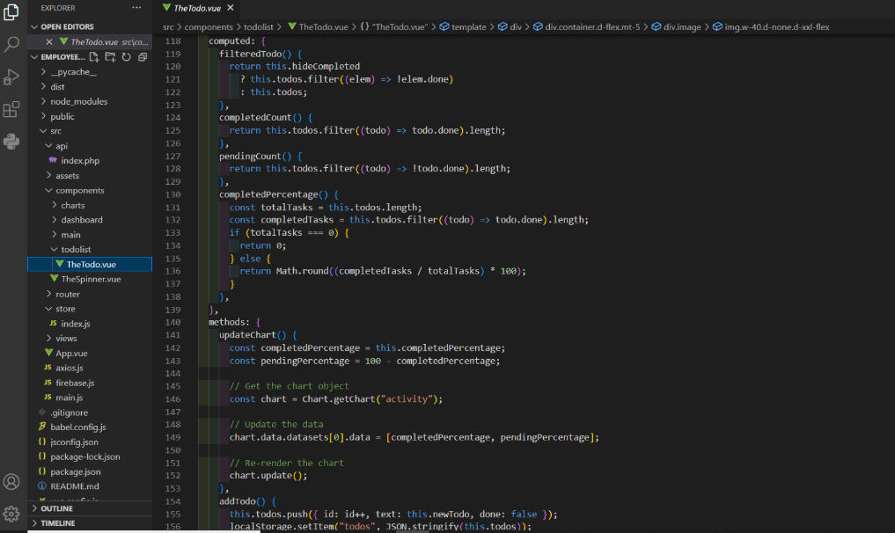

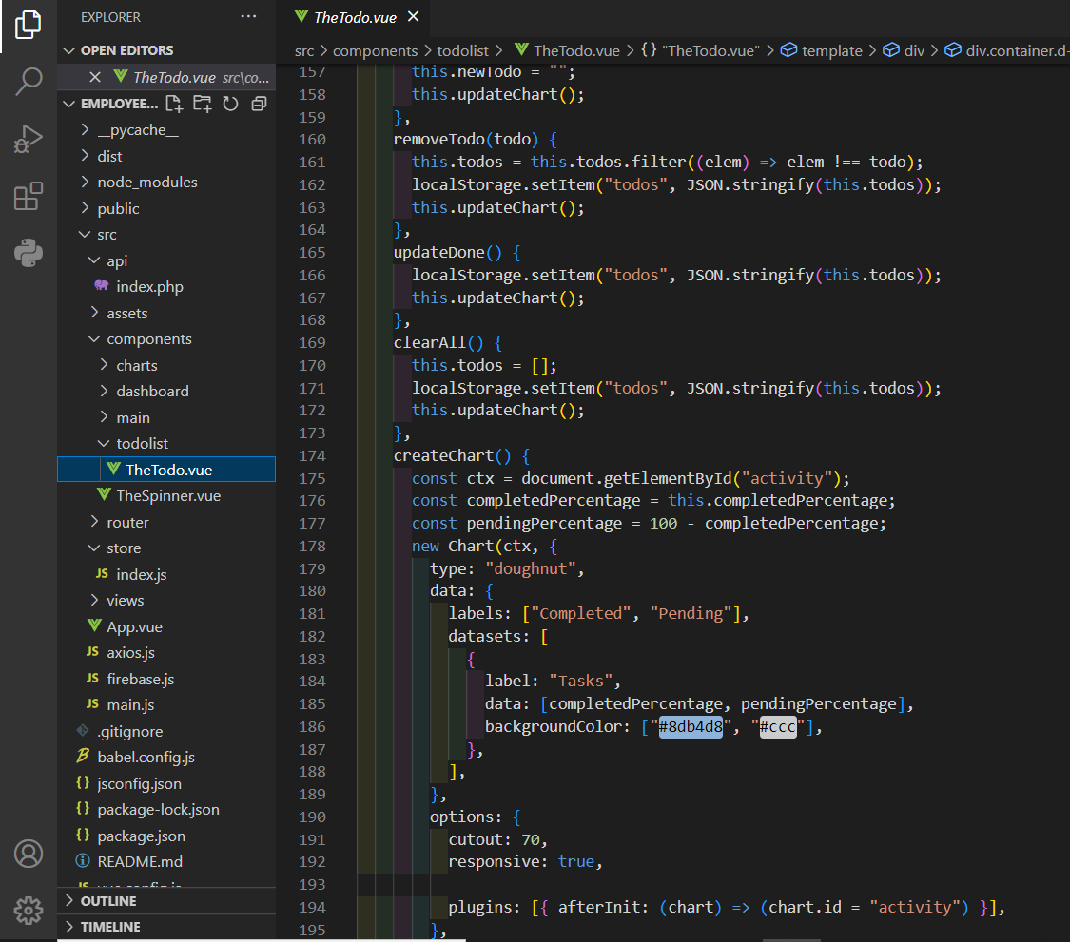

Figure 82 Work Goals Page code

### **4.4.4.20 Prediction page:**

In Figures below, It allows a user to input data about an employee and get a prediction on whether or not they are likely to be promoted. When the "Predict now" button is clicked, the predict() method is called, which sends a request to an external API with the employee data. The API returns a prediction.

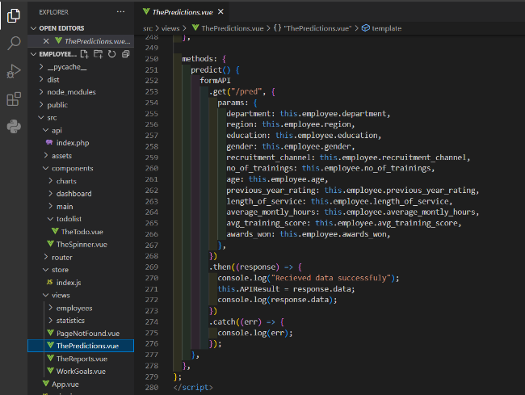

Figure 83 Prediction Page code

### **4.4.4.21 Prediction API:**

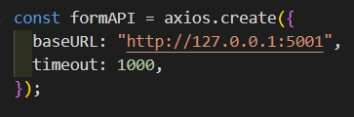

Figure 84 Prediction API

### **4.4.4.22 Not found page:**

In Figure below, it’s a component that is displayed when a user navigates to a page that does not exist (404 error page). The component includes an image of an error message and a button that links back to the home page.

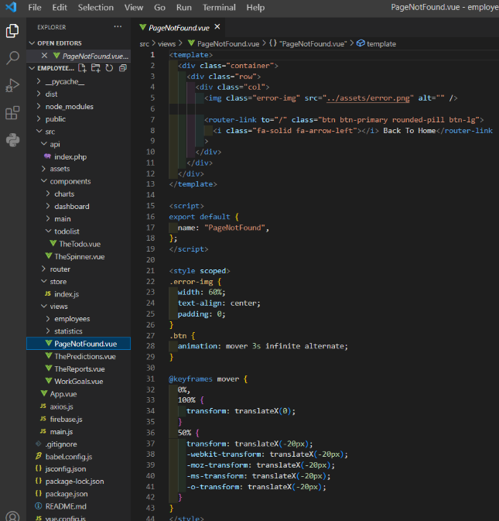

Figure 85 Not Found Page code

## **4.4.5 Implementation issues:**

I faced several issues during my project, one of which was connecting components with each other and retrieving data from the database to create charts. I solved this problem by using the Axios library to fetch data from the database and dynamically use it in my components. Additionally, I had difficulties integrating the ML model with Flask in the Vue.js component, but I was able to overcome this by researching and testing various methods.

# **4.5 Testing**

In this phase we will outline the two types of testing which is performed to test the website, and these mainly divided into performance testing and functionality testing

### **4.5.1 Performance Testing**

I used ngrok to make the website temporarily online so we can test in

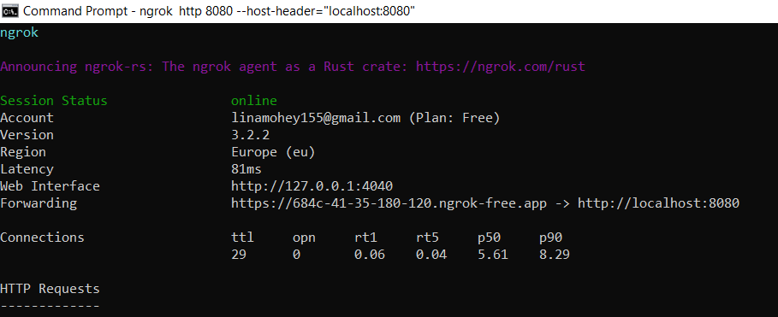

Figure 86 Make the website temporary online by ngrok

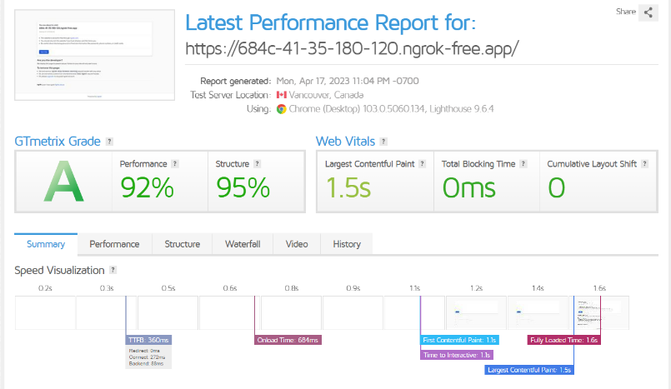

Figure 87 Testing website's performance and structure

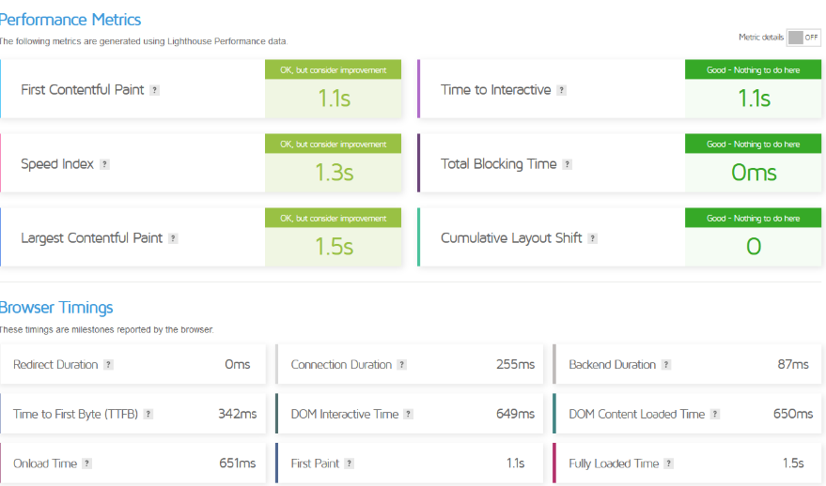

Figure 88 Testing Website’s Performance metrices

## **4.5.2 Functionality Testing**

In the testing process, the responsivity and functions of the website, including the database connection and the forms used to input, edit, retrieve and delete employees’ information were tested and all functionality requirements were met.

## **4.5.2 Security Testing**

To test the security of the website, we tried to access the internal URLs directly by entering them into the browser address bar without logging in. The system was designed to prevent unauthorized access to user information by redirecting the user to a home page if an incorrect admin Email or Password was entered. Additionally, the code prevented SQL injections.

## **4.5.6 Database Testing**

Ensuring that the data is consistent is very important. To achieve this, we verified the integrity of the data and checked for errors when performing functions such as editing, deleting or modifying the database. Also, all database queries are examined to ensure that they execute accurately and properly.

# **4.7 Methodology**

I used the waterfall methodology for this project, which is a linear, sequential model of software development.

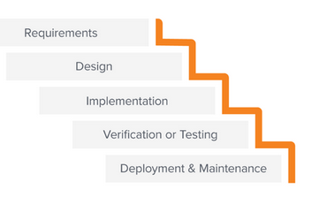

Figure 89 Prediction API

**Requirements**: I gathered and documented the requirements for the website.

**Design**: I created the design for the website, including the architecture, data models, and user interface design and also I used sequence diagram, case diagram, class diagram and activity diagram to visualize the website’s functionality and features.

**Implementation**: I wrote the code for the website using HTML, CSS, JavaScript, and Vue.js. I also integrated the code with the database, flask and tested the system as I went along.

**Testing**: I tested the website to ensure that it was functioning correctly and met the requirements.

**Deployment**: As part of my graduation project, the deployment phase involved preparing the website for presentation to my professors. Although this project was not deployed to a live production, I treated the deployment phase with the same level of importance as I would have if there was a client involved.

**Overall**, the waterfall methodology was a good fit for this project, and i believe that the website meets all the necessary requirements.

# 

# **4.8 Conclusion**

Finally, we discussed the two main phases of which are design, implementation, including the creation of diagrams and the user interface of the website. We also provided a detailed overview of the testing process. Overall, this chapter provides a comprehensive overview of the implementation, design, and testing phases of the system's development, and the key insights gained during these stages.

# **Chapter 5:**

# **Results and Discussions**

# **5.1 Introduction**

In this chapter, we'll explore a dataset through Exploratory Data Analysis (EDA). EDA helps us understand the data's structure and find patterns and relationships between variables. We'll start by describing the dataset and its variables, then analyze the data's distribution and summary statistics.

## **5.1.1 Data visualization**

Graphical representation is used for analyzing the dataset, which contains information about employees. By visually representing the data through graphs, it will provide a clear understanding of the relationships between different parameters and how they impact the eligibility of an employee being promoted.

1. **Distribution of promoted employees based on Department**

The graphical representation shows that the Technology department has the highest probability of promotion, with 11% of employees being promoted. On the other hand, the Legal department has the lowest probability of promotion, with only 5.9% of employees being promoted.

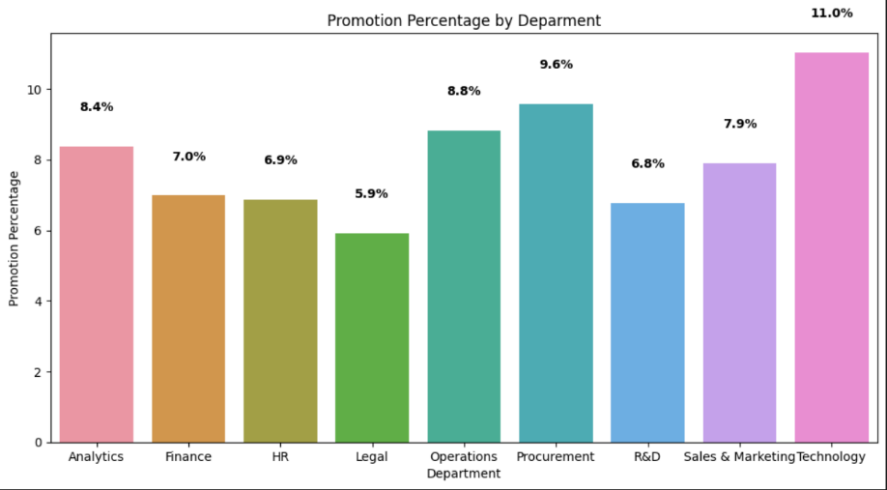

Figure 90 Promotion by Department

1. **Distribution of promoted employees based on region**

According to the graph, employees from certain regions have a higher probability of being promoted. Specifically, employees from regions

4, 1 ,17, 7, 25, 22, 23, and 30 have a probability of being promoted that is greater than 10%.

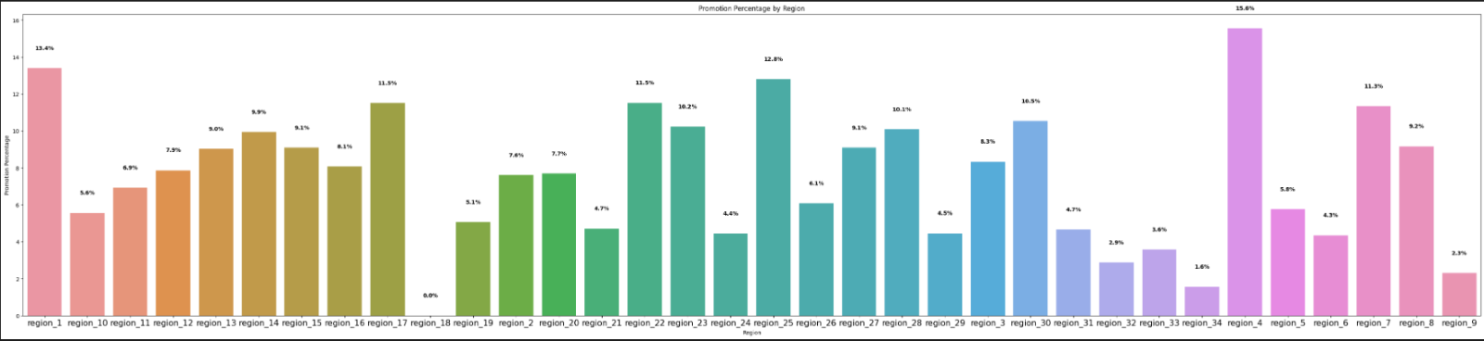

Figure 91 Promotion by Region

1. **Distribution of promoted employees based on Education**

The graph shows that employees who have a Masters's degree are more likely to be promoted, with a probability of 9.7%, while those with an education level below secondary have the lowest probability of being promoted, with a probability of 6.8%.

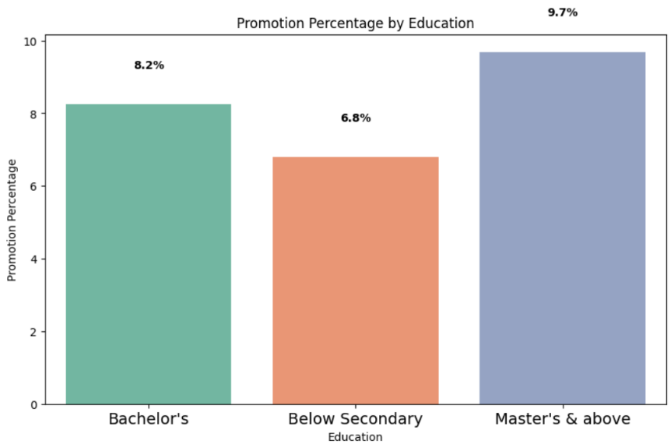

Figure 92 Promotion by Education

1. **Distribution of promoted employees based on Number of trainings,**

The graph shows that employees who have taken less training have a higher probability of being promoted. Specifically, employees who have taken 1 or 2 trainings have a probability of promotion of 8.8% and 8.1% respectively, while those who have taken 3 or 5 trainings have a probability of promotion of 7% and 3.8% respectively. In addition to that, employees who have taken 4 trainings have the highest probability of promotion, with a probability of 10.2%. This suggests that the relationship between the number of trainings and promotion likelihood may not be entirely linear, and other factors may be at play.

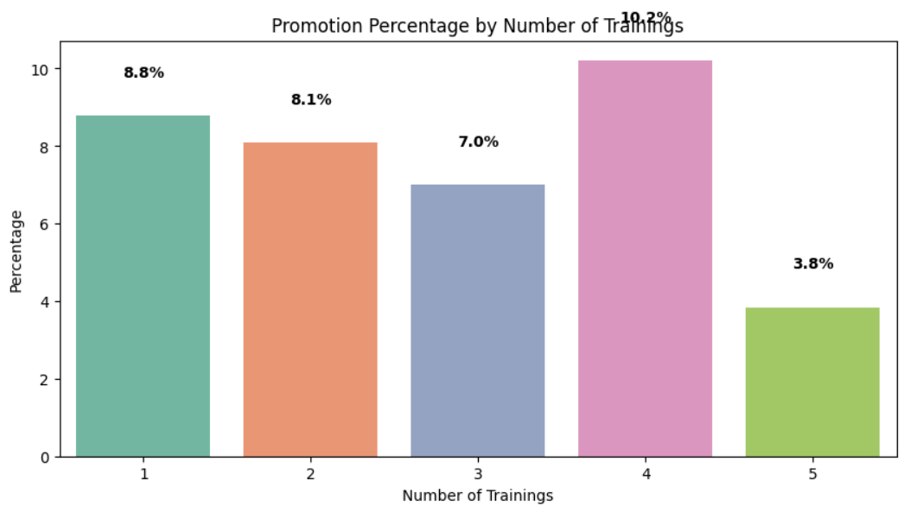

Figure 93 Promotion by Number of Trainings

1. **Distribution of promoted employees based on Gender**

The graph shows that female employees have a slightly higher chance of being promoted than male employees. Specifically, the percentage of female employees who are likely to be promoted is 9.2%, while the percentage for male employees is 8.4%.

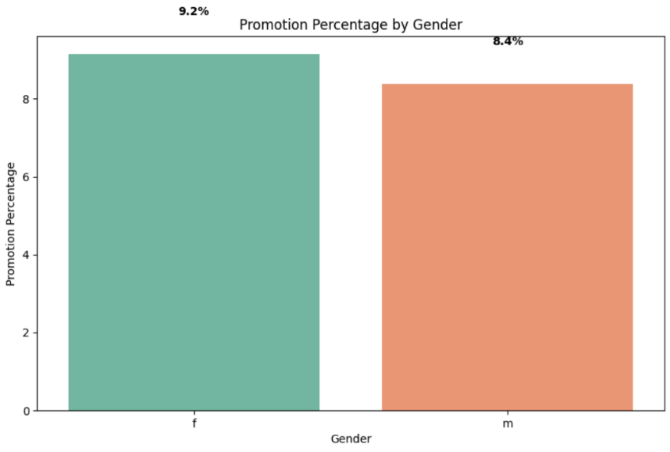

Figure 94 Promotion by Gender

1. **Distribution of promoted employees based on Recruitment Channel**

The graph shows that employees who were referred have the highest probability of promotion at 10.8%, while those who were hired through other recruitment channel have a slightly lower probability of promotion at 8.6%. Employees who were sourced have the lowest probability of promotion at 8.5%.

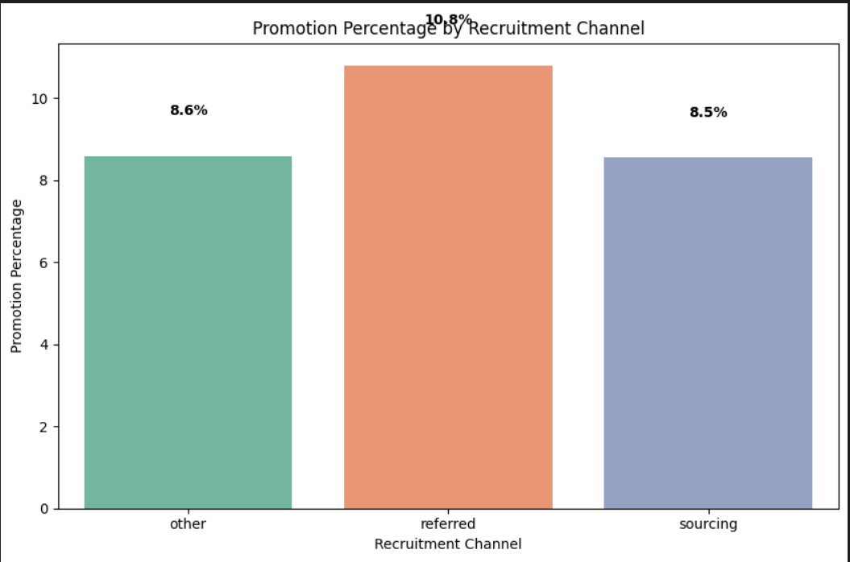

Figure 95 Promotion by Recruitment Channel

1. **Distribution of promoted employees based on Age**

The graph shows that the average age of promoted employees is 34.8 years old while the median age of promoted employees is 33 years old.

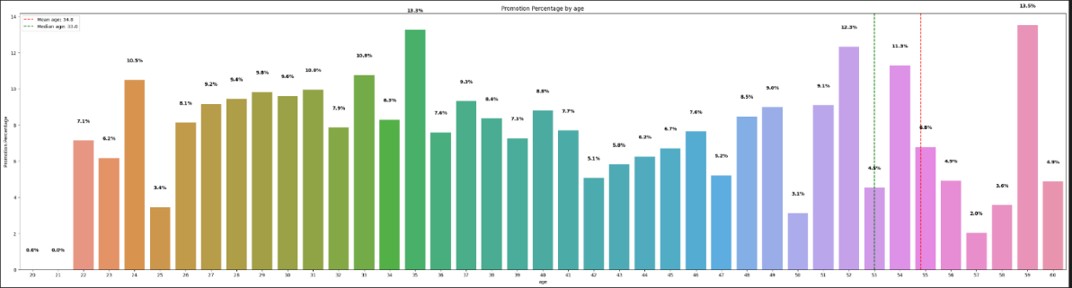

Figure 96 Promotion by Age

1. **Distribution of promoted employees based on Previous year rating**

The graph shows that employees with higher previous year ratings are more likely to be promoted than those with lower ratings. Specifically, employees with a rating of 5 have the highest probability of promotion at 16.4%, while those with a rating of 1 have the lowest probability at 1.8%.

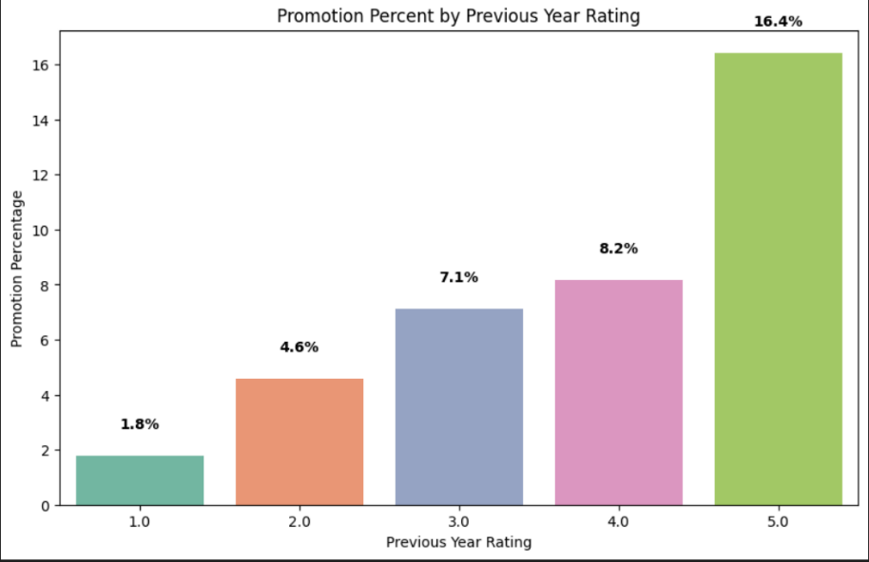

Figure 97 Promotion by Previous Year Ratings

1. **Distribution of promoted employees based on Length of service**

Based on the graph, employees with 20 years of service have the highest probability of being promoted compared to other employees.

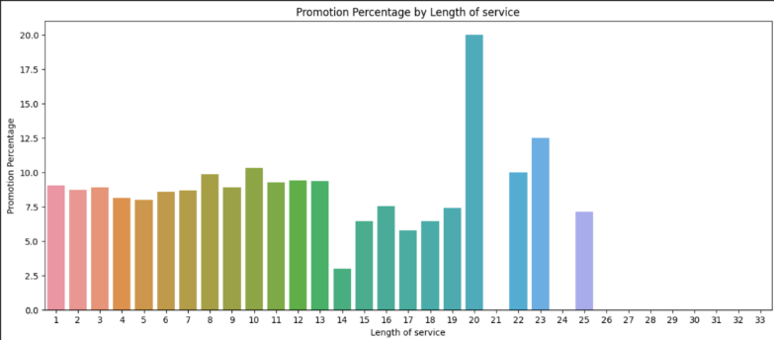

Figure 98 Promotion by Length of Service

1. **Distribution of promoted employees based on Awards won**

The graphical representation shows that employees who have previously won an award have a significantly higher probability of being promoted, with a probability of 44.02%. In contrast, employees who have not won an award only have a probability of 7.67%.

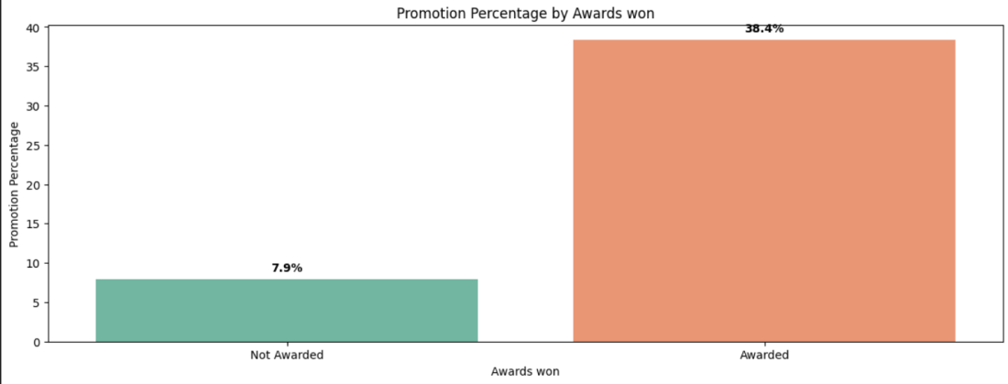

Figure 99 Promotion by Awards Won

1. **Distribution of promoted employees based on Average training score**

Based on the data, employees with an average training score of 90 or higher have a greater chance of being promoted, in contrast, employees with an average training score of less than 90 have a lower probability of being promoted.

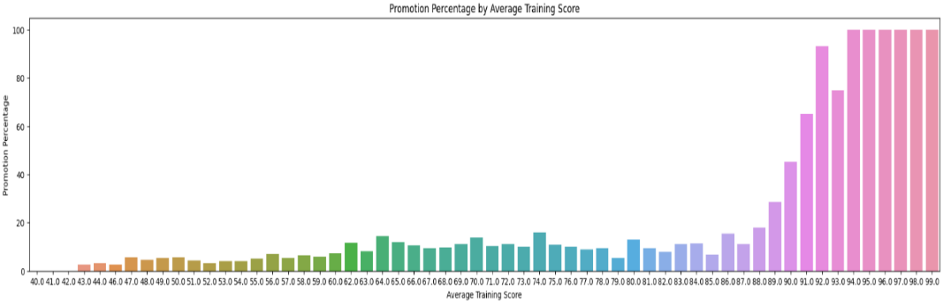

Figure 100 Promotion by Average Training Score

1. **Distribution of promoted employees based on Average monthly hours**

The graph shows that employees who worked an average of 286 to 310 hours per month had the highest probability of promotion, with a peak probability of promotion at 69.6%.

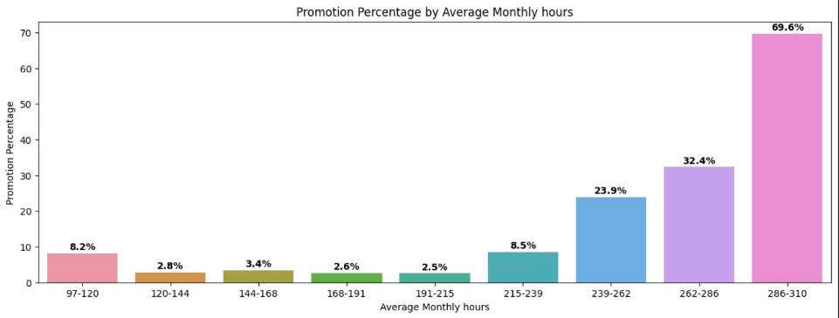

Figure 101 Promotion by Average Monthly Hours

# **5.2 Model Results:**

## **5.2.1 Model I Prediction using Logistic Regression results:**

**For Training:**

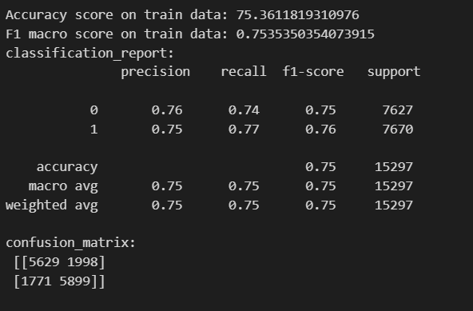

Figure 102 Logistic Regression Training Accuracy

**For Testng :**

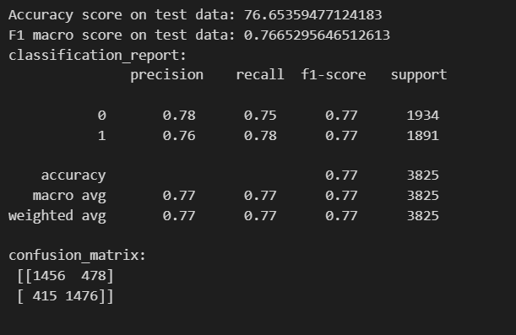

Figure 103 Logistic Regression Testing Accuracy

The results show that the model achieves an accuracy of around 75% on the training set and around 77% on the test set, which indicates that the model is not overfitting to the training data. The F1 macro score for the minority class is around 0.76, which is reasonably high. The classification report and confusion matrix provide additional information on the model's performance, showing precision, recall, and F1 scores for both classes and the confusion matrix in training set case, the model correctly predicted 5629 negative examples and 5899 positive examples, but it made 1998 false positive errors (predicted as promoted but not actually promoted) and 1771 false negative errors (predicted as not promoted but actually promoted). And for the testing set, the model correctly predicted 1456 negative examples and 1476 positive examples, but it made 478 false positive errors and 415 false negative errors.

## **5.2.2 Model II Prediction using Support Vector Machine results:**

**For Training:**

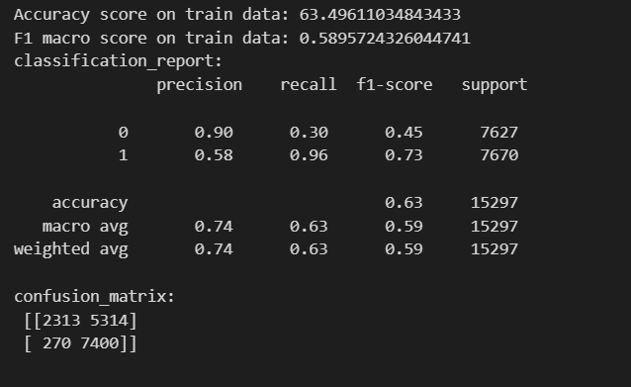

Figure 104 Support Vector Machine Training Accuracy

**For Testing:**

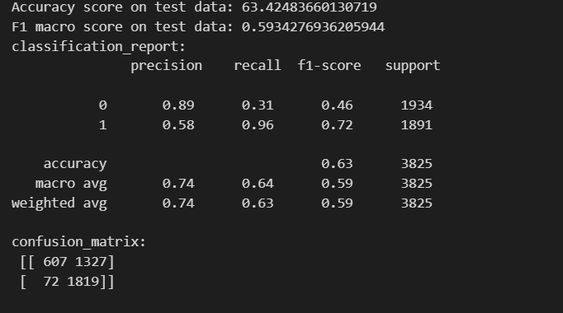

Figure 105 Support Vector Machine Testing Accuracy

The SVM model achieved an accuracy of 63.50% on the training data and 63.42% on the test data. The F1 macro score was 0.59 on both datasets, indicating similar performance. The model had more difficulty classifying instances from class 0 than class 1, as shown in the confusion matrices. The precision for class 0 was high (90% for training and 89% for test data) but recall was low (30% for training and 31% for test data). The model had a high recall for class 1 (96% for both training and test data) but lower precision (58% for both training and test data). The confusion matrix for the training set had 2313 TP, 5314 FP, 270 FN, and 7400 TN, while the test set had 607 TP, 1327 FP, 72 FN, and 1819 TN.

## **5.2.3 Model III Prediction using Naïve bayes results:**

**For Training:**

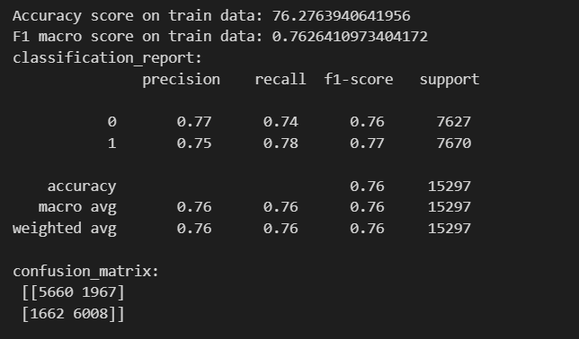

Figure 106 Naïve Bayes Training Accuracy

**For Testing:**

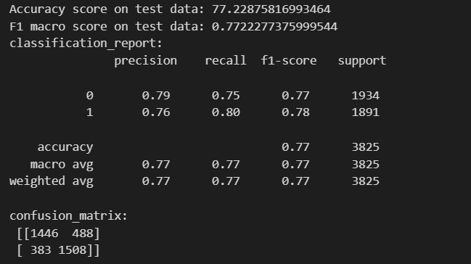

Figure 107 Naïve Bayes Testing Accuracy

The GNB model achieved an accuracy of 76.28% on the training data and 77.23% on the test data. The F1 macro score was 0.76 on the training data and 0.77 on the test data, indicating similar performance on both datasets. The confusion matrices show that the model had more difficulty classifying instances from class 0 than class 1. The training set confusion matrix had 5,660 TN instances, 1,967 FP instances, 1,662 FN instances, and 6,008 TP instances. The test set confusion matrix had 1,446 TN instances, 488 FP instances, 383 FN instances, and 1,508 TP instances.

## **5.2.4 Model IV Prediction using XGBoost results:**

**For Training:**

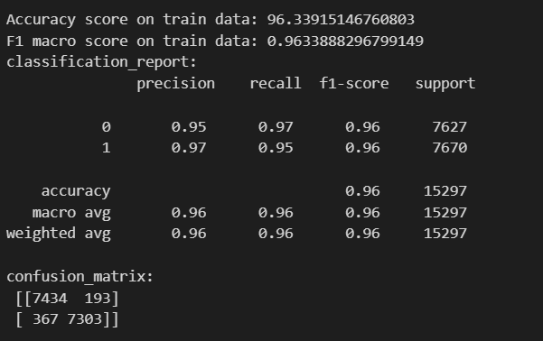

Figure 108 XGBOOST Training Accuracy

**For Testing:**

.

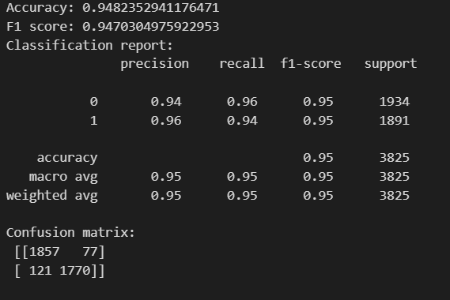

Figure 109 XGBOOST Testing Accuracy

The XGBoost model achieved an accuracy of 96% on the training data and 94.82% on the test data, with an F1 score of 0.947 indicating good performance on both datasets. The confusion matrix for the test data showed 1857 TN instances, 77 FP instances, 121 FN instances, and 1770 TP instances, indicating high accuracy in classifying instances from both classes with low numbers of false positives and false negatives.

# **5.3 Model Comparison:**

1. Logistic Regression: Achieved an accuracy of 63.24% on the test data. The F1 macro score was 0.59, with high precision for class 0 but low recall, and high recall for class 1 but lower precision.
2. Naive Bayes: Achieved an accuracy of 63.63% on the test data. The F1 macro score was 0.586, with high precision for class 0 but low recall, and high recall for class 1 but lower precision.
3. Support Vector Machine (SVM): Achieved an accuracy of 63.42% on the test data. The F1 macro score was 0.59, with high precision for class 0 but low recall, and high recall for class 1 but lower precision.
4. XGBoost: Achieved an accuracy of 94.82% on the test data. The F1 score was 0.947, with high precision and recall for both classes.

Based on these results, the XGBoost model clearly outperformed the other models in terms of accuracy and precision/F1 score, achieving almost 95% accuracy on the test data and high precision and recall for both classes.

# **5.4 Model Serialization**

Finally, we need to save the model’s file, by saving a trained machine learning model to a file using pickle.

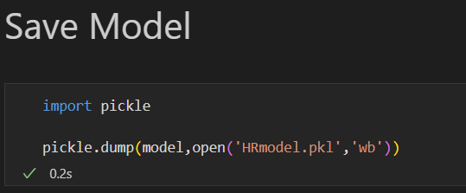

Figure 110 Save XGBOOST Model

# **5.5 Model Integration:**

Flask is used to integrate the model on the website which serves as a machine learning model for predicting employees’ promotion eligibility based on the employees’ data whether it's come from input forms or dynamically retrieved from database. Based on the previous information we have 2 flask models, one for the form data and one for the dynamic data. The application receives input parameters via a GET request, converts them into numerical values using mapping dictionaries, and feeds them into the machine learning model to generate a prediction. The application returns a JSON response containing the prediction result, the probability of the prediction, Image URL depend on gender and training recommendations (in dynamic app) for employees who are not eligible for promotion.

**Dynamic Flask app:­­**

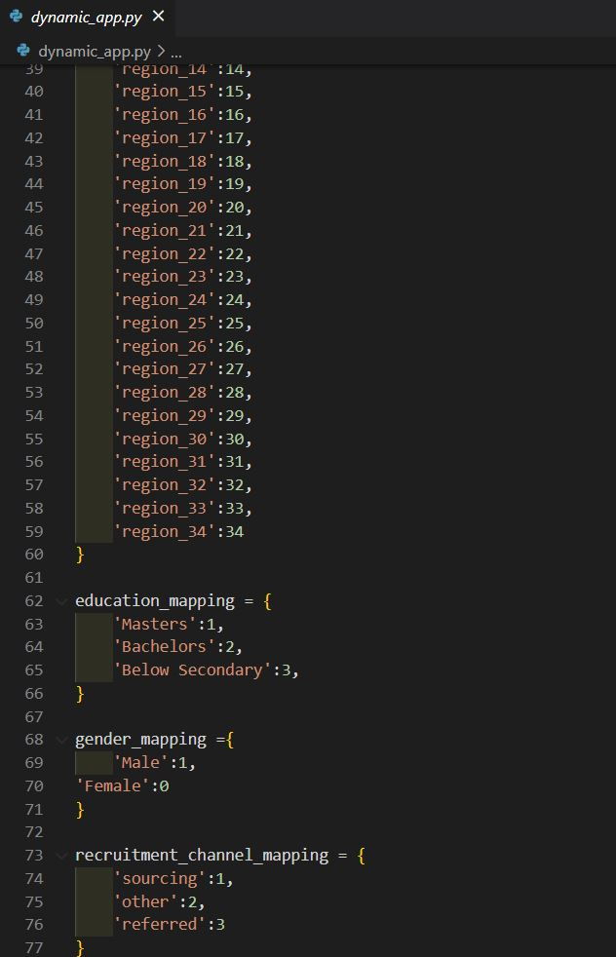

Figure 111 Mapping data dynamic flask app

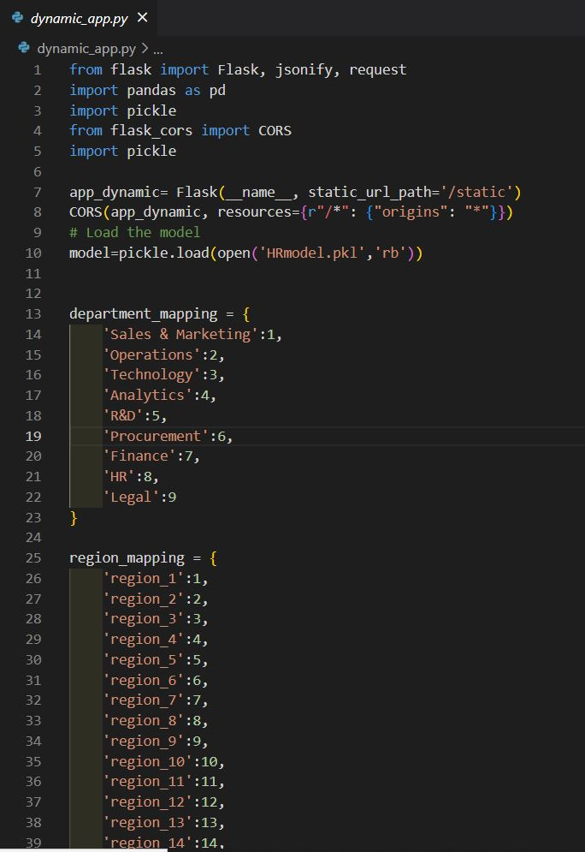

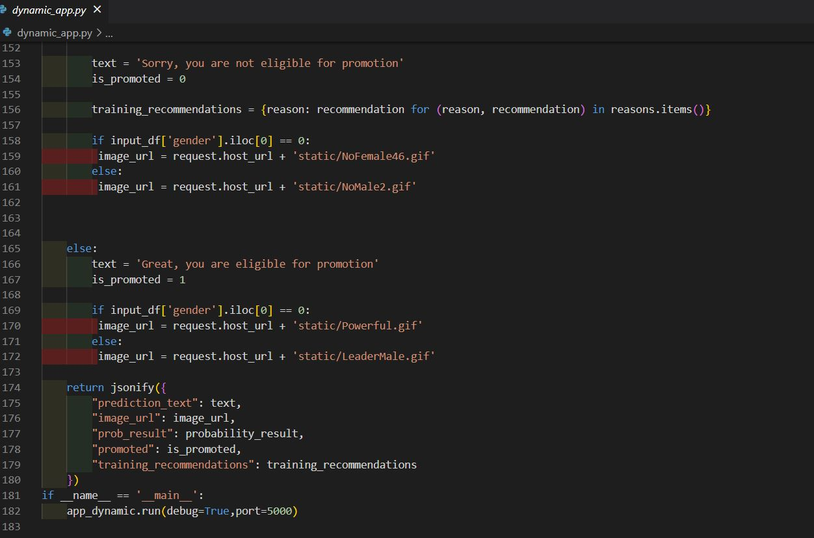

Figure 114 Predict function to get data and predict dynamic flask app

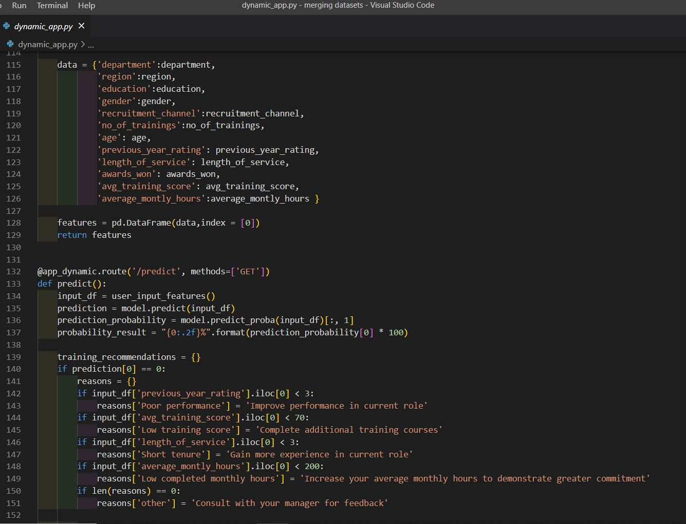

Figure 113 Predict function to get data and predict dynamic flask app

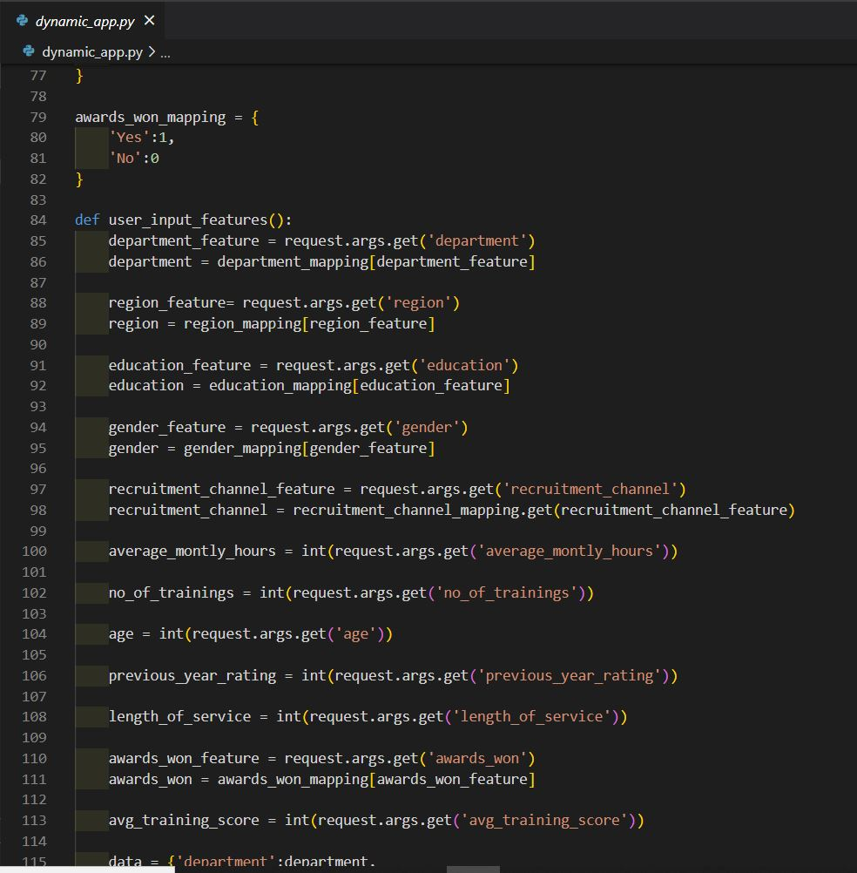

Figure 112 Input function dynamic flask app

**Form Flask app:**

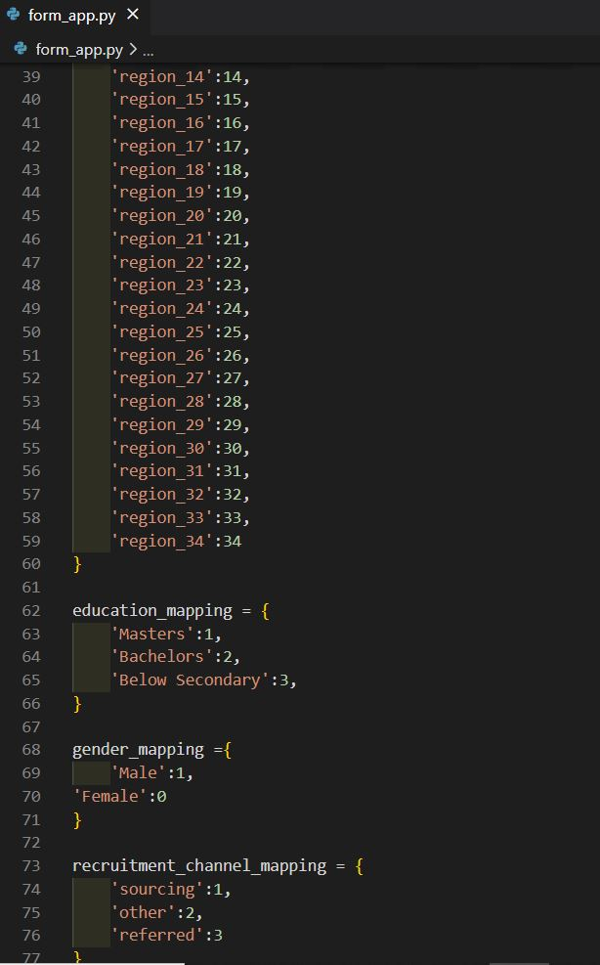

Figure 116 Mapping Data Form Flask app I

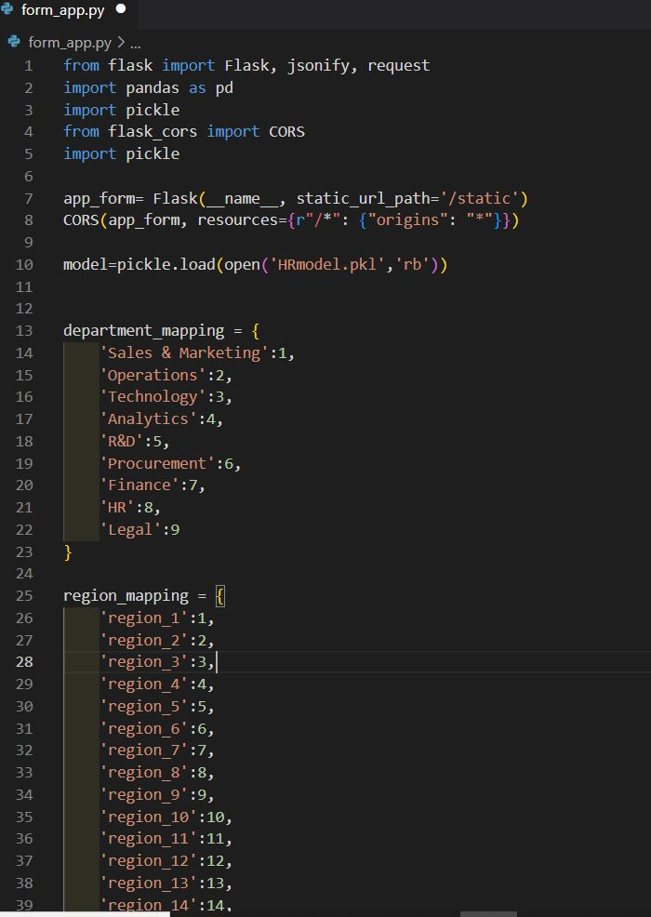

Figure 115 Mapping Data Form Flask app I

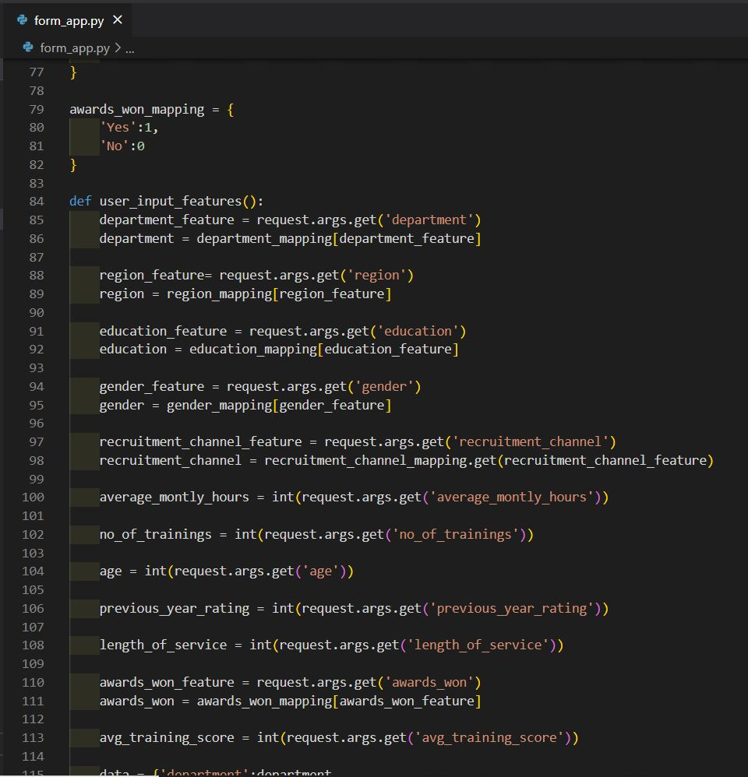

Figure 117 User input function form flask app

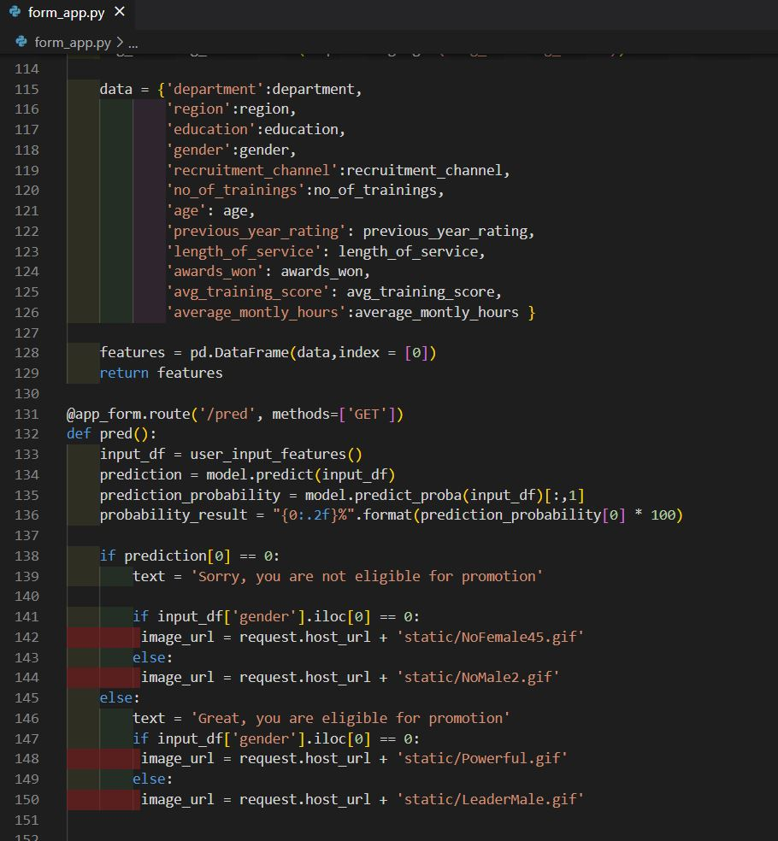

Figure 118 Function to get data and predict form flask app

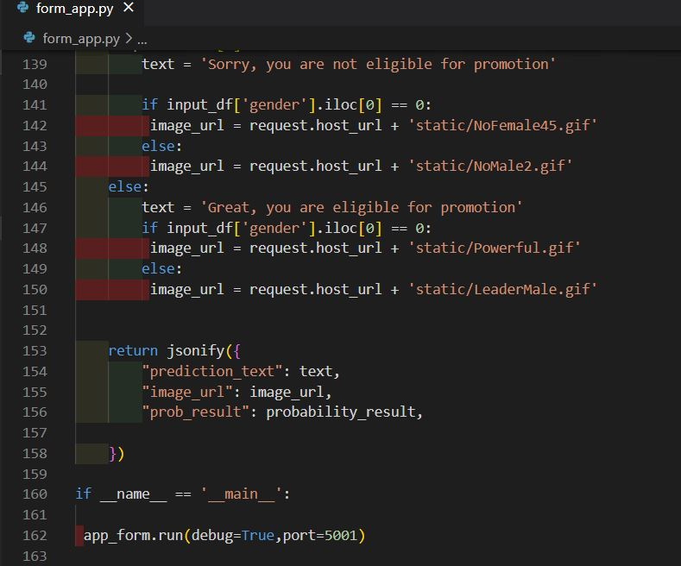

Figure 119 Function to get data and predict form flask app

# **5.6 Comparing related work:**

In this chapter, we compare the predictive performance of two models, our own model and another model that was made by Zhanuzakov M.B. and Balakaeva G.T. The two machine learning models were evaluated for their ability to predict employee promotions. The compared model was based on a research paper and used a small dataset of 17400 entries with only 8 features. The proposed used a larger dataset of 146,468 entries with 14 features.The compared model had a high accuracy of 98% for Keras algorithm, 96% for the Gradient Boosting algorithm, and 95% for the Random Forest algorithm, but it had several limitations.The small dataset size and limited features may have affected the model's ability to generalize well to new data. Additionally, the lack of transparency in the research paper made it difficult to assess the validity and reliability of the model. Furthermore, despite the high accuracy, the model may still make incorrect predictions due to overfitting and limitations in the keras, gradient boosting and random forest algorithms. In contrast, the proposed model had several advantages. The larger dataset size and the inclusion of more features may have improved the model's accuracy and generalization. The model was also more transparent, with a user-friendly UI and a detailed explanation of the training process and feature selection. The proposed model had a high accuracy of 96%, using XGBoost algorithm comparable to the other model, but it may be more reliable due to its larger dataset and more comprehensive feature selection.

Overall, the proposed model is a better solution for predicting employee promotions due to its larger dataset, more comprehensive feature selection, and greater transparency

**Model A: Compared Model, B: Proposed Model**

Table 1 comparison between two models

|  |  |  |  |  |  |
| --- | --- | --- | --- | --- | --- |
| **Model** | **Algorithm** | **Dataset size** | **Number of Features** | **Accuracy** | **Overfitting** |
| A | Gradient Boosting, Random Forest, Keras | 1740 | 8 | 96%  95%  98% | Yes |
| B | XGBOOST | 1146,468 | 14 | 96% | No |

## **5.6.1 The UI of Compared Model:**

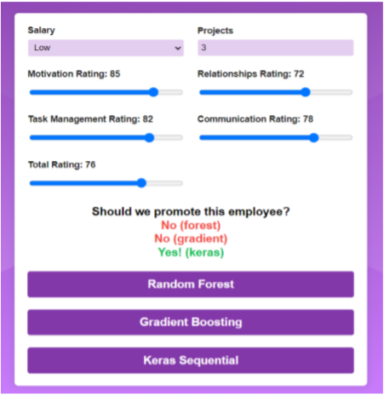

Figure 120 Compared Model’s Prediction Page [1]

**5.6.2 The form part UI of the Proposed Model:**

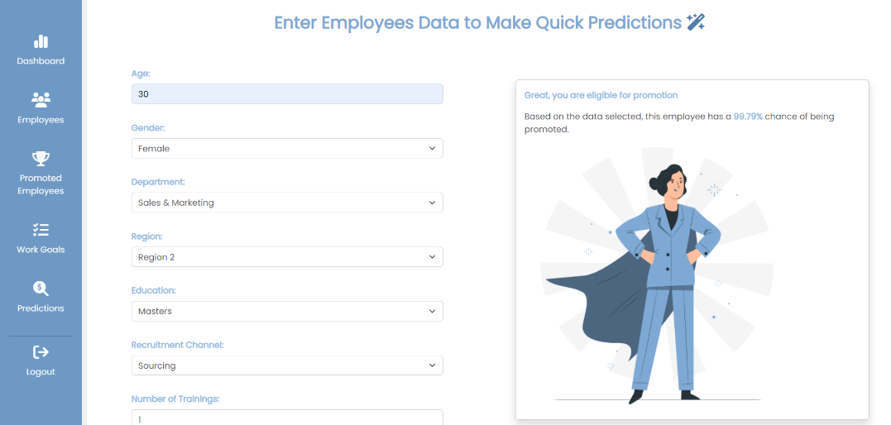

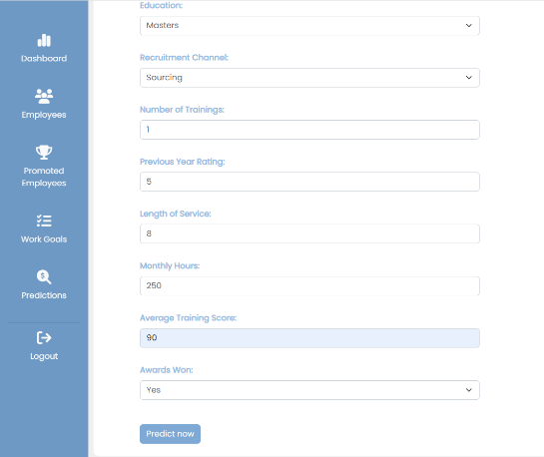

Figure 121 Proposed Model’s Prediction Page

# **5.7 Goals Achieved**

The project aimed to design a user-friendly, visually appealing website using the XGBoost model to identify employees with high promotion potential. The website achieved a website structure score of 95% and performance of 92% and underwent various tests, including performance, functionality, and security tests. The XGBoost algorithm achieved an accuracy of 96% using a large dataset of employee data and factors like performance, education, and experience. The website's dynamic features make data entry easy, and its accurate predictions can help businesses make informed decisions about promotions. Overall, the project delivered a high-quality solution that helps businesses optimize their promotion processes and drive success.

# **5.8 Features**

The website I designed offers a range of features that make it a powerful tool for identifying employees that eligible for promotion These features include:

1. Admin authentication: The website provides a layer of security to the website as it protects employees’ data and prevents unauthorized access.
2. User-friendly UI: The website's user interface is user-friendly and easy to use, with clear navigation and an attractive design that makes it for administrator to interact with the system
3. CRUD operations: admin can perform CRUD (create, read, update, delete) operations on employee records, allowing to manage the information in the system with ease with filtering option to display specific number of employees or search for employees by name.
4. Dynamic promotion status: The website shows whether an employee has been promoted or not with 96% accuracy based on their performance data and suggests specific training to improve their weaknesses. This helps employees understand what they need to do to improve their chances of promotion.
5. To-do list: The website offers a small to-do list that helps admins manage their tasks more efficiently, with charts based on their activity and productivity that show how many tasks are completed and how many are still pending.
6. Promoted employees list: The website also has a feature that shows the names of all employees who have been promoted, with filtering options by department or number of employees, as well as the ability to generate reports based on this information.
7. Quick prediction: The website has a feature that allows for quick predictions that are not related to employees already in the system with accuracy 96%. This can be useful for making informed decisions about future promotions.
8. Dashboard: The website's dashboard provides visualizations of employee performance data and how promotion correlates with various factors, helping admins make informed decisions based on real-time data.

Overall, these features make the website a powerful tool for identifying employees that are eligible for promotion, and for managing employee data more efficiently and easily. With its user-friendly interface, filtering options, and dynamic promotion status, the website is an excellent tool for businesses looking to improve their employee promotion processes.

# **Chapter 6:**

# **Conclusion and Future work**

# **6.1 Summary of project**

Optimizing HR processes is crucial for organizations to succeed in today's fast-paced competitive business world. The promotion process is a critical but challenging process that can be time-consuming to manage effectively. To address this challenge, a system combining website development and artificial intelligence was developed to create a powerful tool for enhancing the promotion process and identifying the most deserving employees, ultimately improving business processes. Having a tool that can predict the employees that are eligible for promotion and the percentage of the chance of having it can help HR departments to make more effective decisions and that’s achieved by analyzing range of data such as performance, education and average score and other features. This not only helps organizations promote the right employees but also ensures that promotions are based on objective criteria rather than subjective evaluations. In addition to that, it can help organizations to identify the training needs within their workforce and suggest training for each employee based on the chance of being promoted so he can improve their week points so they can help them prepare for future promotions and career advancements. Promotion prediction tool not only improves employee retention as soon as they are rewarded for their hard work and dedications, but they also can help to motivate employees to continue performing at high level which in turn will reduce the turnovers and save training cost and time for searching for new employees. So, this tool will be more than essential for any organization looking to optimize the process of promoting employees and drive success The success of the promotion prediction website relied heavily on the design and implementation phases. In the analyze phase, all requirements for the system were specified and in the design phase, a class diagram and database schema were created so it can provide detailed overview of the system’s structure and relationships between each class. The system was implemented using a range of web development techniques, including HTML5, CSS3, Bootstrap, JavaScript, and Vue.js. Programming tools such as PHP and MYSQL DBMS were also used to enable the system to perform a range of complex functionalities, such as storing and retrieving user information from the database and generating dynamic reports. Security was a top priority during the implementation phase, and measures were taken to prevent unauthorized access to employee information by using Firebase for user authentication. In the testing phase, performance and functionality tests were conducted to ensure that the website met all functionality requirements and security measures were evaluated. Specifically, the system was tested for unauthorized access and data integrity to ensure it is consistent with no errors. The project has user-friendly features and functionalities that are easy to navigate, even for non-technical users. The system allows admins to perform CRUD operations on employee data, giving them complete control over the data. The website has a dynamic promotion status feature that tracks the promotion status of each employee based on existing data and updates the status dynamically. This feature helps businesses keep track of the promotion process's progress and identify any delays that may be affecting the process. The website has a to-do list feature to help admins stay organized and manage their time effectively, ensuring no critical tasks are overlooked. The promoted employees feature returns a list of employees who have been promoted, allowing businesses to recognize and reward employees who perform well. The machine learning model includes a quick prediction feature that efficiently identifies eligible employees for promotion. The dashboard feature provides an overview of the promotion process's progress, helping businesses track their progress.

The dashboard shows important metrics for the promotion process, such as the number of employees promoted, still in the process and not eligible, and how these metrics are correlated with other employee data. This helps businesses monitor the progress and make informed decisions. The website's machine learning algorithm is XGBoost, with 92% accuracy, making it a valuable tool for businesses to improve their employee promotion processes and identify eligible employees accurately and efficiently, leading to better decision-making and improved business performance.

In summary, this project explains the importance of using website development and artificial intelligence to enhance business processes and drive success and how it eases the life of HR, data entry and saves time and money by making a promotion prediction tool which is powerful tool for businesses looking to optimize their employee promotion processes. By helping businesses streamline the promotion process and identify the most deserving employees, ensuring that promotions are based on objective criteria. The system's design and implementation phases were critical to its success, ensuring that it met all functionality requirements while also being user-friendly and secure. The integration of artificial intelligence provides valuable insights into employee performance and promotion potential, making it a powerful tool for optimizing the promotion process. This tool can ease HR work by automating the promotion process and reducing the need for time-consuming manual evaluations. Overall, this project represents a valuable tool for businesses looking to enhance their HR processes and contribute to their success.The project was full of challenges, from choosing the appropriate platform and programming languages to implementing artificial intelligence and ensuring the communication between website components. However, through planning, searching, and problem-solving, the project was able to progress and achieve its objectives.

# **6.2 Future Work**

The current version of the website accurately identifies employees with high promotional potential, but there is room for improvement. Future work will focus on adding new features, such as employee access to the dashboard to track their own performance metrics. Improving the accuracy of the machine learning model is also an area for improvement. The potential for future work in this area is significant, with the goal of helping companies make informed decisions about promotions and ensuring employees can advance based on their true potential.

# **7. References**

[1] Zhanuzakov, M.B. and Balakaeva, G.T. (2022) Prediction of Employee Promotion Based on Ratings Using Machine-Learning Algorithms. Bulletin of the Karaganda University-Mathematics, 102(4), pp. 41-48. Available at: <https://bulletin-phmath.kaznpu.kz/index.php/ped/article/view/616/569>

[2] Balaji, D.V. and Arunnehru, J. (2022) Predictive Analysis on HRM Data: Determining Employee Promotion Factors Using Random Forest and XGBoost. In: Gupta, S., Sharma, D., El-Qawasmeh, E. and Rawat, D.B. (eds.) Proceedings of the International Conference on Advanced Computing, Communication and Data Sciences. Singapore: Springer, pp. 173-180. Available at: <https://link.springer.com/chapter/10.1007/978-981-16-5652-1_15>

[3] Yahaya, H. H. (2019). Predictive Analytics on Employees Promotion using Machine Learning. Available at: <http://utpedia.utp.edu.my/id/eprint/24138/1/Predictive%20Analytics%20on%20Employees%20Promotion%20using%20Machine%20Learning.pdf>

[4] Visual-paradigm, Available at: [https://online.visual-paradigm.com/](https://online.visual-paradigm.com/%E2%80%AF)

# **8. Appendices**

## **8.1 Flask code for quick prediction form:**

from flask import Flask, jsonify, request

import pandas as pd

import pickle

from flask_cors import CORS

import pickle

app_form= Flask(_name_, static_url_path='/static')

CORS(app_form, resources={r"/": {"origins": ""}})

model=pickle.load(open('HRmodel.pkl','rb'))

department_mapping = {

'Sales & Marketing':1,

'Operations':2,

'Technology':3,

'Analytics':4,

'R&D':5,

'Procurement':6,

'Finance':7,

'HR':8,

'Legal':9

}

region_mapping = {

'region_1':1,

'region_2':2,

'region_3':3,

'region_4':4,

'region_5':5,

'region_6':6,

'region_7':7,

'region_8':8,

'region_9':9,

'region_10':10,

'region_11':11,

'region_12':12,

'region_13':13,

'region_14':14,

'region_15':15,

'region_16':16,

'region_17':17,

'region_18':18,

'region_19':19,

'region_20':20,

'region_21':21,

'region_22':22,

'region_23':23,

'region_24':24,

'region_25':25,

'region_26':26,

'region_27':27,

'region_28':28,

'region_29':29,

'region_30':30,

'region_31':31,

'region_32':32,

'region_33':33,

'region_34':34

}

education_mapping = {

'Masters':1,

'Bachelors':2,

'Below Secondary':3,

}

gender_mapping ={

'Male':1,

'Female':0

}

recruitment_channel_mapping = {

'sourcing':1,

'other':2,

'referred':3

}

awards_won_mapping = {

'Yes':1,

'No':0

}

def user_input_features():

department_feature = request.args.get('department')

department = department_mapping[department_feature]

region_feature= request.args.get('region')

region = region_mapping[region_feature]

education_feature = request.args.get('education')

education = education_mapping[education_feature]

gender_feature = request.args.get('gender')

gender = gender_mapping[gender_feature]

recruitment_channel_feature = request.args.get('recruitment_channel')

recruitment_channel = recruitment_channel_mapping.get(recruitment_channel_feature)

average_montly_hours = int(request.args.get('average_montly_hours'))

no_of_trainings = int(request.args.get('no_of_trainings'))

age = int(request.args.get('age'))

previous_year_rating = int(request.args.get('previous_year_rating'))

length_of_service = int(request.args.get('length_of_service'))

awards_won_feature = request.args.get('awards_won')

awards_won = awards_won_mapping[awards_won_feature]

avg_training_score = int(request.args.get('avg_training_score'))

data = {'department':department,

'region':region,

'education':education,

'gender':gender,

'recruitment_channel':recruitment_channel,

'no_of_trainings':no_of_trainings,

'age': age,

'previous_year_rating': previous_year_rating,

'length_of_service': length_of_service,

'awards_won': awards_won,

'avg_training_score': avg_training_score,

'average_montly_hours':average_montly_hours }

features = pd.DataFrame(data,index = [0])

return features

@app_form.route('/pred', methods=['GET'])

def pred():

input_df = user_input_features()

prediction = model.predict(input_df)

prediction_probability = model.predict_proba(input_df)[:,1]

probability_result = "{0:.2f}%".format(prediction_probability[0] * 100)

if prediction[0] == 0:

text = 'Sorry, you are not eligible for promotion'

if input_df['gender'].iloc[0] == 0:

image_url = request.host_url + 'static/NoFemale46.gif'

else:

image_url = request.host_url + 'static/NoMale2.gif'

else:

text = 'Great, you are eligible for promotion'

if input_df['gender'].iloc[0] == 0:

image_url = request.host_url + 'static/Powerful.gif'

else:

image_url = request.host_url + 'static/LeaderMale.gif'

return jsonify({

"prediction_text": text,

"image_url": image_url,

"prob_result": probability_result,

})

if _name_ == '_main_':

app_form.run(debug=True,port=5001)

## **8.2 Prediction form page code:**

<template>

<h2 class="fw-bold p-3 my-4 text-center" v-if="!APIResult.length">

Enter Employees Data to Make Quick Predictions

<i class="fa-solid fa-wand-magic-sparkles"></i>

</h2>

<div class="row gx-2">

<form @submit.prevent class="container col-md-4 p-4">

<label class="form-label" for="predict-age">Age:</label>

<input

class="form-control"

v-model="employee.age"

type="number"

id="predict-age"

name="age"

min="18"

max="60"

required

/>

<label class="form-label" for="predict-gender">Gender:</label>

<select

class="form-select"

id="predict-gender"

name="gender"

v-model="employee.gender"

>

<option value="Male">Male</option>

<option value="Female">Female</option>

</select>

<label class="form-label" for="predict-department">Department:</label>

<select

class="form-select"

id="predict-department"

name="department"

v-model="employee.department"

>

<option value="Sales & Marketing">Sales & Marketing</option>

<option value="Operations">Operations</option>

<option value="Technology">Technology</option>

<option value="Analytics">Analytics</option>

<option value="Procurement">Procurement</option>

<option value="Finance">Finance</option>

<option value="HR">HR</option>

<option value="Legal">Legal</option>

</select>

<label class="form-label" for="predict-region">Region:</label>

<select

class="form-select"

id="predict-region"

name="region"

v-model="employee.region"

>

<option value="region_1">Region 1</option>

<option value="region_2">Region 2</option>

<option value="region_3">Region 3</option>

<option value="region_4">Region 4</option>

<option value="region_5">Region 5</option>

<option value="region_6">Region 6</option>

<option value="region_7">Region 7</option>

<option value="region_8">Region 8</option>

<option value="region_9">Region 9</option>

<option value="region_10">Region 10</option>

<option value="region_11">Region 11</option>

<option value="region_12">Region 12</option>

<option value="region_13">Region 13</option>

<option value="region_14">Region 14</option>

<option value="region_15">Region 15</option>

<option value="region_16">Region 16</option>

<option value="region_17">Region 17</option>

<option value="region_18">Region 18</option>

<option value="region_19">Region 19</option>

<option value="region_20">Region 20</option>

<option value="region_21">Region 21</option>

<option value="region_22">Region 22</option>

<option value="region_23">Region 23</option>

<option value="region_24">Region 24</option>

<option value="region_25">Region 25</option>

<option value="region_26">Region 26</option>

<option value="region_27">Region 27</option>

<option value="region_28">Region 28</option>

<option value="region_29">Region 29</option>

<option value="region_30">Region 30</option>

<option value="region_31">Region 31</option>

<option value="region_32">Region 32</option>

<option value="region_33">Region 33</option>

<option value="region_34">Region 34</option>

</select>

<label class="form-label" for="predict-education">Education:</label>

<select

class="form-select"

id="predict-education"

name="education"

v-model="employee.education"

>

<option value="Masters">Masters</option>

<option value="Bachelors">Bachelors</option>

<option value="Below Secondary">Below Secondary</option>

</select>

<label class="form-label" for="predict-recruitment_channel"

>Recruitment Channel:</label

>

<select

class="form-select"

id="predict-recruitment_channel"

name="recruitment_channel"

v-model="employee.recruitment_channel"

>

<option value="sourcing">Sourcing</option>

<option value="other">Other</option>

<option value="referred">Referred</option>

</select>

<label class="form-label" for="predict-no_of_trainings"

>Number of Trainings:</label

>

<input

class="form-control"

type="number"

id="predict-no_of_trainings"

name="no_of_trainings"

v-model="employee.no_of_trainings"

min="1"

max="10"

required

/>

<label class="form-label" for="predict-previous_year_rating"

>Previous Year Rating:</label

>

<input

class="form-control"

v-model="employee.previous_year_rating"

type="number"

id="predict-previous_year_rating"

name="previous_year_rating"

min="1"

max="5"

required

/>

<label class="form-label" for="predict-length_of_service"

>Length of Service:</label

>

<input

class="form-control"

v-model="employee.length_of_service"

type="number"

id="predict-length_of_service"

name="length_of_service"

min="1"

max="37"

required

/>

<label class="form-label" for="predict-average_montly_hours"

>Monthly Hours:</label

>

<input

class="form-control"

v-model="employee.average_montly_hours"

type="number"

id="predict-average_montly_hours"

name="average_montly_hours"

min="96"

max="310"

required

/>

<label class="form-label" for="predict-avg_training_score"

>Average Training Score:</label

>

<input

class="form-control"

v-model="employee.avg_training_score"

type="number"

id="predict-avg_training_score"

name="avg_training_score"

min="39"

max="99"

required

/>

<label class="form-label" for="predict-awards_won">Awards Won:</label>

<select

class="form-select"

id="predict-awards_won"

name="awards_won"

v-model="employee.awards_won"

>

<option value="Yes">Yes</option>

<option value="No">No</option>

</select>

<button @click="predict" type="submit" class="btn mt-3">

Predict now

</button>

</form>

<div v-if="APIResult.prediction_text" class="predictions-card col-md-6 p-5">

<div class="card shadow">

<div class="card-body">

<p class="pred-title">

<strong>{{ APIResult.prediction_text }}</strong>

</p>

<p class="prob">

Based on the data selected, this employee has a

<strong>{{ APIResult.prob_result }}</strong>

chance of being promoted.

</p>

<img

class="img-fluid"

:src="APIResult.image_url"

alt="Promotion Image"

/>

</div>

</div>

</div>

</div>

</template>

<script>

import { formAPI } from "../axios.js";

export default {

name: "ThePredictions",

data() {

return {

employee: {

department: "",

region: "",

education: "",

gender: "",

recruitment_channel: "",

no_of_trainings: "",

age: "",

previous_year_rating: "",

length_of_service: "",

average_montly_hours: "",

avg_training_score: "",

awards_won: "",

},

APIResult: [],

};

},

methods: {

predict() {

formAPI

.get("/pred", {

params: {

department: this.employee.department,

region: this.employee.region,

education: this.employee.education,

gender: this.employee.gender,

recruitment_channel: this.employee.recruitment_channel,

no_of_trainings: this.employee.no_of_trainings,

age: this.employee.age,

previous_year_rating: this.employee.previous_year_rating,

length_of_service: this.employee.length_of_service,

average_montly_hours: this.employee.average_montly_hours,

avg_training_score: this.employee.avg_training_score,

awards_won: this.employee.awards_won,

},

})

.then((response) => {

console.log("Recieved data successfuly");

this.APIResult = response.data;

console.log(response.data);

})

.catch((err) => {

console.log(err);

});

},

},

};

</script>

<style scoped>

input,

select {

margin-bottom: 2rem;

color: #626161;

}

label {

color: #94bce4;

font-weight: bold;

}

strong {

color: #94bce4;

}

h2 {

font-weight: bold;

color: #7ea9d4;

}

.fa-wand-magic-sparkles {

color: #4f7dad;

}

.prob {

color: #626161;

}

.btn {

background-color: #7ea9d4;

color: white;

}

</style>